(Un)Strange Fruit:
Aiming to Understand Zoe Leonard’s Unconventional Memorial

By
Sophia Lennox

An Undergraduate Thesis
Submitted to the Art + Art History Department
Washington College
December 2023

Zoe Leonard’s Strange Fruit
On July 22nd, 1992, thirty-seven-year-old artist David Wojnarowicz died after a five-year battle with AIDS. During his life, Wojnarowicz was a dedicated advocate for LGBT rights, a supporter of HIV/AIDS research, and a talented painter and photographer. His death was devastating to the HIV/AIDS community, the New York art scene, and was especially painful for his close friend and fellow artist, Zoe Leonard. Wojnarowicz and Leonard met in the 1980s when they both worked at ​a nightclub in New York City, and they continued to share their projects and ideas after they moved on from the club. They were friends during the height of the HIV/AIDS epidemic, and they both were committed to activism and mutual aid support systems. In an oral history interview decades after his death, Leonard reflected on how Wojnarowicz pushed her to continue to look for beauty even when life is ugly and difficult. Shortly after Wojnarowicz’s death, Leonard left her home and studio in New York City and went on a year-long retreat to Provincetown, Massachusetts and then on a two-year retreat to Eagle, Alaska. As Leonard has recounted in interviews, one day after finishing her breakfast at the beginning of her stay in Provincetown, she was left with two orange peels. Faced with her immense grief, Leonard could not bear to throw them away. Instead, she sewed the skin back together and saved them in her workspace. She continued to save and sew leftover fruit skins, and over the course of her retreat she sewed the skins of each orange, grapefruit, avocado, banana, and lemon she ate. Reflecting on this period years later, Leonard stated that she did not recognize her mending as an artistic project, but as a way to slow down and think about her late friend. Eventually, the collection of fruit began to grow, existing in various stages of decomposition all around her workspace. After five years of sewing, she had mended over three hundred fruit skins. Leonard has not commented on when she believes the fruit collection transitioned into a recognizable project, but I believe that a substantial shift happened during her time working with art conservator Christian Scheidemann. A year after their partnership in 1997, Leonard declared the work finished and titled it Strange Fruit.
As with any natural material, the fruit that Leonard worked with showed signs of age immediately. She used normal, fresh produce, and even had friends send some to her when she was unable to access it in Alaska so she could continue sewing. This could be an early indication that Leonard was beginning to think about the sewing as a work of art. Instead of using what she had access to in Alaska, she requested specific fruits so that she would have materials that aligned with the collection she was starting to build. By the time Leonard began to sew each fruit, she had already removed and eaten the flesh; instead of molding and breaking apart, the fruit dried slowly, day by day. Between early 1995 and December 1996, Leonard worked with art conservator Christian Scheidemann, who specializes in preserving and conserving contemporary art. Recounted by Scheidemann and corroborated through their letters, the two met at an art gallery opening, where Leonard recognized Scheidemann from his work preserving fresh doughnuts for Robert Gober’s series, Bag of Donuts. As they began talking, Leonard asked Scheidemann if he would be interested in taking a look at ‘her bananas.’ Leonard and Scheidemann wrote to each other extensively during their time working together, and experimented with various methods of preservation, such as preserving the fruits at different stages of decay; with and without the flesh removed; before and after sewing; and by testing other variables to find the best way to maintain the appearance and structural integrity of the fruit. It is during this period of Strange Fruit’s life that I believe Leonard started to recognize and work towards a specific artistic goal. Through each experiment with Scheidemann, Leonard began to understand what she did and did not like, developing a vision for how she wanted the project to take form. The result of these conservation attempts was that Leonard determined she did not want to preserve the work at any stage. Instead, she concluded “the very essence of this piece is to decompose.” This decision is integral to how the work interacts with the world. Without conservation and intervention, the fruit is allowed to dry out, to become thinner and more fragile before eventually decomposing to the point where all that is left of the fruit is dust. Decomposition provides the mechanism for the meaning of Strange Fruit. One day, the fruit will no longer exist, and that is the point.

Stitching: Visibility and Repair
Each fruit is decorated and constructed distinctively. Leonard used combinations of colorful thread, zippers, wire, metal clasps, wax, sinew, and sometimes decorated the fruits with buttons and different fabrics. Many of the fruits combine the skins of separate fruits from different stages of decay or to create unique shapes (Figure 1). One orange in particular is made up of two different oranges sewn together with brown, red, orange, and green thread (Figure 2). Leonard cut the orange into slices instead of messily peeling it and sewed seven sections back together with strips of fresher and older peels alternating. She braided the leftover thread from each section into a colorful tail that sticks out of the orange. Leonard makes no attempt to hide the stitches in any of the fruits. If she wanted to, Leonard could have color-matched the thread, used invisible wire, attempted an inner stitching, or employed any number of other techniques that would have made her labor undetectable. But she did not; she made the evidence of her existence a major visible element of the work. The binding tools she often used are brightly colored, large, and intentionally designed for the viewer to notice. A few bananas are fully encased in wire and thread, making the neck and some of the body peeking through the only visible elements of the original banana. A majority of the stitches on the same fruit are not uniform; they vary in size, thickness, length, and sometimes color and material. The rest of the stitches are incredibly methodical, with thinner thread and even stitches that resemble sutures,.
While some of the binding Leonard used decomposes alongside the fruit, such as cotton thread and sinew, the metal and plastic she used will remain long after the fruit is gone. For the banana that is encased in wire, the organic matter inside will eventually fully decompose, leaving behind the metal casing. A historical tradition from many cultures is the practice of casting a recently deceased person’s face for funerary, artistic, or memorialization purposes, called a death mask. The practice was popular before the development of photography as it provided a nearly direct copy of a person’s face such as drawing and painting cannot achieve. Casts capture each wrinkle, line, and mark in a way that is uniquely accurate. Although not as precise as looking at a person themself, death masks provide a unique and visceral representation of their face. Death masks often supplied likenesses for portrait artists to work from after the subject’s death, and because the mask was formed against the person’s skin, it served as a means of connection to a lost loved one. With a painting, the subject’s depiction is first interpreted through the artist's eyes and then translated onto the canvas through their hands, establishing a barrier of subjectivity in even the most naturalistic paintings. A death mask is a tangible, three-dimensional cast of a person’s face that actualizes the physical space the person took up while they were alive. Like death masks, the wire casing holds and touches Leonard’s banana, taking its shape from the fruit after it was peeled, eaten, and sewn by the artist. The metal wire holding the banana eventually will serve as a memorialization for the fruit when it no longer exists.
Other materials that will outlive the skin of the fruit are the plastic buttons and metal zippers Leonard used. In one case, she left a sewing needle attached to the thread that she sewed an orange with (Figure 3). The needle gives the orange an incomplete feeling, as Leonard did not finalize the work by tying and cutting off the thread. As far as I could see when I visited Strange Fruit at the current exhibit at the Philadelphia Museum of Art (PMA), all of the tears in the orange had been sewn up, showing that Leonard had finished it structurally. In leaving the needle in the orange, Leonard is amplifying her presence beyond the evidence of her stitches. The needle was the tool she used to partake in the labor, which is an extension of the hands and fingers that created the work. The curation of the current PMA exhibit makes the needle visible by positioning it ahead of the orange and placing the fruit at the front of the gallery where visitors enter. If the orange was in the middle or the back of the gallery, it would be difficult to notice it if one did not already know it was there. Although it is unlikely that Leonard participated in this curation, the curatorial decisions made by the PMA influence how viewers see the piece. Once this orange fully decomposes, the needle will remain, still attached to the thread that once held the fruit together long after the fruit is gone. In other individual fruit bindings, Leonard used entire zippers, buttons, and metal clasps. When all of the fruit has deteriorated, these binding materials that once held them together will remain on the floor of the gallery. Just as the survivors of the AIDS epidemic will one day no longer be around to tell their stories themselves, the work done by community members and activists will remain as an unconventional memorial to their lives. Also, dispersed among Leonard’s three hundred unpreserved fruits that serve as a marker of that period in the work’s life are twenty-five of Scheidemann’s preserved pieces. While the rest of the fruit decomposes and eventually becomes nothing, those twenty-five will outlive the rest among the wire and zippers to serve as physical evidence of what once was.
In his unfinished film, A Fire In MY Belly (excerpt), Wojnarowicz incorporates footage of him sewing together a halved loaf of bread intercut with footage from many of his past projects, including him sewing his mouth closed (Figure 4). Wojnarowicz would represent himself with his mouth sewn shut again in his influential 1989 photograph with Andreas Sterzing, Silence = Death (Figure 5). Wojnarowicz used red thread in many of his works over the years, often making futile attempts to stitch together what physically cannot be closed or fixed with thread. Once sliced, the loaf of bread can never become whole again; attempts at stitching it back together end up breaking it down even more. Through her stitches, Leonard is attempting an art form that her friend engaged with during his lifetime, bringing her closer to him in that practice.
Another important connection with Leonard’s stitching is her act of repair. After years of watching her friends and acquaintances struggle with and die from a brutal and draining disease, and after dedicating much of her time to activism and finding medical resources for HIV+ people in need, Leonard had been consumed by taking care of others. After Wojnarowicz died and she left New York, Leonard stepped back from her involvement in the activist organization AIDS Coalition to Unleash Power (ACT UP) and was able to take a break from her busy, chaotic life. On her retreats, Leonard no longer had anyone to take care of aside from herself. This could have been a much-needed reprieve, but also could have created a gaping hole in her daily routine and sense of purpose that was taken up by caring for her close friends and community for so long. Through her sewing, she was mending the wounds of Wojnarowicz and the community that she was constantly fighting on behalf of.

Sculpture, Performance, Process, or Something Else?
Strange Fruit straddles the line between sculpture, performance, and process art. Initially, it seems obvious that the work is a sculpture, as Leonard produced a work of art that fits the criteria; it is comprised of three-dimensional objects created from flat fruit peels that sit free-standing in a gallery space, albeit with an unconventional medium. However, I believe that Strange Fruit cannot be treated as a sculptural work without then ignoring aspects of it that are fundamental to how it exists and interacts with viewers. Strange Fruit is a sculpture, but unlike traditional sculptures that are intended to be the same forever, Strange Fruit will change over the course of its life by design. By going unpreserved and not receiving conservation intervention, the fruit will be affected by mold, bugs, dust, and other elements that progress the fruit’s natural decay. Eventually, the fruit will become so fragile and thin that the structure cannot support itself and it will disintegrate.
There are many elements of Strange Fruit that are aligned with performance art. Leonard participated in an intentional, repetitive, mindful task in which she sewed and decorated each of the fruits. The time she spent sewing gave her a dedicated space in which to bereave the loss of her friend and to think about their time together. I believe that this meditative process could be considered a private performance. Performance art does not need to have an audience to be a performance, as proved by Tehching Hsieh in his Clock Piece (One Year Performance) 1980-1981. In this performance, Hsieh used a punch card and time clock every hour on the hour for an entire year, capturing a picture of himself with the clock. During this year, Hsieh could not go far from his punch clock or sleep for more than fifty-nine minutes at a time without risking breaking the self-imposed regulations of his performance. Other than the people he interacted with in his daily life, Hsieh did not have an audience bearing witness to this performance until he made a video that cycled through all of the images to share with the world. The performance he participated in was the grueling, private year wherein he confined himself to his apartment and its close proximity. With Hsieh’s work in mind, Leonard’s private act of sewing the fruit can be seen as a performance. Leonard lived with the fruit in her studio and home during the entirety of the project, transforming her living space into part of the performance. Much like how Hsieh utilized his home in his performance by making himself bound to it, Leonard bound herself to the fruits by surrounding herself with them in her living space and interacting with them as she went about her day.
However, it does not feel accurate to define Strange Fruit as just a performance, as that would reduce the fruits that Leonard created to only a byproduct or memento of a performance rather than deliberately-created objects that can stand on their own. While the fruits are evidence of Leonard’s labor, they then take over Leonard’s performance through how they interact with their environment. Although Leonard claims to not have recognized her early work as an artistic endeavor, she saved each fruit and continued to innovate her binding and embellishment methods as she went on, indicating that the project had meaning to her. Although the definition of performance does not entirely fit the work, we do not have to disregard it. In a video created by the Tate Modern, performance art is explained as follows: “performance is not a medium, not like painting and sculpture. It’s not about what it’s made of. It is a tool used by artists to raise questions about how art relates to us and the wider social world.” With this definition, Leonard’s performance can be understood as vital to the meaning and interpretation of the piece, but not fundamentally what the work is comprised of.
It also seems clear that Strange Fruit is a work of process art. Defined by the Tate Modern, process art “refers to where the process of its making art is not hidden but remains a prominent aspect of the completed work, so that a part or even the whole of its subject is the making of the work.” As written about at length earlier in my argument, Leonard makes very clear her sewing is a major aspect of Strange Fruit. Another piece that has both elements of process art and grief work is A Flor de Piel (Figure 6) by Doris Salcedo, in which she sutured preserved flower petals together to create a very fragile and thin cloth that is carefully draped on the floor. The title is taken from a Colombian phrase that is left untranslated to preserve the cultural significance. The Gugenheim attempts to explain the meaning to an English speaking audience, writing, “the phrase a flor de piel links flowers and skin, suggesting a sensation so overwhelming that it is expressed physically through a coloring of the body’s surface.” Salcedo similarly participates in a labor-intensive work, as she sutured each individual rose petal together in sections and then sewed each section together until it was large enough to cover a floor. In speaking about the meaning of her work in an interview, Salcedo said, “The piece is, I make it.” This quote resonates with Strange Fruit, as the work is, Leonard made it. Salcedo began to make the work as a reaction to hearing about the torture and murder of a woman in Columbia, and says that the cloth is her offering to victims of violence. Both Salcedo and Leonard could not control or help the situations that they were grieving for, and they both used mending as a way to recognize and offer something to the people who died.

Strange Fruit, the Viewer, and the World
Over its life, Strange Fruit has been exhibited in different galleries and museums, each exhibition taking on a different form depending on Leonard’s requests and the institution’s space and requirements. At the fundamental level, each exhibition has a shared the following attributes; all of the fruit have been exhibited in the same room, sprawled out on the floor, wall, or shelf, and the piece has invited a certain level of viewer interaction at each location. The way that Strange Fruit is presented is important to how the audience develops a relationship with the work. There are three generalizations we can make to define the periods of Strange Fruit’s exhibition: (1) the Gallery Period, (2) the Early Museum Period, and (3) the PMA Acquisition Period. In the Gallery Period, visitors were invited to Leonard’s personal studio to view a number of her works. The fruits were placed all over her workspace, presumably how she arranged them after creating them. This was an intimate and private experience as viewers interacted with Strange Fruit with as much similarity as possible to the way Leonard experienced the piece every day. The Early Museum period includes the exhibits at the Museum of Contemporary Art North Miami (MOCA) and in the Kunsthalle Basel, both in 1997. At the MOCA, the fruits were scattered all over the gallery floor and viewers were encouraged to walk and step between the fruits. This was a pivotal moment in Strange Fruit’s life, as Leonard worked towards removing the boundary between work and viewer. In 2018, she recalled the process of the installation design; “I spent like three days organizing them on the shelf, and then I was like, wait a minute, take the fucking shelf down! The floor! It’s an orchard, it’s a battlefield, it’s a landscape of sorts.” In the third period, after PMA Acquisition, Strange Fruit is still exhibited on the floor, but now behind metal wire and stanchions. The fruit is placed on about two thirds of the floor, with an open space in front of the work for people to walk through and a bench if they want to sit and stay for a while.
When museum visitors see Strange Fruit for the first time, they meet the fruit at a specific point in its decomposition. When they come back to see the fruit again, the fruit has continued to decompose while the viewer’s life has moved forward. It could be understood that, collectively, the fruit’s decomposition begins with the first two oranges that Leonard sewed shortly after Wonjarowicz’s death as indicators of the initial moment of grief. Every day, Leonard’s moment of grief becomes further and further behind her, documented by the fruit’s slow decomposition. Another way to interpret the interaction is through a personal relationship developed between the work and the viewer. Typically, works of art are meant to be the exact same every time a visitor comes to see them in a museum. Part of why visitors develop their favorite pieces and museums is because they are familiar, comfortable, and even nostalgic. However, that relationship is different when the artwork is designed to change, as with Strange Fruit, viewers are encouraged to see if they can notice any discernible developments in decomposition. On a daily basis, the fruit’s decomposition is incredibly slow, but over months and years, change becomes more visible. If the work is on display for an extended number of years, than viewers will begin to pick up on differences every time that they return and compare each visit to the first time that they saw the work. The first time that a viewer meets the work initiates this relationship.
In every gallery and museum that has exhibited Strange Fruit, aside from the gallery show in Leonard’s personal studio, the work has occupied a whole room by itself. Leonard compared her exhibition design to an orchard and a battlefield, which evokes very specific and poignant imagery. During the crisis, Leonard and other members of the activist organization ACT UP organized events called ‘die-ins.’ Die-ins were a variation of the protest tactic developed during the Civil Rights Movement. Protesters would feign mass death by lying still on the ground in streets, on the steps of government buildings, and in other high-profile or highly-trafficked areas. ACT UP protesters would often hold signs including the names of victims of AIDS, demands for action, statistics, and varying political information. These die-ins resembled battlefields with unwavering bodies strewn all over the floor, overlapping haphazardly. Die-ins were often successful at getting the public’s attention, as they would disrupt commuter flow in unavoidable, heavily trafficked areas. As an active participant and organizer, Leonard would have been very familiar with this form of protest and what it meant for the AIDS activist movement. The die-ins were performative and they got the message across that thousands of people were dying from a disease that was being ignored by large sections of the population. Laying the fruit across the floor evokes this practice, with each fruit taking on the role of a body. While three hundred fruits is a considerable amount–– especially considering the work dominates an entire gallery room–– the actual number of people who died is over twenty-two times the number of fruits. By the time Leonard finished the project in 1997, the CDC reported that 6,516 people had died as a direct result of AIDS.￼ Even though viewers encounter bananas, oranges, lemons, and other fruits on a daily basis without a second thought, these specific fruits symbolize the 6,516 lives cut short. The now dry, decomposed fruits were once fresh, full of substance, and healthy. Each person who died of AIDS had a unique life filled with friends, family, a career, experiences, and desires that are now gone. When looking out at the hundreds of fruits, with the thousands of lives lost in mind, the grief that Leonard feels for Wojnarowicz is amplified. Strange Fruit then begins to resemble the hundreds of famous battlefield photographs that capture the raw and horrific realities of fighting a constant war.
I also think there is a compelling argument to be made for Leonard working on Strange Fruit for exactly five years. Wojnarowicz died five years after his positive HIV diagnosis, where he slowly lost more and more of his capabilities as the disease progressed. As is typical of people who die from AIDS, Wojnarowicz had a difficult last few years of his life; he struggled with dementia, with taking care of himself, and with managing occasional outbursts of rage or distressed confusion. Leonard helplessly witnessed the disease take her friend over those years, and after he passed away, she worked for five years to repair him through mending the fruit skins. I do not think that the five-year period is a coincidence. During the AIDS crisis, Leonard participated in a variety of forms of activism, including mutual aid, protests, and organizing ACT UP events as an early member. Leonard frequently put her freedom on the line by organizing needle exchanges to try and slow the rate of HIV exposure for intravenous drug users, which was illegal and highly controversial. Leonard’s participation shows her commitment to the HIV/AIDS activist community, but she did not feel like it was enough for those who were sick and dying. In a conversation with Wojnarowicz that Leonard later recalled, she told him that she felt guilty for creating art and continuing a mostly normal life while her friends and community were dying or having severe physical and mental complications due to the disease. This leads me to believe that in the five years after his death, Leonard participated in a ritual of remembrance and recognition of the toll the disease had on Wojnarowicz. This ritual was a private performance that emphasized the time, effort, and thought that Leonard put into the work. Although I believe that this is a plausible connection, it is entirely speculation, and Leonard has never spoken about a deliberate timeframe that she worked within. There are other reasons that Leonard may have decided to finish her sewing in 1997. According to a CDC report from 1998, the first substantial decrease in AIDS-related deaths since the beginning of the epidemic happened the year prior due to implementation of life saving medication. Perhaps, as the disease began to slow down and fewer people were dying, Leonard’s drive to mend began to dissipate. As she worked through her grief, she may have left bits of her sadness, frustration, and hurt within each peel, so that as time went on, she did not have the urgent need for relief. Leonard had been working on variations of the same project for five years, so she might have become disinterested in it and wanted to close that chapter in her life. Grief is complicated and often does not follow linear or rational progression. Leonard very well could have woken up one day and felt like she no longer needed the ritual connection to Wojnarowicz.

The Weight of a Title
A strong comparison Leonard evokes in Strange Fruit is through titling it after a song with a deep and meaningful history. In 1937, poet Abel Meeropol saw the widely circulated photograph of the 1930 lynching of two teenage boys, Thomas Shipp and Abram Smith. The lynching was violent; an angry mob destroyed the walls of the jail that Shipp and Smith were held in with sledgehammers, dragged them out, and beat them with bricks, boards, and fists. After the murder, the boys were hung on a local tree and left there for hours. A photographer took a photograph of the boys’ lifeless bodies and sold thousands of copies in lynching postcards and souvenirs. After seeing the photograph and learning the story of the murders of Shipp and Smith, Meeropol was horrified at the inhumanity and brutality of the crime. He wrote and published a poem in response, which he later set to music and performed with his wife at anti-lynching protests. He called this song, “Strange Fruit.” In just twelve lines, Meeropol delivers vivid and poignant imagery:
Southern trees bear a strange fruit
Blood on the leaves and blood at the root
Black bodies swingin’ in the Southern breeze
Strange fruit hangin’ from the poplar trees

Pastoral scene of the gallant South
The bulgin’ eyes and the twisted mouth
Scent of magnolias sweet and fresh
Then the sudden smell of burnin’ flesh

Here is a fruit for the crows to pluck
For the rain to gather, for the wind to suck
For the sun to rot, for the tree to drop
Here is a strange and bitter crop

The song was famously recorded by American jazz singer Billie Holiday in 1939. Holiday instantly found power in the song's lyrics and began to close each of her performances with it. Before she would begin singing “Strange Fruit,” the venue would dim all of the lights, except for a spotlight on her face, and she would “stand with her eyes closed, as if she were evoking a prayer.” “Strange Fruit” went beyond a reaction to the murders of Shipp and Smith. Though the exact number is unknown due to a lack of record keeping and local government participation, it is estimated by the NAACP that 3,446 Black people were lynched in the United States between 1882 and 1968. Pervasive brutality, ritualized white supremacy, and extensive racial segregation were woven into American culture during the early 20th century. Meeropol translated his outrage into a powerful and beautifully-written protest song that resonated with the frustration, outrage, and sense of tragedy felt by many Americans. Holiday’s recording of “Strange Fruit” became immensely popular, selling over one million copies. It also inspired other works, including Lillian Smith’s 1944 novel by the same name about interracial marriage, and many other singers to record their own renditions of the song.
By titling her work Strange Fruit, Leonard is associating it with the extensive history of the song. That is an incredibly weighted comparison. Meeropol’s lyrics and Holiday’s emotional rendition of the song are pillars of the anti-lynching movement. But titling a work is a very deliberate choice. Leonard was aware of what she was bringing to the work, as she shared in a 2018 Wojnarowicz panel discussion. She said, “this idea of cracking [it] open, by laying a different history across the work in conversation with the history I’d sewn into the work, that it could open it up to something much broader.” Before she decided on Strange Fruit, the work had been exhibited as Sewn Fruit (In Memory of David W). Just like Leonard’s Strange Fruit, Holiday’s “Strange Fruit” is about a deeply felt loss. Although directly about Wojnarowicz and Leonard’s personal loss, she is broadly mourning victims of vitriolic and aggressive homophobia, people who have died from AIDS, and the period of immense stress and heartbreak her and her community went through. In the title, Leonard also draws connection to the derogatory usage of the word ‘fruit’ against gay men during this period. The fruit extends beyond pieces of produce as they get marked with a term that was used secretively to question their sexuality or used aggressively in accusations. Being gay in the late 20th century meant a lot of different things, and I will not pretend to know what these men went through as they reconciled their identity with their position in the United States. Homosexuality was not nationally decriminalized in the United States until 2003 when the Supreme Court ruled that criminal punishments for consenting adult same-sex relationships were unconstitutional. People’s careers were taken away from them, children were disowned by their families, and access to a person’s basic rights was restricted. In 1986, The New York Times published an article reporting that violent homophobic attacks in New York City rose from 167 in the first nine months of 1985 to 351 in the first nine months of 1986. This number only included violent crimes that had been reported to advocacy organizations such as ACT UP, since the New York Police Department did not record if attacks were LGBT related. By drawing parallels between the derogatory usage of the word fruit to the death and loss of the AIDS crisis, Leonard highlights the physical and destructive impact of homophobia in the United States.

Conclusion:
In 2001, two years after its acquisition of Strange Fruit, the PMA took the work off of permanent display and decided to conserve each fruit. Over a twenty-year conservation process, the PMA arrested the decay of the fruit and ensured that the work would not be damaged by dust, mites, or any other mechanism for decay. In doing so, without telling the public, the institution changed the meaning of the work. During the conservation period, the PMA did not publicize why the work was taken off display, and many researchers assumed that it was because the fruit had decayed past the point of being displayed in a gallery. Leonard wove ephemerality into the meaning and understanding of the work, and within a short time of owning it, the PMA stripped that intention from the work. This decision is very frustrating, as it goes against the verbal agreement the PMA made with Leonard, in addition to altering a fundamental aspect to a work of art about loss, grief, and repair. At the same time, however, I am also grateful for this decision in some ways. The museum object label and website do not mention anything about the conservation, and it is not readily available with a quick Google search. Essentially, the experience for a casual museum visitor is unchanged unless you are already aware of the work’s history. This makes Strange Fruit physically available for future generations to experience. If the PMA had not decided to conserve the work when it did, I might never have had the chance to see it in person. I have visited the work many times since the exhibit reopened in 2022, and even though I know that the fruits are no longer changing, I still compare the first photographs I took with more recent ones. I think about how much my life has changed since I first saw the work, and how, as I move forward, the fruits are stuck there, decomposing.
Bibliography
“Abel Meeropol: “Bitter Fruit”, Black Americans in World War II, United States Holocaust
Memorial Museum, accessed November 3, 2023. https://perspectives.ushmm.org/item/abel-meeropol-bitter-fruit,

“ACT UP Archival Website”, ACT UP NY, Last Updated August 2018, actupny.org.
Carr, Cynthia. Fire in the Belly: The Life and Times of David Wojnarowicz, Bloomsbury USA,
2013.

Centers for Disease Control and Prevention. “Morality Patterns- United States, 1997”,
Morbidity and Morality Weekly Report, Atlanta: US. Department of Health and Human
Services, 1999. https://www.cdc.gov/mmwr/preview/mmwrhtml/mm4830a4.htm

“Death Masks”, Collection Summaries, The Hunterian Museum. Accessed November 28,

2023.https://www.gla.ac.uk/hunterian/collections/collectionssummaries/archaeologyandw
orldcultures/historical/deathmasks/

Hayes ,Shannan L. and Max Symuleski. Counterpublic and Counterprivate: Zoe Leonard,
David Wojnarowicz, and the Political Aesthetics of Intimacy. New York: Women &

Performance.

“History of Lynching In America”, History Explained, NAACP. https://naacp.org/find-

resources/history-explained/history-lynching-america

Kaplan, Fran. “An Iconic Lynching in the North”, The American Black Holocaust Museum,
accessed November 1 2023.
https://www.abhmuseum.org/an-iconic-lynching-in-the-north/

Leonard, Zoe, artist statement, Strange Fruit exhibit, Museum of Contemporary Art, North
Miami, Florida. March 8 to April 10, 1997.

Leonard, Zoe. Oral History by Sarah Schulman, ACT UP Oral History Project, 106, (January
13th, 2010).

Leonard, Zoe. “Philosopher of the Sequence Out of Sync: Zoe Leonard with Thyrza Nichols
Goodeve, The Brooklyn Rail, June 2018. https://brooklynrail.org/2018/06/art/ZOE-LEONARD-with-Thyrza-Nichols-Goodeve-

Potts, Alex. ‘The Enduringly Ephemeral’ in Tate Papers no.8, Autumn 2007.
https://www.tate.org.uk/research/tate-papers/08/the-enduringly-ephemeral

Quabeck, Nina.“The Artist's Intent in Contemporary Art: Matter and Process in Transition,”
(PhD diss., University of Glasgow, 2019).

Salcedo, Doris. “A Flor de Piel”, Online Collection, The Guggenheim, 2013.
https://www.guggenheim.org/artwork/31379

Schulman, Sarah. Let the Record Show: A Political History of ACT UP New York, 1987–1993,
Farrar, Straus and Giroux, 2021.

“Strange Fruit”, Signature Songs, Billie Holiday, accessed September 13, 2023.
https://billieholiday.com/signaturesong/strange-fruit/

Tate. “Process Art.” Art Terms. Accessed October 20, 2023.
https://www.tate.org.uk/art/art-terms/p/process-art

Temkin, Ann. “Strange Fruit” in Mortality Immortality?: The Legacy of 20th Century Art. 45-51,
Los Angeles: The Getty Conservation Institute, 1999

White Cube, “In the Studio: Doris Salcedo making 'A Flor de Piel’”, Youtube Video, 13:56,
January 2, 2023. https://www.youtube.com/watch?app=desktop&v=GCtJ9Za8baM

Whitney Museum of American Art, “Zoe Leonard: Strange Fruit”, 2:26:28
https://www.youtube.com/watch?v=sfD8iWicHB4

Strange Fruit, Gallery View
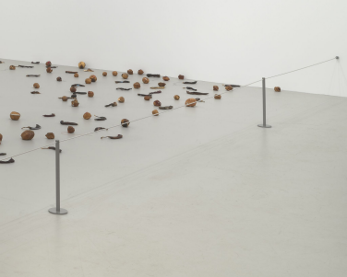
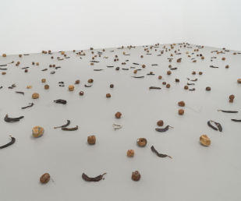

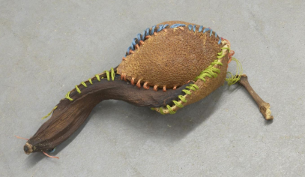
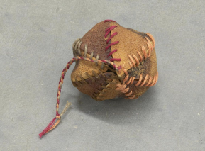

Figure 1: Strange Fruit (detail)

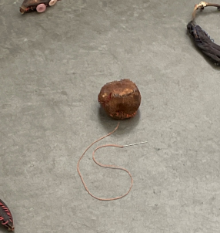

Figure 2: Strange Fruit (detail)

Figure 3: Orange with needle attached to threaddd

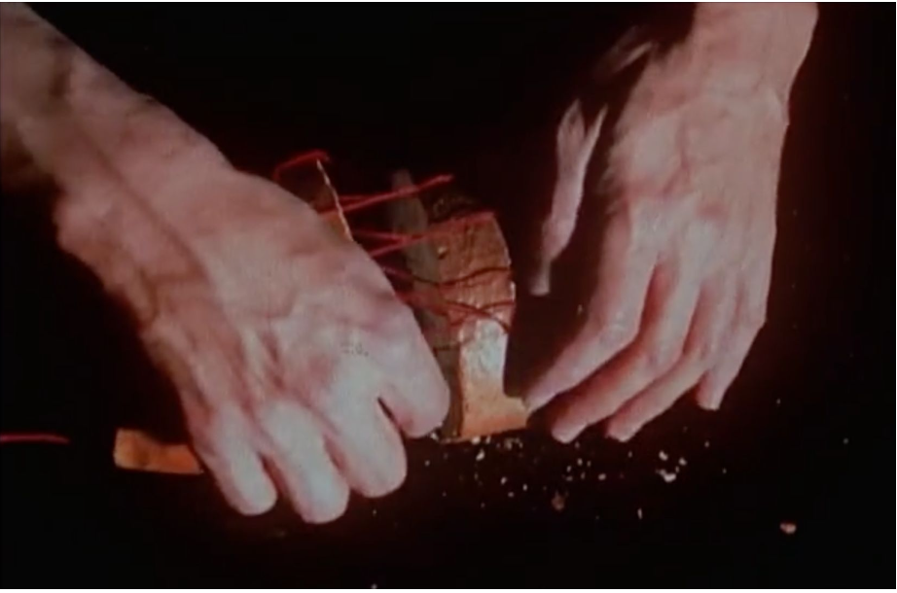
Figure 4: Still from A Fire in MY Belly, Single-channel digital video, transferred from Super-8 film, black-and-white and color, silent, 21 min, 1986-87.

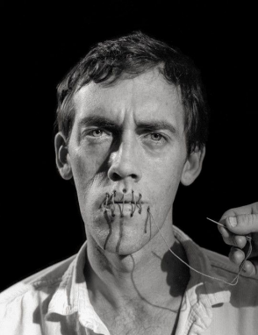

Figure 5: Andreas Sterzing, David Wojnarowicz (Silence = Death), New York 1989

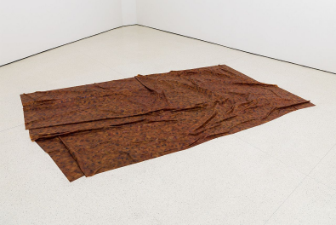
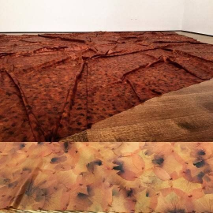

Figure 6: Doris Salcedo, A Flor de Piel, rose petals and thread, 12 feet 2 13/16 inches x 92
1/16 inches (372.9 x 233.8 cm), 2011-2012

Cynthia Carr, Fire in the Belly: The Life and Times of David Wojnarowicz, Bloomsbury USA, 2013. 163.
Shannan L. Hayes, and Max Symuleski. Counterpublic and Counterprivate: Zoe Leonard, David Wojnarowicz, and the Political Aesthetics of Intimacy. New York: Women & Performance. 257.
Zoe Leonard, “Philosopher of the Sequence Out of Sync: Zoe Leonard with Thyrza Nichols Goodeve, The Brooklyn Rail, June 2018. https://brooklynrail.org/2018/06/art/ZOE-LEONARD-with-Thyrza-Nichols-Goodeve-
Nina Quabeck “The Artist's Intent in Contemporary Art: Matter and Process in Transition,” (PhD diss., University of Glasgow, 2019). 128.
Strange Fruit is commonly cited as Strange Fruit (For David), including by former curator of the Philadelphia Museum of Art (PMA) and leader of the PMA’s acquisition of the piece in her landmark essay, Strange Fruit. This however, is incorrect, as Leonard dropped the (For David) before it was acquisitioned by the PMA in 1998. Quabeck “The Artist's Intent in Contemporary Art,” 134.
Quabeck, “The Artist's Intent in Contemporary Art,” 131.
Quabeck, “The Artist's Intent in Contemporary Art,” 136-37.
Quabeck, “The Artist's Intent in Contemporary Art,” 138-41.
Zoe Leonard, artist statement, Strange Fruit exhibit, Museum of Contemporary Art, North Miami, Florida. March 8 to April 10, 1997.
“Death Masks”, Collection Summaries, The Hunterian Museum. Accessed November 28, 2023.https://www.gla.ac.uk/hunterian/collections/collectionssummaries/archaeologyandworld cultures/historical/deathmasks/
Quabeck “The Artist's Intent in Contemporary Art,” 138-44.
The unfinished film is owned by the Metropolitan Museum of Art and rights and reproduction are reserved by the Estate of David Wojnaorowicz, and is not currently available. There is a reupload of both excerpts of the film available on Vimeo.
AIDS Coalition to Unleash Power, or ACT UP, is a grassroots activist organization founded in 1987 that advocated for research, public awareness, and government action through protests, civil disobedience, and community outreach programs during the AIDS crisis. “ACT UP Archival Website”, ACT UP NY, Last Updated August 2018, actupny.org.
Zoe Leonard, Oral History by Sarah Schulman, ACT UP Oral History Project, 106, (January 13th, 2010).
Quabeck “The Artist's Intent in Contemporary Art,” 128.
Tate, “An Introduction to Performance Art”, TateShots, Youtube Video, 2:42, September 22, 2017https://www.youtube.com/watch?v=6Z-YZ3A4mdk. 1:39-1:52>
Tate. “Process Art.” Art Terms. Accessed October 20, 2023. https://www.tate.org.uk/art/art-terms/p/process-art
“Doris Salcedo, A Flor de Piel”, Online Collection, The Guggenheim, 2013. https://www.guggenheim.org/artwork/31379
White Cube, “In the Studio: Doris Salcedo making 'A Flor de Piel’”, Youtube Video, 13:56, January 2, 2023. https://www.youtube.com/watch?app=desktop&v=GCtJ9Za8baM, 0:30-0:32
“Doris Salcedo, A Flor de Piel”, The Guggenheim.
Whitney Museum of American Art, “Zoe Leonard: Strange Fruit”, 2:26:28 https://www.youtube.com/watch?v=sfD8iWicHB4 2:04:10-2:04:28.
Whitney Museum of American Art, “Zoe Leonard: Strange Fruit”, 2:26:28
Sarah Schulman, Let the Record Show: A Political History of ACT UP New York, 1987–1993, Farrar, Straus and Giroux, 2021.
Centers for Disease Control and Prevention. “Morality Patterns- United States, 1997”, Morbidity and Morality Weekly Report, Atlanta: US. Department of Health and Human Services, 1999. https://www.cdc.gov/mmwr/preview/mmwrhtml/mm4830a4.htm
Cynthia Carr, Fire in the Belly.
Leonard, Oral History by Sarah Schulman.
Leonard, Oral History by Sarah Schulman.
“Abel Meeropol: “Bitter Fruit”, Black Americans in World War II, United States Holocaust Memorial Museum, accessed November 3, 2023. https://perspectives.ushmm.org/item/abel-meeropol-bitter-fruit, Fran Kaplan, “An Iconic Lynching in the North”, The American Black Holocaust Museum, accessed November 1 2023. https://www.abhmuseum.org/an-iconic-lynching-in-the-north/
“Strange Fruit”, Signature Songs, Billie Holiday, accessed September 13, 2023. https://billieholiday.com/signaturesong/strange-fruit/
“History of Lynching In America”, History Explained, NAACP. https://naacp.org/find-resources/history-explained/history-lynching-america
“Strange Fruit”, Signature Songs, Billie Holiday, accessed September 13, 2023.
Originally transcribed as “sown” by Nina Quabeck in her dissertation. It could also be spelled as “sewn”. The spelling ‘sewn’ alludes to Leonard’s act of sewing, whereas ‘sown’ could reference her decision to exhibit Strange Fruit on the floor. The variations of the spelling slightly changes the meaning for this statement.
Whitney Museum of American Art, “Zoe Leonard: Strange Fruit”, 2:26:28
Lawrence vs. Texas, 539 U.S. 558 (2003).
Greer, William R. “Violence Against Homosexuals Rising, Groups Seeking Wider Protection Say” The New York Times, 1986, https://www.nytimes.com/1986/11/23/us/violence- against-homosexuals-rising-groups-seeking-wider-protection-say.html
Quabeck “The Artist's Intent in Contemporary Art,” 168.

