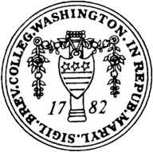

The Quest for Legitimacy: How Organized Criminal
Groups Gain Legitimacy
Mexico as a Case Study

Keywords: narcocultura, organized crime,
legitimacy, community outreach, and state fragility

A thesis submitted to the Faculty of the International Studies Program
in partial fulfillment of the requirements of the degree of Bachelor of Arts
in International Studies

By:
Esmeralda Chavez Jimenez
Advised by Dr. Wade
Washington College

I pledge my word of honor that I have abided by the Washington College Honor Code while completing this assignment
Acknowledgements
This thesis is in dedication to Jaime Chavez and Marilu Jimenez, my parents who taught me from a young age to pursue my dreams and aspirations despite the barriers in my path. Choosing to write my senior capstone experience on this subject has led me to understand in greater depth organized criminal groups in Mexico, but also contributing to scholarly discussions about non-state actors and their path to legitimacy. These issues are of utmost importance and relevance to my identity and culture, and I hope to one day be the change in these communities through improved education quality.
¡Ama y Apa si se pudo!

Special thanks to Dr. Wade, my advisor and the Chair of the Political Science Department, for her unwavering support and guidance through this entire process that began in her course Drugs and Politics.

Table of Contents
Abstract 4
Introduction 5-9
Literature Review 10-11
Legitimacy in Non-state Actors 11-14
The Presence of a Fragile State 14-17
Legitimacy of Non-State Actors in a Fragile State 17-19
Methodology 19-20
Case Study: Mexico’s Fragile State
Part I: State Fragility 21-25
Part II: The rise of Organized Criminal Groups & Drug Trade Organizations 25-30
Part III: Organized Criminal Groups: Indicators of Legitimacy 30-36
Part IV: Narco Cultura as a source of Legitimacy 36-40
Analysis: How has narco-cultura infiltrated Mexican culture? 40-42
Conclusion 42-43
Bibliography 44-48

Abstract

The rise of organized criminal groups (OCGs) and drug trade organizations (DTOs) in Mexico has become a transnational concern that has quickly spread within the past twenty-years, with no indication of fading. Most political scientists and policies in the past have focused on the king-pin approach to tackle the increase of OCGs and DTOs, centered on capturing leaders and increasing state militarization such as ‘Plan Mexico’ under the Merida Initiative. However, this has led to the fragmentation of the main OCGs, an increase of new competing OCGs for turf, and an increase of violence in the country. A bottom-up approach on how OCGs interact with communities in rural areas where they experience the most control and dominance has been overlooked. As such, the following argues that the presence of a fragile state and the creation of subcultures by OCG’s may legitimize them as political actors and make them more difficult to dismantle or disrupt. In the case of Mexico, the weak state, and the development of narcocultura have legitimized OCGs & DTOs throughout the country. This analysis is of the various ways in which the subculture has become embedded in mainstream culture and reveals that Mexican DTOs are a multidimensional phenomenon that use music and aesthetics to create messages around socio-cultural issues and critique the state. This, in turn, creates popular legitimacy for these groups, which becomes deeply embedded in society.

Introduction
The rise of organized criminal groups (OCGs) in Mexico has become a transnational conflict that highlights the institutional fragility of the Mexican state. In particular, drug trade organizations have become the country's most dominant OCGs in recent years. Drug cartels such as the Sinaloa, Jalisco Nueva Generación, Los Zetas, and La Familia engage in drug trafficking, murder, kidnapping, and assault, amongst other crimes in Mexico.
It is important to note that the term ‘cartel’ is a misnomer emerging from the offices of U.S. Drug Enforcement Agency (DEA). In economic terms, a cartel is defined as a group of similar independent companies who join together to control prices and competition. However, in drug trade the opposite is true. There isn’t a monopoly but rather multiple ‘companies’ that compete for territory and dominance. For purposes of clarity however, the term ‘cartel’ will be used from this point forward as it is widely recognized.
OCGs have become stronger in recent years despite strategic plans from the state and international aid, such as the Merida Initiative or Plan Mexico. Militarized policing strategies to combat cartels has proven ineffective and has only led to instability by fracturing the cartels and increasing the number of cartels that compete for territory. The so-called kingpin approach, which targets cartel leadership, has been a key strategy of the Mexican government. For instance, the capture of Edgar Valdez Villarreal “La Barbie” in 2010, Joaquin Guzman “El Chapo” in 2016, and Rafael Caro Quintero in 2022 all became major news headlines. However, this strategy has also been ineffective and resulted in increased homicide rates.
The capture of a DTO leader in a municipality increases its homicide rate by 80 percent over a twelve-month period. This can help explain 36% of the 130% increase in the homicide rate between 2006 and 2010 in Mexico. The overwhelming effects of the DTOs and OCGs have become major. Despite their ineffectiveness, most policy approaches have targeted the supply side “focused on disrupting operations by way of confiscation of drugs and guns, targeting precursors, and arresting and punishing those involved in the drug trade.” While the failure of the Mexican state to quash DTO’s can be attributed to a variety of factors, one of the most often overlooked has been the extent to which these organizations have become culturally rooted within Mexican society.
The failure of the Mexican state to effectively address OCG’s and DTO’s has been a result of state weakness and has impacted the state’s legitimacy. Indeed, the relative weakness of the Mexican state created the conditions that made it suitable for such organizations to become rooted in the first place. In this environment, DTO’s challenged state legitimacy through a subculture that has become embedded in the region’s mainstream culture—narcocultura.
Narcocultura is narco expression in a variety of platforms, whether that be represented in music, film, or symbology. An important aspect of narcocultura is narco-corridos which originates from mainstream culture of corridos. ‘El corrido’ is a Mexican genre that tells the story of a real and/or mythical character. These compositions narrate important moments to pay tribute and show respect towards a person or a town. Since they are rooted in Mexican history, specifically during the time of the Mexican revolution from 1910 to 1920, they represent a via of public expression and information.
In fact, the history of the Mexican revolution can be learned through corridos of major leaders such as Francisco “Pancho” Villa in ‘El Corrido de Villa,’in ‘La Toma (Battle) de Zacatecas’ which was the bloodiest battle in the campaign to overthrow the Mexican president of the time Victoriano Huerta, or ‘El Corrido de Benjamin Argumedo’ who was a Mexican general against re-election. Re-election of presidential candidates was a major force that led to the Mexican revolution since Mexico had a history of dictatorships. However, through the past twenty years, corridos have transitioned to have a major subgenre, narco corridos that essentially inform the public of major OCGs/DTOs, their main leaders, important confrontations between them and the state, and also as a means to praise their lifestyle.
Narco corridos create a path to also name or include symbols in music videos relevant to the OCG. Yet, narcocultura is multidimensional as it expands beyond narcocorridos and includes a major industry—film. For instance, the film Narcos was estimated to cost about $25 million dollars to produce. Such an investment would not carry out had the directors projected a lack of audience—there is evidently a market for it. An in-depth analysis of the different ways that narcoculture manifests will be explained further in future sections.
Most scholarly literature focuses on the cultural anthropological perspective of narcocultura. Essentially it emphasizes the mechanisms of expression, like music, religion, linguistics, and gender, which highlight the mentalities, strategies, and approaches of these organizations. Tellingly, some songs even narrate confrontations between the state and the OCG more accurately and efficiently than reports. This was the case for the song ‘El Bazucazo’ sung by El Tigrillo Palma.
I argue that narcocultura helps to legitimize the DTOs and makes them more difficult for the state to combat. In the regions where they operate, narcoculture has targeted the masses to introduce, inform, and familiarize the population—which leads to a process of legitimation, acceptance, and even elements of approbation.
My research seeks to illuminate the ways in which non-state actors, particularly criminal groups, vie for legitimacy normally associated with the state. Most studies of legitimacy concentrate on the state, less so on non-state actors. Moreover, there is very little understanding of how criminal organizations develop legitimacy. I argue that the power vacuum that occurs in a fragile state creates opportunities where non-state actors can gain legitimacy typically reserved for state actors. This legitimacy translates into the acceptance (and sometimes admiration) of these organizations and their leaders. In these circumstances, such organizations transcend from being DTO’s to the leaders with approval that may rival the state. In Mexico, where DTO’s are especially strong, cartels have created a subculture that rivals (or has supplanted) the mainstream culture. Although DTO’s were present in Colombia as well, the degree and power that they had are not to the same standard and degree of that in Mexico. In the same way that OCGs and DTOs have expanded in Mexico differently than in Colombia.
As evidence of the power of narcoculture, some states such as Tijuana and Baja California have banned public displays or concerts than sing ‘corridos tumbados’ or narcocorridos. Artists have been assassinated for singing lyrics or songs dedicated to specific groups and are therefore killed by the opposition. Essentially, it’s a method used by the OCGs to contract popular artists of the time to sing songs of battle and praise for them and, with time, publicly popularize said songs in the radios, leading to the infiltration of private spheres. It is not only music and film but also fashion.
So, when people ask themselves: how is it that figures like Joaquin Guzman are popular? What does it mean when OCGs provide services and food in struggling regions for the people in times of trouble like the COVID-19 pandemic? How does the creation of symbols that are recognizable to people across regions they don’t control mean for the OCGs? The bottom-line foundation comes down to gaining legitimacy.
It is crucial to understand that organized criminal groups in Mexico are becoming stronger and more rooted on the ground. The inability of the state, or the state’s fragility, fosters an environment where the ability of the OCG can gain ground rooted within social structures and dynamics. This symbiotic relationship is evidence that the problem of organized crime in Mexico is not merely the inability of the state to provide security and support for its people but also about the ways in which the infiltration and the misappropriation of existing culture is used by the OCG to influence people—those who affiliate to the culture of narcocultura—to legitimize, support, and even compete with the mainstream culture.

Literature Review
Most scholarly literature on legitimacy is state-centric, focusing on how the state can consolidate its legitimacy through governance. German sociologist Max Weber identified three bases for legitimate rule in society: ration-legal, charismatic, and traditional. The most relevant to the following research is that of charismatic authority. This refers to the ability of a leader to gain legitimacy based on personal qualities and the charisma of an individual who comes into play during a time of crisis. These leaders can be found in religious, political, or revolutionary movements.
As I will discuss in the coming sections, this becomes an element of legitimization. Weber isn’t, however, the only one who has studied elements of legitimacy but also (Spencer 1970), (Grafstein, 1981), and (Johnson, Dowd, & Ridgeway, 2006).
Johnson, Dowd, & Ridgeway focus on the process of understanding legitimacy as a general social process. Essentially, their argument goes further into Weber’s statement regarding legitimacy and focus on the ways in which new social objects, both individual (worthy/unworthy individuals) and collective (organizational forms), gain legitimation: innovation, local validation, diffusion, and general validation.” Specifically in their contribution of organizational forms, the following states, “once its numbers reach a certain ceiling (i.e., carrying capacity), legitimacy is less of an issue; instead competition now matters, as the sizable number of this particular organizational form now tax available support and resources.” The latter statement is relevant to this research, as it is the case in Mexico. Unlike Colombia, OCGs have multiplied, and there are more OCGs than in the 90s. These sociologists argue, in particular, that an indication post-legitimacy is that of securing their position as an organization. This statement correlates to the following research as I argue that through the process of cultural infiltration they have become legitimate, and OCGs are currently competing against not necessarily tax, but territory and revenue. The concept of competition post-legitimacy is, however, beyond the scope of this research. Yet, it is an element of understanding how organized criminal groups interact post the process of legitimacy that can be studied in future research.
Additionally, Hamm, et al developed a concentric diagram of legitimacy that speaks about the relationship between authority and acquiesce—the audiences’ positive recognition of and response or consent that are at the basis of legitimacy. Elements of an organization’s support, authority, public approval, interactions of legal actors, and social context are factors of state legitimacy. One issue with this analysis, however, is that the focus is on legal actors in the theory. These contributions are crucial to understanding the theories surrounding legitimacy and debates in the perspective from the state, but “there is a lack of empirical evidence on the causes and consequences of external and nonstate legitimacy.” This reveals a gap in the literature on legitimacy as it pertains to non-state actors. The question remains, how do non-state actors attain legitimacy?

Legitimacy in Non-State Actors
The study of legitimacy applied to non-state actors has generally focused on revolutionary movements. These actors have been considered “deviant” as they typically oppose the rule of the state. While not focused on criminal organizations, this literature provides the theoretical framework of legitimacy related to non-state actors. Most research has been state-centric, whereas revolutionaries have been considered as non-legitimate powers.
In “Competing Revolutionaries: Legitimacy and Leadership in Revolutionary Situations,” Huseyin Rasit bridges literature on revolutions and organizational legitimacy. He argues that legitimacy operates along a spectrum that “as a population’s willingness to follow an entity’s authority because the entity’s actions are seen as appropriate, it becomes possible to see that nonstate entities should also cultivate legitimacy if they are to assert authority over a group of people…” In other words, non-state actors can cultivate legitimacy through the use of authority.
David Beetham also discusses rebel legitimacy in The Legitimation of Power, as “a normative perspective legitimacy in essence addresses the rightfulness of power relationships; ‘legitimacy entails the moral justifiability of power relations.’” Again, a similar theme is reoccurring: the use of power or authority as a process to legitimacy.
Another contribution to this framework is Isabelle Duyvesteyn in “Rebels and Legitimacy; An Introduction, Small Wars and Insurgencies,” in which essentially there are two different distinctions that she contributes to—legitimacy and legitimation. Legitimation, the processes that lead to the creation of legitimacy, has three main elements. The first is based on beliefs that conform with established norms or rules in place. The second is beliefs about what is legitimate that can inform power to be considered as containing legitimacy; for instance religious or traditional legitimacy. The third is about pledging allegiance which officially establishes the presence of the power. These three approaches to the normative process are what I consider the building blocks that Weber also speaks about. However, like mentioned previously Duyvesteyn mentioned elements of legitimacy as the process, where “not only does legitimacy need to be established for the collective but at the same time it needs to be accepted by the individual.” In other words, individuals must accept the entity to consider its legitimacy, not solely recognized by the collective.
Since there is a limited framework on non-state actors, the closest organization similar in its stance against the state is that of revolutionary groups. A major contribution to the construct of revolutionary groups’ networks and identity is provided in “Rebel Governance—Constructing a Field of Inquiry: Definitions, Scope, Patterns, Order, Causes,’ by Nelson Kafir. He argues that “revolutionary actors do not act, or even think of themselves as acting alone.” In other words, it’s the efforts and actions of the collective that operate to act accordingly. The elements that are relevant to this research are the three sources to protest identities. Protest identities are people “who are brought together who share and justify grievances, with the ability to remedy those grievances by collective action.” Their three elements are: one, the group helps to justify and validate the individual grievances against the status quo; two, they give a sense of empowerment, autonomy, and efficacy; and three, there is a sense of oppositional identity by labeling a group as its enemies. This is essentially where people are able to pledge their allegiance with a common ideological connection for collective acceptance rooted in individual allegiance or acceptance of the rebel group. This is key to the legitimacy of an organized group—rebels—because it creates a strong bond between members of the group. In short, a sense of allegiance to the group who, like Kafir mentioned, are bonded together by the same struggles but have advocacy via the group to act in opposition to the enemy.
This information is pivotal and provides an understanding of the internal framework within non-state actors as in this case—revolutionary groups. Furthermore, if we take into consideration that organized criminal groups are considered deviant in society, revolutionary groups are similar to organized criminal groups; not necessarily on the basis of purpose but that they’re seen as non-state actors. As for in the case of Mexico, there is inherently a correlation between protest identities in the revolutionary movement between the years 1910 and 1920 in their opposition to the status quo, and therefore, giving a sense of empowerment autonomy and efficacy that lead it to create allegiances with a common ideological connection—a key indication of legitimacy according to Kafir. The connection stems in the way of legitimizing narco cultura. Essentially, OCGs infiltrate the existing and present culture of corridos—originated in the times of Mexican revolution—to gain momentum.

The Presence of a Fragile State
To understand the power and establishment of organized criminal groups, it goes without a doubt that understanding the fragility of the state is a precursor and the existing condition that allows the latter to occur in the first place. State fragility is a spectrum and is not a simple dichotomous process that states either do or don’t process. It’s a continuous process that states seek to ensure the security of their people while also establishing a life with dignity.
One of the ways in which state fragility is conceptualized is through the use of quantitative and qualitative measures that rank the fragility of the state using various criteria. For instance, the Fragile States Index (FSI), powered by The Fund for Peace, created some mechanisms of how state fragility can be measured. The methodology used from FSI is a content analysis with twelve indicators divided into four main general concepts: cohesion, economic, political, and social. A quantitative data and qualitative review analysis is then used to integrate the data sets. Finally, after the data is reviewed, the FSI ranks countries.
For instance, the three subsections of political indicators are: state legitimacy, public services, and human rights and rule of law. In terms of economic indicators, there are three subsections: economic decline, uneven economic development, and human flight/brain drain. For the purposes of clarity and efficiency, the following three characteristics used to explain the framework of state fragility are authority, capacity, and legitimacy.
This framework was developed from the Center for Global Development in 2004; “Commission on Weak States and U.S National Security.” The Center for Global Development uses “three sets of gaps: capacity, legitimacy, and security.” The following has a similar approach with the exception of security, which instead replaces it with authority. The reason behind this shift is because security is obtained through the authority of the state—through the monopolization and central authority to implement and enforce rules. Another way to conceptualize the above is to think of the state as being apt to keep its citizens safe and have low rates of impunity.
State authority as mentioned previously is essentially the ability of the state to control violence, implying elements of domestic sovereignty. Three types of authority are traditional, legal, and charismatic—according to Max Weber. Charismatic authority refers to that of the leader who has, in essence, a charismatic style of leadership in which people follow. This is considered unstable and unreliable as the perceptions of the people can change depending on the way they perceive the leader. Traditional authority is rooted in the society itself, with elements of social practices and beliefs—values. Lastly, the legal/rational authority is the ability to give legitimacy to the rules and policies where people vote, and there are democratic practices that wield the power distributed amongst various branches of government. Additionally, a quantitative method that is used to measure authority is the violence or crime index of the state. Are there high homicide rates or is the state able to contain the violence?
State capacity refers to the effectiveness of policies and how well they can provide basic public services. Public services include health care, education, electricity, and food. According to Mauricio Cardenas, who is a professor of Professional Practice in Global Leadership at Columbia University’s School of International and Public Affairs, state capacity is defined as “the ability of the state to provide public good and support the economy with a sound legal framework.” Although he dives into the distinction of state capacity as “fiscal” and “legal,” he places an emphasis on the “fiscal” dimension—which is the state’s capacity to raise revenues from the population. The following can be measured in various ways: literacy rate, poverty rates, and economic growth. In a state that is considered fragile, the lack of structured and institutionalized systems that provide public services are present.
State capacity and legitimacy are related as the dynamic of state capacity is what leads to legitimacy. In other words, if the state promises its citizens increased health or education programs, and it goes through, this increases the perception of the citizens to see the state’s legitimacy through the effective policy measures. For instance, FSI defines state legitimacy as “the population’s level of confidence in state institutions and processes, and assesses the effects where that confidence is absent, manifested through mass public demonstrations, sustained civil disobedience, or the rise of armed insurgencies.” A limitation to this definition is that it does not necessarily consider the democratic practices, but it does provide public perception on the integrity of elections.”

Legitimacy of Non-State Actors in a Fragile State
Before understanding the presence of organized criminal groups in Mexico, it is
important to set a foundation of understanding the current position of the state. Weak or fragile states are more susceptible to criminal networks. The inability to maintain a monopoly on violence or provide citizen security may, in turn, erode state legitimacy. Thus, state fragility, crime, and legitimacy are intertwined.
State fragility is defined as a state that demonstrates weak capacity, legitimacy, and authority. While fragility exists on a spectrum, more than 70% of all countries in the world have significant areas of limited statehood. In “Legitimacy in areas of Limited Statehood,” Stollenwerk argues that no state is either consolidated or failed, rather statehood refers to the ability of the state to control violence. As such, legitimacy exists on a spectrum. His main framework is under the argument that understanding the legitimacy of non-state actors is essential for analyzing areas of limited statehood. According to Stollenwerk, legitimacy may be derived from a variety of sources. While it can be difficult to measure legitimacy, some indicators and sources are illustrated in Figure 1 below.

FIGURE 1: Sources of Legitimacy and Examples for Indicators
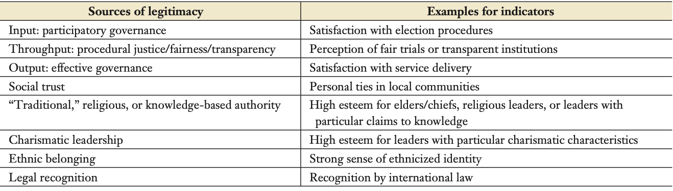
For the purposes of clarity, the following research will focus primarily on two of the sources of legitimacy mentioned. The first is that of social trust, in which someone of the same community can build legitimacy based on their personal ties to the community. The second source pertains to charismatic leadership, where leaders possessing charismatic traits are esteemed and considered worthy of leadership roles.
Overall, the three main frameworks that are used in scholarly literature are theories of legitimacy, revolutionary groups as a non-state actor, and the fragility of the state or limited statehood that allow for these non-actors to gain legitimacy. A common theme mentioned by Duyvesteyn, Risse, and Stollenwerk is that few scholars have focused on actors other than the state. OCGS and DTOs are fundamentally underrepresented in terms of legitimacy.
Current scholarly literature analyzes narco cultura in the ways that it manifests in music, gender studies, and fashion. This refers to the contribution that I will use in my analysis below of how scholars analyze the manifestation of narco culture in Mexico and how it infiltrates. Therefore, I argue that the existence of narco culture can’t be studied without first understanding the environment—a fragile state—that allows for emergence of such.

Methodology
The chief aim of this study is to demonstrate how Organized Criminal Groups (OCGs) can acquire legitimacy amongst the populations the de factor governs. While Mexico’s fragile state created opportunities for the establishment of OCG’s throughout its territory, Mexican drug cartels have derived their legitimacy through the spread of narco cultura. Therefore, the subsequent analysis aims to provide an original case study examining the relationship between the state, OCGs, and narco cultura. Using process tracing, the study will begin with an examination of Mexico’s state fragility supported by data on rates of violence, organized crime, corruption, and impunity. This methodological approach is suitable to capture the dynamic interactions between OCGs, the state, and narco cultura.
Subsequently, it will delve into the emergence of territorially based drug cartels and the origins of drug trade in Mexico. This will provide context of the trajectory of illicit drugs throughout the country. Previous government intervention and initiatives, such as the Merida Initiative, will be mentioned. These efforts have contributed to increased militarization in Mexico, resulting in the fragmentation of cartels and the emergence of new ones, ultimately leading to an increase in violence. Following this, I will then analyze how a subculture—narcocultura—perpetuates a widespread acceptance and support for organized criminal groups in Mexico, while also debilitating the legitimacy of the state. To substantiate this argument, empirical evidence will be drawn from four overarching themes: physical control over the region by OCGs, symbolic politics, psychological charismatic authority, and social trust. This study will investigate symbols associated with from four major cartels (Cartel de Sinaloa, Cartel Jalisco New Generation, Los Zetas, and Los Caballero Templarios) as portrayed in narcocorrido music videos or media as a means of spreading messages of support and loyalty to the OCG.
Furthermore, I will examine public interaction with music and symbols through accounts of public protest for the release of major OCG leader, Joaquin ‘El Chapo’ Guzan. For this point, I will obtain information from news reports on the public protests demanding the release of OCG/DTO leaders and include images of different public messages, symbols, and new narcocorridos created shortly after. This is crucial, as an element of legitimacy is the ability of OCGs to have an explicit support from the community while also debilitating the legitimacy of the state.
Lastly, I will focus on demonstration of narco cultura represented in narcocorridos, religion with figures like Jesus Malverde and La Santa Muerte, and the highly profitable market of the Netflix film Narcos. This study concludes with an analysis of the process of legitimation for OCGs—a combination of physical and psychological elements.

Case Study: Mexico’s Fragile State

Part I: State Fragility
By various metrics, Mexico exhibits the characteristics of a fragile state. This can be attributed to the historical struggles with weak institutions. Following independence in 1821, power was not democratically transferred, fostering a culture of corruption that to this day persists. The Mexican revolution catalyzed against the re-election of Porfirio Díaz, who ruled Mexico for 35 years, marked a turning point. Dissatisfaction among the middle and lower classes fueled protests against abuse, exploitation, and undemocratic institutions. While the revolution can be considered a success, preventing Diaz’s re-election and instituting a no-reelection policy in positions of governance, Mexico saw a transition to an authoritarian style of government. 71 years of political party dominance from the first political party, the National Revolutionary Party or ‘PRI.’ It wasn’t until 2000 that the National Action Party (PAN) won its first presidential election with Vicente Fox.
Some theories suggest that with the election of a PAN presidential candidate and overall growing PAN presence in the country, this dissolved and fractured potential political ties and agreements between corrupt government officials and Organized Criminal Groups/Drug Trade Organizations (OCGs/DTOs). Geopolitical factors also contribute to the fragility of the state in that effective governance and territorial control is a challenge in the mountainous regions—where illicit drug production flourishes, exacerbate governance, and territorial control issues.
To grasp the complexities contributing to state fragility, international relations scholar Jose Miguel Alonso-Trabanco offers valuable insight framing Mexico’s complexity as such:
“Mexico is an amalgam of regions whose geographic contexts, demographic profiles, historical backgrounds, economic dynamics, and cultural traits are highly heterogeneous. Hence, said conditions have given birth to powerful local entities, including political groups, business communities, and criminal networks.”
This is important, as the fragility of the state began from its early independence as noted above, and although this section doesn’t delve to the criminal networks just yet, it begins to lay the foundation of the complexity of geopolitics in Mexico and how the fragility of the state is led by impunity and corruption from its historic lack of democratic practices.
For the purposes of this project, state fragility is measured by three components: state authority, state capacity, and state legitimacy. According to the Fund for Peace, the four attributes of a fragile state are: 1) the loss of physical control of its territory or a monopoly on the legitimate use of force; 2) The erosion of legitimate authority to make collective decisions; 3) An inability to provide reasonable public services; and 4) The inability to interact with other states as a full member of the international community. The Fragile State Index (FSI) ranks about 179 countries on four major indicators influenced from the statement above: cohesion, economic, political, and social. For the purposes of this research the most relevant are the political indicators that measure state legitimacy, public services, and human rights and the rule of law. The second relevant indicator is that of cohesion that includes security apparatus which considers threats to the state such as organized criminal groups. The results of the FSI for Mexico is a 69.8 in a maximum of 120. (1 being the best and 120 the worst).
FIGURE 2: State Fragility in Mexico from 2006 to 2023
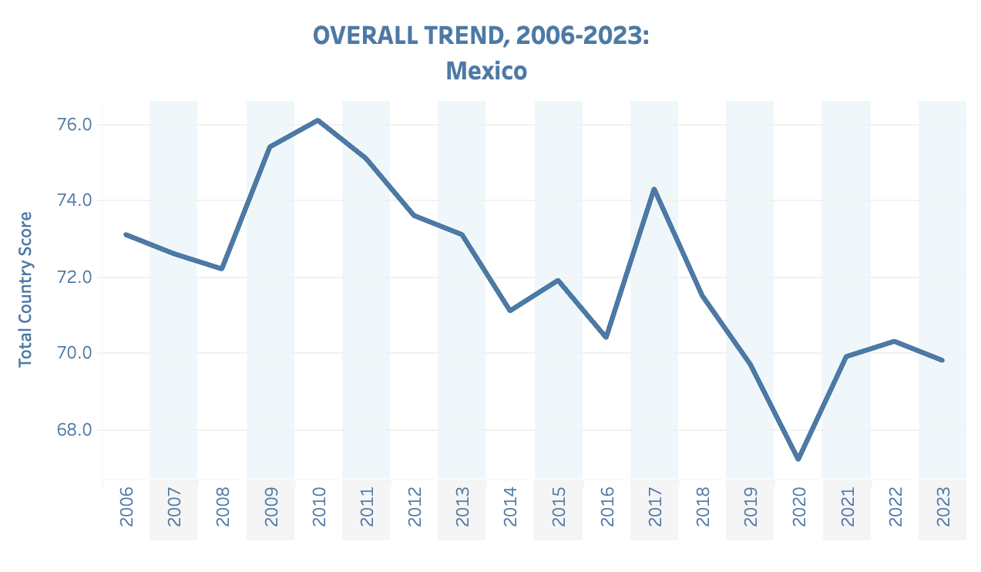
*The following image is from the Fragile State Index powered by The Fund for Peace
FIGURE 2 depicts the overall trend of the state fragility in Mexico from 2006 to 2023. An indication of state fragility is that of security. This refers to the ability of the state to ensure and monopolize the security of its people. A decrease in the total country score indicates improving while an increase in the country’s score indicates worsening. It is important to acknowledge the years of progress from 2018 to 2020, from which Mexico experienced a positive change consecutively. However, 2017 was by far the worst year since 2007. This demonstrates the volatility of the Mexican state, in that specific years are markers of extreme state fragility with the worst scores on Cohesion Apparatus in security apparatus. For further context, the security apparatus indicator considers the security threats to the state, such as bombing, attacks and battle-related deaths, rebel movements, mutinies, coups, or terrorism. This is relevant to elements of state fragility because it also considers serious criminal factors, such as organized crime and homicides. Therefore, state fragility index trends can also note higher rates of violence because of OCGs in Mexico.
FIGURE 3: Public Satisfaction in Mexico from 2002 to 2017
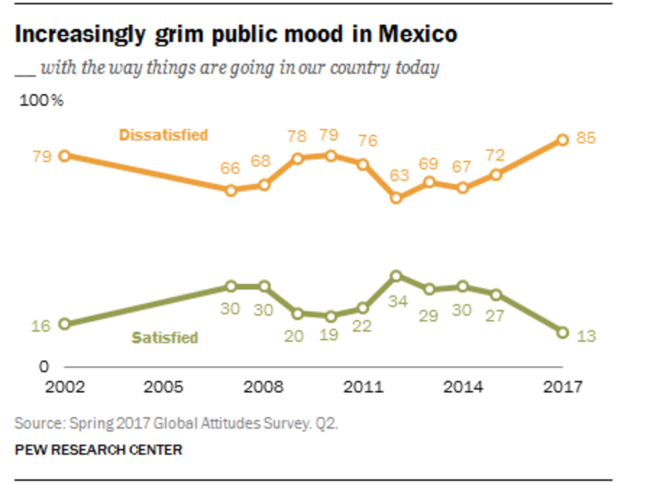
Another form of qualitative data that can help conceptualize state fragility, specifically state capacity, are opinion polls. In 2017, The Pew Research Center published a report on Mexican views in which states that the satisfaction was at its lowest since 2007. “Only 13% of Mexicans are satisfied with the way things are going compared with 85% who report being dissatisfied.” If we correlate back to the Fragility Index, the year in which fragility was at its worst coincides for the most part with the satisfaction poll—2017. Notably, during that same year, the top concerns for Mexicans were crime and political corruption, each at 84% closely followed by concerns about drug cartel-related violence with 82%. There is a common theme and relationship between drug cartels, violence, and the disruption of the state fragility—state’s capacity, authority, and legitimacy.

Part II: The Rise of Organized Criminal Groups & Drug Trade Organizations
Before understanding how it came to be that OCGS became so powerful in the context of
a fragile state, it’s important to first lay out the history of illicit drugs and trafficking in Mexico and their trajectory. As such, the subsequent section will provide context on the early stages of drug trafficking in Mexico with European and Chinese migrations. Then it will delve into the importance of geopolitical elements that influenced these rural remote regions to participate in the production of opium, marijuana, and synthetic drugs in the ‘third wave’ during the 1940s. This will provide some context of how 1.) Why is production mainly centered in the state of Sinaloa? and 2.) How rural regions are major actors in the production of drugs. This section highlights the existing connection between places of production in remote regions, poverty, drug trade and organized crime. Lastly, it will do a brief context analysis of Plan Merida of increased militarization and King Pin Approaches as ineffective policy measures in the context of Mexico.
The history of the production of illicit drugs in Mexico originates from the 1800s by Chinese immigrants who brought poppy plants and settled in the state of Sinaloa. According to the Time, the first recorded traffickers who were arrested were Patricio Hong, Felipe Wong, and Luis Siam. Ioan Grillo, writes and notes that the Chinese built a network that could harvest poppies, turn them into gum, and sell the opium to Chinese traffickers on the American side.
Just as the British had challenged Chinese prohibition, the Chinese would challenge American law. When immigration was prohibited in 1882 in the United States, Chinese migrants moved to Mexico. In Mexico, they (Chinese immigrants) found jobs on the railways of the northwest and around the Crananea mine (in northern Mexico), in the cotton field around Mexicali, and in small retail and commercial operations dotted throughout Mexico’s principal towns and ports.” According to Juan Antonio Fernandez Velazquez and Benjamin T. Smith in “A History of Opium Commodity Chains in Mexico, 1900-1950” in the Collection: Why The Drug War Endures: Local and Transnational Linkages in the North and Central America Drug Trades by the London School of Economics and Political Science, most of the smoking opium was imported into the small Pacific port of Ensenada. Yet, the Chinese were not the only ones to bring drugs; the German and the Dutch were also involved. “In November 1924 an informant explained to a Mexican secret service agent how the drugs came in. Most were imported on German and Dutch passenger ships, often by boat employees such as barbers and cooks to the port of Veracruz. Traffickers would pay workers to move the drugs off the docks, taking them into small packets of four or five kilos.” A similar landscape was seen throughout the decades up until the 1940s with not much government resistance.
In the 1940s, Sinaloa merchants dominated the opium market that grew from the Sierra Madre Occidental. This is a major shift, as the two major chains that are mentioned in the previous source were 1.) European pharmacists that ran from Veracruz, through Mexico City, Torreon, and up to Ciudad Mexico, and 2.) centered on smoking opium that was dominated by the Chinese in Northwest Mexico. The third one however, became ‘local’ after the expulsion of Chinese communities in a Sinophobe Mexico in the early 1930s, with not heroin or morphine (that the European brought) or opium (from the Chinese), but rather the start of the process of changing raw opium into morphine and heroin in Sinaloa. There was some attempt by former Mexican president Lazaro Cardenas in 1938-1939 to place the production of narcotics under state control. However, this led the U.S to place an embargo against all medicinal products coming from Mexico. As a response the Mexican state “simply [allowed] the industry to exist with covert help from the army, police, politicians, and regional movements.” WWII blocked Turkish and European imports of opium, marijuana, and heroin which led to an increase of Mexico’s production of poppy and hemp.Arguably, this was the beginning of the earliest forms of drug production but also of the early Sinaloa Cartel.
The Golden Triangle region is in northwestern Mexico, encompassing the states of Sinaloa, Chihuahua, and Durango. Geopolitically, it is also a mountainous terrain and desert further north, especially in Chihuahua. This is to say that these regions are remote and of difficult access, but it is also the region marked by drug cartel violence. FIGURE 4 displays the production of synthetic drugs in the West Sierra Madre Mountains. Two main points can be drawn from this map. The first is centered on how geography plays a role in the production of synthetic drugs as in the case below. The second reaffirms how Sinaloa is a major player in OCGS and DTOs.

FIGURE 4: The production of synthetic drugs (Updated in 2022)
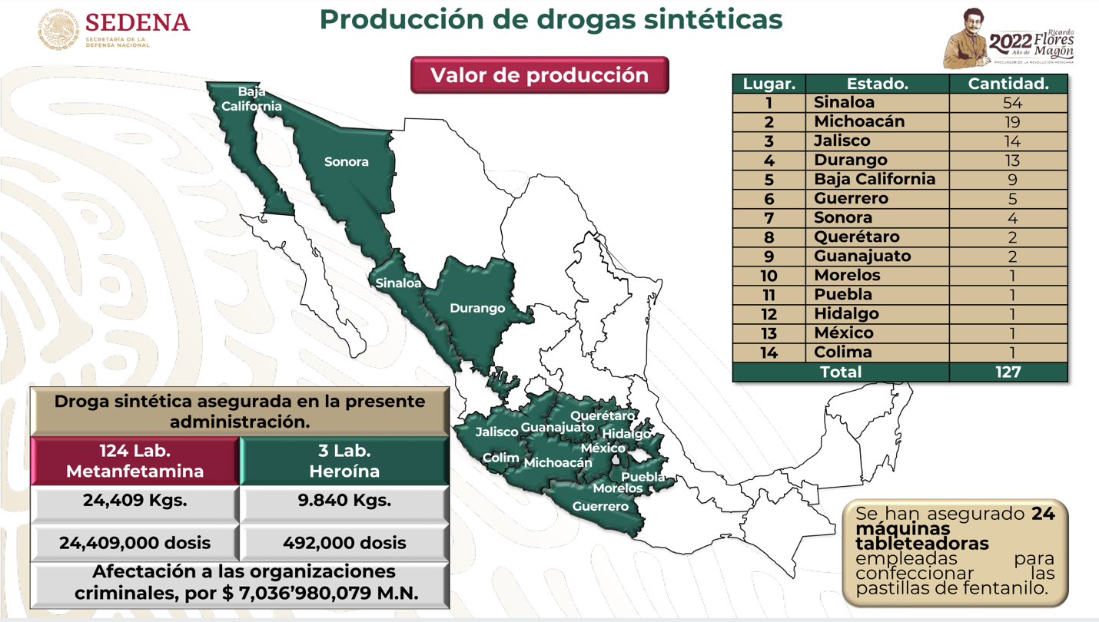
*The following source is from the Mexican Secretary of National Defense
While cocaine production was taking shape in Colombia, U.S former president Richard Nixon coined the “war on drugs.” From 1968 to 1982, the Dirty War in Mexico that took place disappeared more than 1,200 people under state’s claims that they perceived these people as threats. According to “journalist Diego Osorno, a report from the Departamento de Investigaciones Políticas y Sociales dated June 30, 1971, under the guise of combating drug trafficking and with the help of U.S., Mexican President Luis Echeverría dispatches 12,000 troops to Guerrero in order to suppress a popular guerrilla which demanded changes to the socio-economic order of the campesinos.” This is important because there is a mix of political fragmentation, corruption, and human rights abuse while simultaneously an increase of drug production in the regions displayed in FIGURE 4.
Mexico’s first cartel was the Guadalajara Cartel in the 1980s that served as a federation under three main leaders: Miguel Angel Felix Gallardo, nicknamed “The Godfather” and also an ex-agent of the federal judicial police of Mexico; Rafael Caro Quintero; and Ernesto Fonseca Carillo. Due to the cooperation among these three figureheads, the cartel shipped cocaine and marijuana to the United States; the cartel worked as a liaison to the infamous Medellin cartel. However, “after the murder of U.S Drug Enforcement Administration Agent Enrique Camarena in 1985, Gallardo divided Mexico into ‘plazas’—or regions to be controlled by various drug-trafficking organizations, further solidifying major played in the trade such as the Sinaloa Federation and the Arellano Felix brother of Tijuana.” In turn this has led to new cartels to rise to power and form alliances with other regional cartels. In 1992, the DEA instituted the King Pin Strategy. “The DEA planned to disable major organizations by attacking their most vulnerable areas—the chemicals needed to process the drugs, their finances, communications, transportation, and leadership structure.” However, this approach has become ineffective, as this only causes displacement and long-term violence in a competition for turf between OCGS/DTOs.
Mexican government approaches, alongside international intervention like the Plan Merida, which was financed by the United States, led to an increase of militarization and human rights abuses without much progress. According to the U.S Embassy & Consulates in Mexico, “December 2008, Mexico and the United States signed the first Letter of Agreement (LOA) for the Merida Initiative, opening a chapter of historic cooperation and acknowledging the shared responsibilities of the United States and Mexico to counter drug-fueled violence threatening citizens on both sides of the border.” Essentially the initiative had four main objectives: 1.) Disrupt the capacity of organized crime to operate; 2.) Institutionalize capacity to sustain rule of law; 3.) Create a 21st century border structure; and 4.) Build strong and resilient communities. However, only a year after Plan Merida, in 2009, the Cartel Jalisco New Generation (CJNG) was formed. As a means of debilitating the major cartel of Mexico, the Sinaloa Cartel, CJNG sought alliances with members of the Tijuana Cartel. One could arguably state that Plan Merida was unsuccessful based on the creation of new cartels (like CJNG) and the increase of state perpetrated violence against people.

Part III: Organized Criminal Groups (OCGS): Indicators of Legitimacy
In the case of Mexico, OCGs and DTO exhibit four major significant findings regarding indicators of legitimacy: physical security, symbolic politics, psychological charismatic authority, and social trust established between OCGs and the territories under their complete control. The subsequent section explores each indicator of legitimacy and its manifestation in the Mexican context.

Physical: Security—Control over certain region
The process of legitimation through a subculture cannot be without the physical establishment as well. Essentially, this can be in the form of physical legitimacy—control over certain regions. The state of Sinaloa is a prime example of physical legitimacy of organized criminal groups that operate and control the region. A prime indication of such was after the apprehension of Osvaldo Guzman, son of main drug lord, Joaquin Guzman. In 2019, Guzman was captured by authorities and arrested in the city of Culiacan. Upon his arrest, the city broke out in days’ worth of non-stop fighting against the state. According to reports from Aljazeera, “The Mexican army used Black Hawk helicopter gunships against the cartel’s truck-mounted heavy machine guns. The cartel’s gunmen hit two military aircraft forcing them to make emergency landings and then sent gunmen to Culiacan city’s airport where military and civilian aircraft were also hit by gunfire.”As such, Mexican President, Andres Manuel Lopez Obrador to avoid bloodshed, ordered his release. This is a clear indication of the power and dominance that the cartel of Sinaloa possesses were one, the law competes with security and two the government competes with the advanced armament of cartels.

Symbolic Politics
An aspect of legitimacy is the establishment and recognition of OCG symbols. As mentioned, unlike in Colombia, in Mexico the capture of one cartel leader results in the emergence of two new ones. As such, among the priorities of the cartel are competition and recognition from their enemies but also for non-affiliates (members of the community). In the case of the Sinaloa cartel, symbols are represented with emblems and numbers. The cartel’s leader, Joaquin Guzman is considered, in 2009, the Forbes millionaire list. In the commerce of establishing legitimacy, their merchandise included caps, t-shirts, sweaters with the numbers 701 imprinted. Furthermore, as a continuation and reinforcement, the song “701” by Los Alegres del Barranco had over 70 million views nearly a decade ago. Narcocorridos was not a phase of the early 2000s; about seven months ago, new artist Panter Belico released the song “La 701” in dedication to Joaquin Guzman. It states something along the lines of:
When the old man had a party. The 701 is always in trouble. Good rhythm for dancing. Good step with blonde hair. Pretty security throughout the place. Relaxed and safe. Under the command of the cholo Iván. Pure ex-military more armored than a wall.
With a melancholic feeling and lyrics, the song is a recollection of the persona that Guzman embodies—devious, powerful, and protected under the command of an ex-military leader.
In some cases, symbols and corridos are interconnected to represent narco-cultura. Below is a representation of two of the most popular emblems for the Sinaloa Cartel and Nueva Generación de Jalisco. As part of the Sinaloa Cartel, 701, and for Cartel Jalisco Nueva Generación, the emblems below are used. This is important to note, as it has become a way of establishing themselves among non-affiliates where they are still able to participate/consume.

FIGURE 5 : Symbols of Cartel de Sinaloa, Cartel Nueva Generación de Jalisco, & Los Caballeros Templarios
ABOVE: Cap with initials of main drug lord of Sinaloa Cartel, Joaquin Guzman Loera (JGL). Symbol sometimes used in military-like uniform
BELOW: Cartel of Sinaloa from members of the Cartel Jalisco New Generation
(CJNG) *Mecho (main leader) special forces
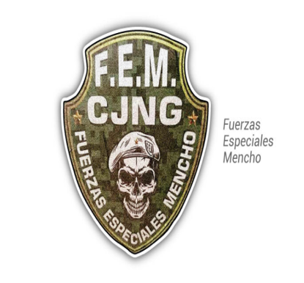

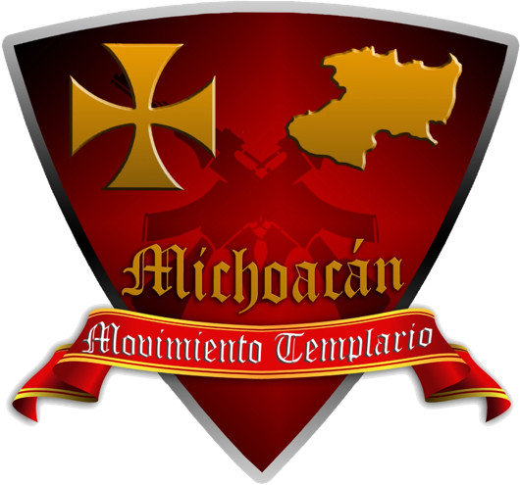
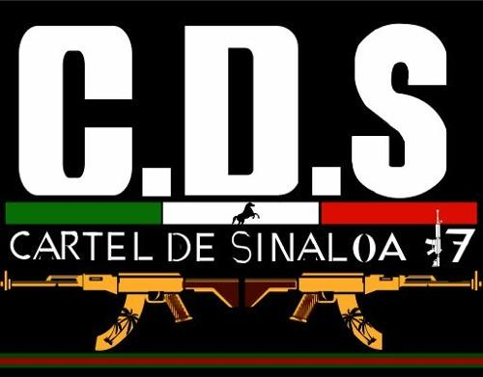
*Symbol of the Los Caballeros Templarios, composed of remnants of Cartel Familia Michoacána in 2010.

Psychological: Charismatic Authority
Charismatic authority refers to the ability of the main leader to persuade and influence others because of the position that they have within the community. In the case of OCGs in Mexico, this has led to major influence and acceptance of the drug leaders. Specifically in the case of the Sinaloa cartel, Joaquin Guzman was praised in a “Robin Hood” mentality where, although he engages with the elicit, the community receives a portion of the gains. The loyalty of the community is dependent upon a sense of security and protection in exchange for silence. Revisiting the concept of charismatic authority, Guzman is seen as a protector and defender of the public. Specifically looking at narcocorridos that narrate his life story, the song “La Tuna”, the lyrics that reiterate the previous statement are below.
As a child he sold oranges, back in the mountains
Just to be able to eat
He is never ashamed of that
On the contrary, he says that it was a source of pride for him.
In these lines he is narrated from the perspective of his youth and the challenges he faced but with an inner sense of resilience and humility.
The greatest symbol of loyalty and charismatic authority was the public protests in the city of Culiacan territory of the Sinaloa Cartel, where people publicly demonstrated discontent for the apprehension of the drug leader Joaquin Guzman Loera. The following image displayed below represents how the state of Sinaloa protested for the immediate release of ‘El Chapo’ in 2014.
FIGURE 6: “Sinaloa wants Chapo Guzman Free”
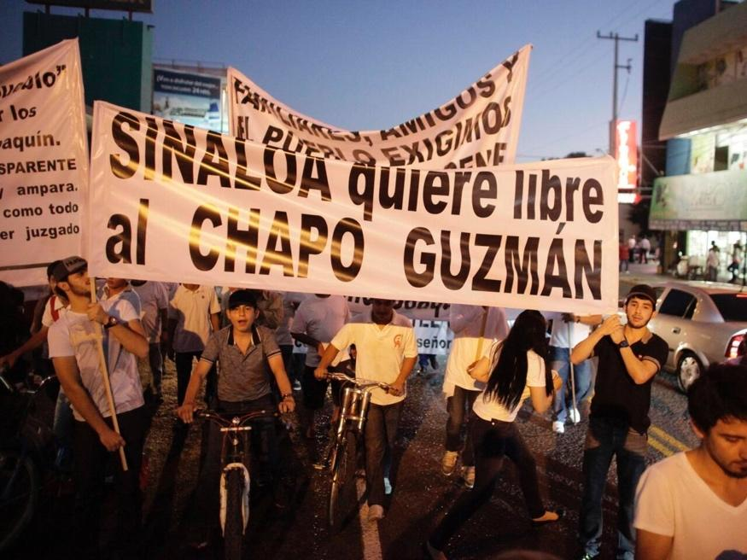

Creating Social Trust
An indicator or source of legitimacy for OCGs is social trust. This refers to the ability of the organized criminal group to establish social ties with the community, especially the ability to provide necessary support and funds during a time of crisis. Such was the case in 2020 during the COVID-19 pandemic. As depicted in the image below, during the pandemic, the daughter of Guzman distributed food and toiletries in packages that were stamped with the face of her father. The purpose is to establish a sense of community while also providing in a time of need. This is where the elements of state fragility are important to understand; this goes beyond a noble cause and is more about establishing legitimacy. Trust is also built when people of these remote regions, particularly in the North, feel seen and protected. Because of state fragility, this leads to a power vacuum in these regions where OCGs such as the Sinaloa cartel can provide for these ‘forgotten’ communities.
Figure 7: Establishing Trust Among the Community During a Time of Need
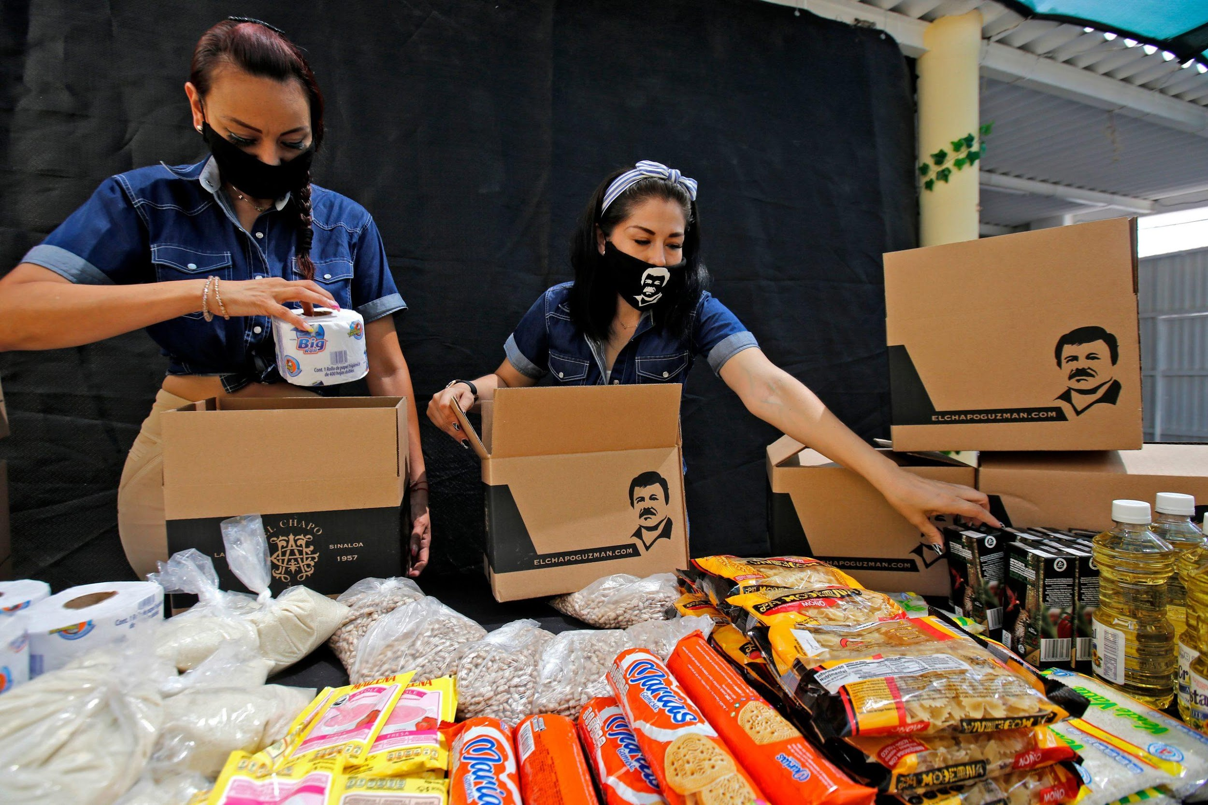
*The following image is from The Scottish Sun by Dan Hall published in May 2020.

IV: Narco Cultura as a Source of Legitimacy
The term narco-cultura in the context of Mexico originated in the 1970s, with the increase and diversification of the production of films, music, television series, and documentaries related to drug use and trafficking, but also due to the media coverage that has the lifestyle of drug traffickers, their language, consumption, clothing, accessories, among other aspects. However, to understand the power of narco cultura, it's important to understand the popularity of corridos first.
Corridos have been around since the 1920s—during the time of the Mexican Revolution. Corridos like “El Zapatista,” “Corrido de Pancho Villa,” and “La Tumba de Villa,” amongst others, depict the battle in full detail that incites a feeling of national pride after the defeat of the opposing side. This style of music, apart from narrating a story or a battle, can also represent the life of ordinary citizens. Therefore, corridos have been a symbolic representation of the contemporary feelings, attitudes, and current issues of Mexican citizens. Corridos are a symbol of the shared identity of a marginalized community. In other words, during the time of the Revolution, figures like Emiliano Zapata, who fought for the redistribution of land that was illegally seized by the elite of the time, would eventually have his own corridos. Although Villa and Zapata are after distinct goals—Villa against the Porfiriato and Zapata for a land reform—they both symbolize resistance against the state. It’s worth noting that the “state” in the 1920’s had no limitations of power in the executive power and was highly oppressive against those who were not Spanish. Therefore, although considered “deviant” in the eyes of the state, their cause was just and humane, and it revolutionized mostly Mexico’s economic and social conditions.
The transition of corrido to narco corridos took full effect in the early 2000s with the major establishment of Twiins Culiacan, a label record company based in Sinaloa’s capital city, Culiacan. Culiacan is known to be the epicenter of narco culture, especially with the mass production and emphasis on the capo lifestyle. Twiins Culiacan created a $2.76 million platform for artists to become part of the movimiento alterado, or altered movement. The video clips that align with this movement are “Carteles Unidos” (United Cartels) and Sanguinarios del M1 (Bloodthirsty Cartels of the M1), in which a clear claim is made—don’t mess with us; we will kill you.
Narco corridos are not built with the intention of "telling" a story, but rather "presenting" some characteristics of the “movement”: its members, its features, the font, etc. The visual representation of specific characteristics that define this movement is what distinguishes that transition from simply being corridos to becoming narcocorridos. It is important to note that a significant number of narcocorridos are generated independently with the financing of the capos, who seek immortality through songs. If artists don’t have a platform or the support of major record labels, such as Twiin Culiacan or Twiins Music group, they can still be drawn to release their music through the support of the capo himself. The opposite can be true as well, where cartel members can ask or demand an artist to compose a song in his honor. This is one of the many ways in which narco-culture influences and infiltrates Mexican culture. Although some might claim that narcocorridos aren’t relevant to OCGs and DTOs, in 2006 Valentin Elizalde, a popular narco-corrido singer was gunned down, ambushed, and killed. In the same way, Sergio Vega, Chalino Sanchez, and other artists who sign this genre are threatened and killed for singing in opposition territory. Additionally, this emphasizes narco-corridos as a form of recognition and legitimization.
Yet narco cultura has transcended from being simply corridos; it has become a lifestyle where gender plays a role. The terminology of life of a buchona/buchon derives from Sinaloa. It is mainly focused or centered on the sexist and components of hypermasculinity associated with the music videos and films. Women are lured to believe that they will transcend the economic and social ladder by becoming the wives or girlfriends of cartel leaders. In most cases they are forced in exchange for security of their relatives and family members.
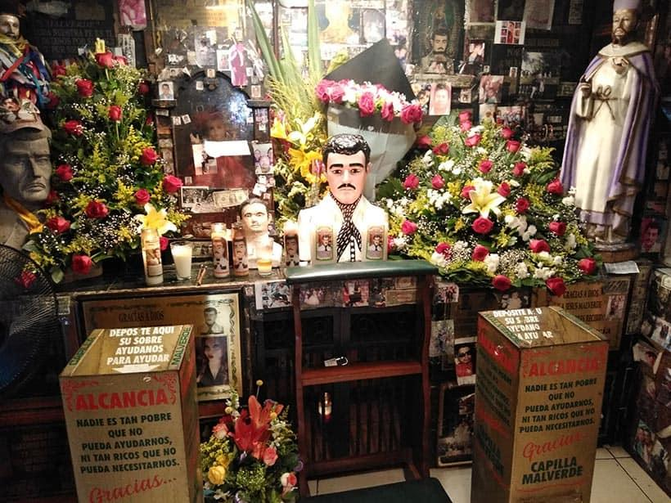
Narcoculture has also infiltrated religion, with new symbols of veneration, such as Malverde and La Santa Muerte. Religion is a major component of influence in Mexican society. According to reports by Statista, as of 2020, about 72% of the citizens affiliate with the Roman Catholic Church. A key symbol or manifestation of this subculture is that of Jesus Malverde. Malverde is considered the narco-saint whom devotees pray to for certain business transactions to follow through. His story dates to the 1900s, as the legend goes when he was hung by the governor. His popularity derived after his death when a strong faith grew among Sinaloa’s poor residents. Although some critics have argued that Malverde is not a cultural symbol of narcos, they fail to realize with what frequency narcos devote to Malverde. Former DEA Assistant Special Agent in Charge, Albuquerque, Ron Riddle stated, “More often than not, whenever and wherever we conduct a drug bust, we find an image of Jesus Malverde. Whether it’s a statue like this one, or a photo image or drawing, Malverde is watching out over these operations.” However, the Catholic Church does not officially recognize Jesus Malverde as a saint, despite the people considering him a patron saint. Yet, thousands of worshippers attend the official chapel and fill the altar with flowers and candles dedicated to him monthly.
FIGURE 8: Altar for Jesús Malverde in Culiacán, Sinaloa

The media is another major contributor to the wide acceptance of narco culture. The introduction of production films such as “La Reina del Sur,” “Narcos,” and “Pablo Escobar, El Patron del Mal,” amongst other films, has increased over the past decade. Not only are narcos gaining popularity in the music industry but also in cinema productions. For instance, the Narcos (2015) film which only had 10 episodes, had a rough estimated cost of about $25 million, each episode worth $2.5 million. This further emphasizes the wide acceptance of a narco culture because of the potential market for filmmakers—increasing popularity is the equivalent of monetary gains. The same can be seen in how the record company Twiins Culiacan has a million-dollar net worth. Overall, this is important because it highlights the mass consumption of narco culture and its accepting audience.
Lastly, another symbol of the presence of narco cultura is the presence of
fashion.
“It begins with the media images of the apprehension of different key figures in the drug trafficking scene in Mexico during 2011. One of the appreciable coincidences in the style of clothing of these characters, all male, has to do with the use of T-shirts. "Polo" style collar, a famous garment of the American firm Ralph Lauren. On the mercadolibre.com/Mexico portal, the description "Ralph Lauren Barbie polo shirt" can still be found, referring to the item of clothing.”
Although it is easy to overlook this aspect of narco culture, this is still a subtle and consistent way of infiltrating culture to the ordinary Mexican citizen.

How has narco-cultura infiltrated the Mexican culture?
Narcoculture has become popular among Mexican citizens. The previous emphasizes the outreach of narco culture and how it has transcended from simply being an organized criminal group involved in an illicit economy to the societal influence, infiltration, and continuation for the longevity of narco cultura. The following is important, as the main consumers of narcoc ultura are predominately from regions that happen to have the highest rates of homicide. Although the following research does not focus on the correlation between narco cultura and crime, the following can still be substantial in addressing.
Homicide data by state released in 2022 highlighted that murders (intentional homicides) stayed elevated, near record levels throughout 2020 and 2021. The three most violent states in Mexico for 2020, using the rate of homicides per 100,000 persons, were (1) Colima, (2) Baja California, and (3) Guanajuato; in 2021, they were (1) Zacatecas, (2) Baja California, and (3) Colima, from data published by Mexico’s National System of Public Security. In both 2020 and 2021, all these states had homicide rates greater than 80 per 100,000 persons. Violence in Mexico has only gotten worse over the years. These are also the states (primarily the North) were narcocorridos are most popular.
Corridos are of specific importance to regions or states from the North that also happen to be the states that mobilized the Mexican revolution in 1920. States like Chihuahua, Zacatecas, and Sonora were all part of the movement.
Internally at the time that narco corridos were popularizing, an affiliation and expansion of the narco corridos became a movement that expanded now not only from the Northern states but also the south. Mexican philosopher Maria de los Angeles Navidad Tarin, who Works in…….. shred in El Sol de Sinaloa:
“Personalmente, creo que es porque se están expandiendo y se están involucrando con otros géneros. Desde la ruptura con el reggaetón, que inició con la Banda MZ, ya se eliminaron las fronteras y se mezclan todos los géneros. Creo que le están dando un sentido urbanizado a los narcocorridos”, señaló la filósofa.” Original Text

“Personally, I think it's because they are expanding and getting involved with other genres. Since the break with reggaeton, which began with Banda MZ, borders have already been eliminated and all genres are mixed. “I think they are giving an urbanized meaning to the narcocorridos,” said the philosopher.” Translation
The conclusion that can be drawn from the different forms it manifests (whether music, religion, or fashion) is that narco culture is a mechanism of legitimization for drug trafficking. The two main cartels that are known more recently to be in the competition are Cartel Jalisco Nueva Generación (CJNG) and the Sinaloa Cartel. This is vital in understanding how narco culture plays a role in the continuation of cartels, because it is through narco culture that they are legitimized and solidified as a potential force.
The popularity of the narco-corrido “701” (701 referring to El Chapo’s rating according to the Forbes billionaire list) with nearly 12 million views is a form of introducing and establishing his place. What cartel leader is ranked by Forbes? Hence, this is seen as a powerful method of influence derived from pride and global recognition.
Just recently, one of the regional Mexican bands called “La Addictiva” collaborated with another artist, Luis R. Conriquez, to release the song “JGL,” (El Chapo’s Initials) with nearly 38 million views in less than a year. Conriquez is known for singing narco-corridos and using the word “belicos” (war-like) to express the state he is in while performing. Despite Guzman getting captured in early 2016 and then extradited to the U.S. in 2017, his popularity has not diminished. During the World Cup in Qatar, videos of soccer fans singing the lyrics to this song circulated on social media platforms like Facebook, Tik Tok, and Instagram. This is a symbol of longevity of narco culture despite the criminal apprehension of such.”
Mexico’s current struggle with cartels dates to the early 1970s when the most powerful cartel in Colombia sought a new smuggling trade route. Instead of exporting through the Atlantic and into the Caribbean, smuggling would be by land through Central America and Mexico. The Guadalajara Cartel had a federation of alliances between the Sinaloa, Juarez, and Tijuana cartels. Over time, the power and influence of organized crime groups have become larger and with a more well-established presence around the region. The cartel Nueva Generación Jalisco, Los Zetas, and the Sinaloa Cartel are among the three largest dominating cartels that control Mexico today. The rise of narco-cultura or narco culture, as it will be referenced from this point forward, has also been synonymous with the rise of cartels. However, this rise of a culture that idealizes the life of a capo is contributing to the perpetrated violence and continuation of cartels in Mexico. Narco culture is a tool of legitimization through the infiltration of culture.

V: Conclusion
The proliferation of Organized Criminal Groups (OCGs) and Drug Trade Organizations (DTOs) continues despite initiatives and interventions. As I have discussed in this research, most approaches seek to tackle the so-called ‘war on drugs’ through increased militarization and operations. Yet they have proven ineffective—like the 2008 Merida Initiative—as two major cartels formed after the creation of the initiative (CJNG in 2009 and Los Caballeros Templarios in 2010). The government’s inability to address issues of security is caused by a history of un-democratic practices, weak institutions, and corruption.
This research offers a unique lens from which scholars can conceptualize how non-state actors, in this case OCGs and DTOs, can gain legitimacy in a power vacuum caused by the fragility of the state through culture.
Narco cultura is a representation of how OCGs and DTOs have reached communities that the government has left behind or simply overlooked. They’ve managed to adopt the power of the ‘El corrido’ genre rooted in Mexican history during the time of revolution; to inform, influence and persuade the public of their power and seek praise, followed by physical control and dominance. In some cases, OCGs/DTOs are a source of support during a time of need, as I mentioned in the example of COVID that further establishes the public perception and support of OCGs/DTOs. Such has been the case of the Sinaloa Cartel and their presence and support from the community. The ability of the leader to be in the same community he once was marginalized and impoverished as a drug lord creates a dynamic shift of acceptance and in some cases praise. This elaborative process is through narcocorridos that play in social venues and media consumption.
In the future, I aim to pursue further research on the same overarching topic. Specifically, I plan to examine the impacts of this culture on regions where narco cultura is most popular among young adults. Additionally, I intend to explore potential venues for diminishing the influence of narco cultura through education initiatives and human development. As I would like to call it, a bottom-up approach.

Bibliography
Alejandro, Astorga Almanza Luis. El Siglo de las drogas: Del Porfiriato Al Nuevo Milenio.
México, D.F.: Peguin Random House Grupo Editorial, 2016.
Alonso Trabanco, Jose Miguel. “Backgrounder: Evolution of Organized Crime in Mexico.” Geopolitical Monitor, April 21, 2022. https://www.geopoliticalmonitor.com/backgrounder-evolution-of-organized-crime-in-mexico/.
Al Jazeera. “Ovidio Guzman, Son of Feared Mexican Drug Lord ‘El Chapo’, Extradited to Us.” Al Jazeera, September 16, 2023. https://www.aljazeera.com/news/2023/9/16/ovidio-guzman-son-of-feared-mexican-drug-lord-el-chapo-extradited-to-us#:~:text=Guzman%2C%20one%20of%20the%20heirs,struck%20back%20following%20his%20arrest.
Ángel Reyes, J. C. (2020). Narco-estética mexicana. La re-configuración del imaginario a
partir del estilo, la moda y el consumo. Confluenze. Rivista Di Studi Iberoamericani,
12(1), 88–101.
Beltrán Minehan , Edith. “Research Guides: Mexico’s Mass Disappearances and the Drug War
(Ayotzinapa: The Missing 43 Students): Drug War Timeline 1930-2015.” Research Guides at University of Wisconsin-Madison. Accessed March 29, 2024. https://researchguides.library.wisc.edu/c.php?g=560513&p=3904772.
Cardenas, Mauricio. “State Capacity in Latin America.” Economic 10, no 2 (2010): 1-45
Cabañas, Miguel A. “Introduction: Imagined Narcoscapes: Narcoculture and the Politics of
Representation.” Latin American Perspectives 41, no. 2 (2014): 3–17.
http://www.jstor.org/stable/24575495.
The Drug Enforcement Administration (DEA) 1990-1994. Accessed March 29, 2024.
https://www.dea.gov/sites/default/files/2021-04/1990-1994_p_67-76.pdf.
Fernandez Velazquez, JA and Smith, BT.20220 A History of Opium Commodity Chains in
Mexico, 1900-1950. Journal of Illicit Economies and Development, 4(2), pp113-127.
DOI:https://doi/org/10.31389/ied/113
Grillo, Ioan. “How the Mexican Drug Trade First Began.” TIME, January 8, 2016. https://time-com.translate.goog/4173833/el-narcoexcerpt/?_x_tr_sl=en&_x_tr_tl=es&_x_tr_hl=es&_x_tr_pto=rq&_x_tr_hist=true.
Hall, Dan. “How Drug Cartels Are Exploiting Coronavirus to Gain Power and Influence.” The Scottish Sun, May 21, 2020. https://www.thescottishsun.co.uk/news/5620384/coronavirus-drug-cartels-lockdown/.
Karam Cárdenas, Tanius. “Mecanismos Discursivos En Los Corridos Mexicanos De
Presentación Del ‘Movimiento Alterado.” Anagramas -Rumbos y Sentidos De La
Comunicación, vol. 12, no. 23, 2013, pp. 21–42. https://doi.org/10.22395/angr.v12n23a1.
Lindo, Jason, and María Padilla-Romo. Kingpin approaches to fighting crime and community
violence: Evidence from Mexico’s Drug War, 2015. https://doi.org/10.3386/w21171.
OECD (2022), “States of Fragility 2022”, OECD Publishing, Paris,
https://doi.org/10.1787/c7fedf5e-en
Ocampomi. “The Merida Initiative .” Technical difficulties, September 7, 2021.
https://mx.usembassy.gov/the-merida-initiative/.
Patrick, Stewart. “Introduction & Chapter 1.” In Weak Links: Fragile States, Global Threats, and
International Security, 3–61. New York: Oxford University Press, 2011.
“P1: State Legitimacy.” Fragile States Index. Accessed November 18, 2023.
https://fragilestatesindex.org/indicators/p1/.
“¿Qué Es El Corrido Mexicano?” Acceso. Accessed March 29, 2024.
https://acceso.ku.edu/unidad4/almanaque/corrido.shtml.
Risse, T., & Stollenwerk, E. (2018). “Legitimacy in Areas of Limited Statehood.” Annual
Review of Political Science, 21(1), 403–418.
Rice SE, Patrick S. (2008). Index of state weakness in the developing world. Rep., Brookings
Inst., Washington, DC 2006, 3-24.
Ramírez Pimienta, Juan Carlos. “‘El Bazucazo’: Un Antecedente Histórico De La Guerra
Contra El Narco En La Corridística Mexicana.” Cultura y Droga, vol. 25, no. 29, 2020,
pp. 163–181., https://doi.org/10.17151/culdr.2020.25.29.8.
Roush, Laura. “Santa Muerte, Protection, and Desamparo: A View from a Mexico City
Altar.” Latin American Research Review, vol. 49, no. S, 2 Sept. 2014, pp. 129–148.,
https://doi.org/10.1353/lar.2014.0064
Romo. “Kingpin Approaches to Fighting Crime and Community Violence: Evidence
from Mexico's Drug War.” 2015, https://doi.org/10.3386/w21171.
Valencia, M. L. (2019, October 28). Culiacán shambles exposes lack of any security plan for
Mexico. InSight Crime. Retrieved December 15, 2022, from
https://insightcrime.org/news/analysis/culiacan-shambles-security-plan-mexico/
Vice, Margaret. “2. Mexicans Are Downbeat about Their Country’s Direction.” Pew Research
Center’s Global Attitudes Project, September 14, 2017.
https://www.pewresearch.org/global/2017/09/14/mexicans-are-downbeat-about-their-
countrys-direction/.
XIX. México en el mundo – el mundo en México. iMex Revista. (2021, February 5). Retrieved
December 15, 2022, from https://www.imex-revista.com/ediciones/xix-meem/

Astorga, El siglo de las drogas, 194–95.
Cambridge Dictionary
Jason Lindo and Maria Padilla Roma. Kingpin Approaches to Fighting Crime and Community Violence: Evidence from Mexico’s Drug War, 2015, PP4
Ibid, 16
Ibid. 2
Acceso. ¿Qué es el corrido mexicano?
Ramírez-Pimienta, J. C. (2020). “El bazucazo”: un antecedente histórico de la guerra contra el narco en la corridística mexicana. Revista Cultura y Droga, 25 (29), 163-181.
Weber, Max. 1978. Economy and Society. Berkeley: University of California Press
Cathryn Johnson, Timothy Dow, and Cecilia Ridgeway Legitimacy as a social process)
Down,Cathryn Page 56
Reorganizing Legitimacy Theory by Joseph A. Hamm, Scott E. Wolfe, Caitlin Cavanagh and Sung Lee PG 132
Risse & Stollenwerk, 2018, p404
Risee and Stollenwerk, 2018, p.407
Huseyin Rasit 1096
Husyin 1095
David Beetham, The Legitimation of Power Basingstoke: MacMillan, 1991, 5,
Isabelle Duyvesteyn (2017), Rebels and Legitimacy; An Introduction, Small Wars & Insurgencies 28(4/5): 669-685. https://doi.org/10.1080/09592318.2017.1322337
Ibid 11
Nelson Kafir, ‘Rebel Governance – Constructing a Field of Inquiry: Definitions, Scope, Patterns, Order, Causes’, in: Ana Arjona, Nelson Kasfir and Zachariah Mampilly (eds.) Rebel Governance in Civil War New York: Cambridge University Press 2015 153
Ibid
Ibid
Susan E. Rice & Stewart Patrick, Index of State Weakness in the Developing World (Washington D.C:Brookings Institute, 2018), 5. *The following source is exactly from the assignment turned in the POL394 Latin American Politics
“Introduction to Sociology: Understanding and Changing the Social World: Power and Authority” https://pressbooks.howardcc.edu/soci101/chapter/14-1-power-and-authority/#:~:text=According%20to%20Max%20Weber%2C%20the,else%20after%20the%20leader%20dieCas.
Cardenas, Mauricio. “State Capacity in Latin America.” (Page 1)
Ibid.
“Fragile State Index power by The Fund for Peace” https://fragilestatesindex.org/indicators/p1/
The following is from a previous document of my authority,
Stewart, Patrick “Introduction: Weak States, Global Threats, and International Security
From a previous document of my authority
Risse, T., & Stollenwerk, E. (2018). Legitimacy in areas of limited statehood. Annual Review of Political Science, 21(1) PAGE 403-406
Ibid
Stollenwerk 403
Stollenwerk 410
Alonso Trabanco, Jose Miguel. “Background: Evolution of Organized Crime in Mexico.” Geopolitical Monitor
Fragile state index “what does state fragility mean? https://fragilestatesindex.org/frequently-asked-questions/what-does-state-fragility-mean/
Ibid
Ibid.
Ibid.
The Fund for Peace. “Fragile State Index: Security Apparatus” https://fragilestatesindex.org/indicators/c1/
Ibid
Maragaret Vice and Hanyu Chwe “Mexicans are downbeat about their country’s direction,” Pew Research Institute. September 14, 2017 https://www.pewresearch.org/global/2017/09/14/mexicans-are-downbeat-about-their-countrys-direction/
Ibid.
Grillo, Ioan. “How the Mexican Drug Trade First Began.”
Fernandez Velazquez & Smith, Journal of Illicit Economies and Development DOI: 10/31389/jied.113
Ibid. Page
Ibid. Page 115
Beltran Minehan, Edith. “Research Guides: Mexico’s Mass Disappearances and the Drug War (Ayotzinapa: The missing 43 Students): Drug War Timeline 1930-2015.” Drug War Timeline 1930-2015—Research Guides at University of Wisconsin-Madison.
Ibid.
Ibid.
Davis, Kristina. “A short history of Mexican drug cartel”.
The Drug Enforcement Administration (DEA) 1990-1994 (Page 73)
Ocampomi. “The Merida Initiative.” September 7, 2021.
“Ovidio Guzman, son of feared Mexican drug lord ‘El Chapo’, extradited to the US” Aljazeera September 16th, 2023 https://www.aljazeera.com/news/2023/9/16/ovidio-guzman-son-of-feared-mexican-drug-lord-el-chapo-extradited-to-us#:~:text=Guzman%2C%20one%20of%20the%20heirs,struck%20back%20following%20his%20arrest.
Tapia, Roberto. “La Tuna”
Hall, Dan. “How Drug Cartels Are Exploiting Coronavirus to Gain Power and Influence.” The Scottish Sun, May 21, 2020
1 (Tonantzin, Investigación documental sobre la narcocultura como objeto de estudio en Mexico 2018)
(Affaris 2019)
The following source is written by me in the previous course Drugs & Politics in Latin America.

