“Let our souls drive us”: The Monomyth as Rebellion in The Arabian Nights and Atsushi Ohkubo’s Soul Eater
A Senior Capstone Experience
By Dante Chavez

Submitted to the Washington College Department of English
April 5th, 2024
Advised by Dr. Katherine Charles

I pledge my word of honor that I have abided by the Washington College Honor Code while completing this assignment.
Acknowledgements

Thank you to my advisor Dr. Charles for her invaluable insight during the inception, research, composition, and revision of this project.

Thank you to my mom for always being there with open arms and an open heart whenever I needed support. I would not be here if it weren’t for her.

Thank you to my fellow dungeoneers for making this process much more fun and much more communal to get me out of my own head.

Thank you to all the other English professors including, but not limited to, Dr. Knight, Dr. Hall, and Dr. O’Connor for their academic and additional guidance over the years.

Thank you to whoever reads this for taking the time to go on this journey with me.
Table of Contents

I. Introduction 4
II. The Mythic Hero and the Mythic Enemy 13
III. Agon 27
IV. Pathos 39
V. Conclusion 62
VI. Works Cited 67

Introduction
Myth and, consequently, the techniques that myth operates through, have long been inseparable from the foundations of societies. The Ancient Greeks and Romans relied on the myths of Zeus and Persephone to account for the world around them while “providing a standard of behavior” in “the lives of human beings” (Comstock). In the East, the Chinese mythic figure Kwan Yin or Kannon—as they are known in Japan—is said to be a “world-redeeming, world-sustaining…benevolent regarder of the world” (Campbell 129). Even on the other side of the world, the Mayans of central America did the same with their version of the creation myth, as
The Mayan creation myth involves four gods who want to make men for the Earth, but cannot find a material that is strong and durable enough. They even try making a man of gold. Finally, the fourth god cuts off his own fingers to make men, and they tumble to the Earth and live well, worshiping the gods and making fine offerings. They find the man of gold, who is cold and still, but the kindness and warmth of the men of flesh bring him to life. The gods call the man of gold rich and the men of flesh poor, and they decree that the rich must take care of the poor and no rich man may reach heaven unless a poor man takes him there. (Comstock)
In all of these early myths, myth is not just a presence created to entertain, but to explain why the world came to be and how the people that consume the myth should behave in order to meet the standards of their respective societies.
From this history, Percy Cohen, a scholar of the London School of Economics and Political Science, derives the primordial school of thought of myth as “a mode of anthropological thinking which, apparently, attributes to primitive or early man characteristics of intellectual curiosity” (Cohen 338). In this perspective, myth “is to be read literally, and treated as an explanation of certain phenomena” (Cohen 339). Through this lens, myth becomes man’s first attempts to think about the world around him and explain it as a way to “personalise the forces of the natural world which he seeks to understand and control” (Cohen 339). By “personali[sing] the forces of the natural world[,]” man exerts his own impetus over the world, defining a voice for himself, and, on a larger scale, an identity to share. In a purely anthropological sense, the practice of mythmaking becomes a way to organize people around a central belief in not just the tales but the principles behind those tales. Therefore, myth becomes a powerful uniting tool that can be used to transform a group of humans from a mere conglomeration into an established society. However, this perspective on myth runs into trouble due to the fact that “it is never difficult to demonstrate that as science and history mythology is absurd. When a civilization begins to reinterpret its mythology in this way, the life goes out of it” (Campbell 213). As history has realistically and science has technologically advanced, myth does not suffice as the all-encompassing explanation Cohen indicates it once did. In contemporary society, to say that we know that there is no chariot that pulls the sun as in the story of Phaethon and Helios or that modern day spiders are not descendants of an arrogant seamstress as in the story of Arachne states the obvious. Easily disproved in a contemporary educated setting, myth is unable to survive as a legitimate explanation, something laughable even if theoretical, something confined to the world of pure metaphor. There is a kind of death in the myth as it can no longer be used as the instrument of societal establishment it once was.
However, instead of leaving its history there, Cohen supposes an alternate evolutionary route the myth took to get to its modern state:
A myth is a narrative of events; the narrative has a sacred quality; the sacred communication is made in symbolic form; at least some of the events and objects which occur in the myth neither occur nor exist in the world other than that of the myth itself; and the narrative refers in dramatic form to origins or transformations. (Cohen 337)
Through this lens, events in myth are not touted as actual historical events but become symbols for and lessons about larger concepts such as courage, despair, war, love, and just about every other construction similarly trapped in the abstract. These concepts become more palatable to the skeptical reader through their apparent fabricated quality. When presented to readers as literary and not literal, myth takes on a second life as a way of understanding the world not as an explanation for its objects but as an approach to its complexities. Myth becomes something even more human in its creation, target, and subsequent effect. When man makes myth, according to this exclusively literary perspective, he is still able to honor its tradition or “sacred quality” without the dangerous, self-destructive tone of explanation by drawing upon myth’s history as the “sacred communication” of the past. When used in this way that echoes its origin, myth becomes a way to create a specific commentary for and about its society. The sly nature of this commentary achieves the original mission to produce a “standard of behavior” much more furtively than it did as explanation;this commentary lies within the subtext of the myth, whereas the explanation resided in the denotation.
“The fact that myths are narratives is of primary importance” (Cohen 349) is the cover behind which commentary hides. “This activity [of creating the myth] requires the establishment or creation of a moment of origin or a moment of transformation” (Cohen 349).It is through this origin or transformation that the commentary forms and solidifies the standard of behavior. For the purposes of this project, the narrative of transformation is of special interest as it is relevant to both texts this project will explore. Through this narrative, mythmakers are able to create the “hero,” one who “has been able to battle past his personal and local historical limitations” to become an “eternal…perfected, unspecific, universal man” (Campbell 14-15). In essence, a myth’s hero creates a metaphorical evolutionary passageway from an average individual limited by personal and worldly qualities to a golden, aspirational standard. The texts studied in this project, The Arabian Nights as translated by Sir Richard F. Burton and Atsushi Ohkubo’s Soul Eater, adapt this narrative in order to rebel against a dominant standard of the era the respective text is situated within by proposing an alternative. However, where The Arabian Nights rebels against a certain movement of thinking, Soul Eater rebels against the prevalent narrative format itself.
Prior to any discussion on the narrative of The Arabian Nights, it is important to understand some of its history as a “vertiginously unstable text” that led to this project’s proposal of the text as a destabilizing response to the Enlightenment period, during which it was published. On the surface, the text appears to be a collection of ancient myths passed down through Eastern oral tradition presented by the master storyteller Scheherazade. However, there are numerous complications behind this appearance that orient the text and, subsequently, its mythic commentary; it largely exists now as a Western product rather than one of Eastern origin, despite its title. Primarily, as with any myth over time,
the outlines of [the work] are subject to damage and obscuration. Archaic traits are generally eliminated or subdued…Furthermore, in the innumerable retellings of a traditional story, accidental or intentional dislocations are inevitable. (Campbell 212)
To produce the original commentative effect for a new audience, the myth must be “dislocated” in order to maintain relevance to its era and the location of its composition. During the long history of The Arabian Nights as a largely oral tradition before its first publication, this becomes a factor to consider. It creates a natural diversion from the original ancient Eastern narrative and commentary within the text’s culture of origin to update it to be applicable to the time of the retelling. When the element of translation across not only language but culture is introduced to the text’s history, the intention of the myth changes further. Additionally, it is important to remember “the fact that ‘we’ [as translators and scholars] are studying (let alone ruling) ‘them’ [,the Eastern creators of the original tales,] and collecting ‘their’ cultural artefacts”. Therefore, the version of the text that exists now does not serve as a faithful reproduction of the original tales, but as a potentially unauthorized Western interpretation. This distinction makes the text a product of the Orientalist movement of the Occidental world rather than a product of the Orient. Due to the print culture of the time, there are even “sometimes inventions. Endlessly repeated, modified and rewoven” with “no known Turkish, Persian or Arabic originals.” To meet demands of readers and publishers, translators of The Arabian Nights often composed completely original tales to add onto the text. For this project, trying to discern which elements of the narrative are of Arabic origin and which are uniquely European would be a fruitless effort, as “establishing a border between Arabic and European language sources, between East and West, sets up too sharp a division because it suggests stable and readily identifiable entities” that would neglect the ever-evolving commentative nature of myth. For these reasons, it is important to consider The Arabian Nights a strictly Western text; therefore, it does not depict an accurate reflection of Eastern peoples, culture, and religion but “a pseudo-Arabia and a pseudo-Islam as filtered through European languages and translations.”Hence, this version of Arabia and Islam actually adheres more closely to the principles of Western society and Christianity.
The transformation narrative inscribed within The Arabian Nights, primarily follows Scheherazade in her journey from despised but devout daughter of the Wazir to noble queen and savior of a kingdom under the tyranny of the once noble king, Shahryar. Shahryar is in the midst of a gradual genocide of the kingdom’s women spurred by his heartbreak over the betrayal of his former queen. Scheherazade undergoes her metamorphosis by way of the titular 1001 nights of myth tales she relays to the king from her own library of legendary stories. Fantastical figments of the collective human imagination such as jinn, necromancy, and other mythical beasts, “evok[ing] an exotic ethos of mystery and fantasy” lie within these tales and make them “serve as counter-narratives to Enlightenment rationalism”. During the Age of Enlightenment, when reason and realism dominated cultural discourse, The Arabian Nights acted as a notable exception through its continuation of the tradition established by myth, a form Western society had long since abandoned; thus, the text became a product of counterculture that rebuked Enlightenment ideals.
In the other central text of this project, Ohkubo’s Soul Eater, the transformation narrative revolves around three high school students—Maka Albarn, Death the Kid (or Kid as he is often referred to colloquially) and Black☆Star—who begin as flunking yet promising prospects at the bottom of their class and become heroes of global significance. The school they attend is not a normal high school; all three are students of the Death Weapon Meister Academy (DWMA), a school where weapons—humans with the magical power to shapeshift into various weapons from scythes to guns to lamps—and meisters—wielders of these weapons—are trained to respectively become or make “death weapons.” Each of the three heroes are meisters who aim to create a “death weapon” by “eating the souls of 99 humans and one witch” (Ohkubo 1:14). Witches are members of “a sealed space [separated from society]” known as the “witch realm” (23:16). However, while the three students are still studying at the academy, a rogue witch resurrects a kishin, an ancient, evil being formed by killing and absorbing the souls of good people not meant to be taken (3:29). As the academy’s three most promising meisters, they must revert the kishin to its dormant state.
In his version of the transformation narrative, Ohkubo employs the medium of the manga, a Japanese comic which Scott McCloud, a best-selling graphic novelist, defines as “juxtaposed pictorial and other images in deliberate sequence, intended to convey information and/or produce an aesthetic response in the viewer” (9). McCloud explains words in comics as “other” kinds of images (8) rather than giving them their own separate distinction, already hinting at cartoonists’ mangakas’ untraditional approach toward storytelling. Therefore, in order to account for Soul Eater's presentation of its narrative, this project must consider the pictures included in the text alongside its words. Disregarding the “pictorial” aspect of the text would ignore Soul Eater’s operation upon the “iconic” (as in the literal) plane, which includes the literal “images we use to represent concepts, ideas and philosophies” (McCloud 27); this plane provides a second layer of abstract representation Ohkubo often uses to deconstruct the transformation narrative. In an age where the monomyth, a version of the transformation narrative more popularly known as the hero’s journey, can be found everywhere from classics like Greek and Roman mythology to contemporary works like Star Wars and Harry Potter, Soul Eater, in form and narrative, acts as interrogator of the transformation narrative tradition spurred on by works like The Arabian Nights.
Joseph Campbell, who is widely regarded as the first recorder of the monomyth formula (Campbell 416), declares that it consists of three stages: “a separation from the world, a penetration to some source of power and a life-enhancing return” (27), Northrop Frye, another myth scholar, calls these stages the “agon or conflict, the pathos or death struggle, and the anagnorisis or discovery” (187). In the transformation narrative, these three stages act as the protagonist’s or protagonists’ coming of age into the hero. Agon presents the hero’s “perilous journey and preliminary minor adventures”, pathos presents “some kind of battle in which either the hero or his foe, or both, must die,” and anagnorisis presents the “exaltation…and recognition of the hero, who has clearly proved himself to be a hero” (187). Using this structure, mythmakers have created memorable conquerors of great evils including Hercules, Buddha (Campbell 46) and, of course, Scheherazade. For this project, the first two stages, agon which simultaneously and pathos which, are essential to compare how each text uses or plays with the monomyth structure in order to make their arguments. Agon establishes the absolute wrong that becomes the hero’s ultimate mission to right by the end of the myth and establishes the hero’s worthiness of that task. Pathos acts as the clash between good and evil in which the hero must prove they possess or have matured into the required worthiness for the task given. Where The Arabian Nights follows the formula of this tradition to cultivate the legend of Scheherazade, Soul Eater defiantly challenges it at every step of the journey, giving rise to a contemporary exploration of heroism through the characters of Maka, Kid, and Black☆Star.
This project places these two texts in conversation with each otherhere. By falling in line with its tropes, The Arabian Nights reflects the traditional values of myth, casting myth as the ‘savior of societies’ and as a way to rebel against the direction of rationalism Western society was moving in at the time. Soul Eater, by subverting and altering those same tropes, offers a rebellion against the dynasty the monomyth has become, potentially calling for a new approach to storytelling altogether. Through this adverse relationship, the effect of which mirrors that of the primary adverse relationship at the core of the monomyth, both texts expose the underlying effect of the other.

The Mythic Hero and the Mythic Enemy
The monomyth’s core is made up of two figures around which the narrative operates: the mythic hero and the mythic enemy. Of the “two contrasting worlds of total metaphorical identification[,]” the hero of myth fittingly represents the side of the conflict the mythmaker seeks to portray as “desirable” while the enemy or opposition to the hero represents the side of the conflict the mythmaker wishes to portray as “undesirable” (Frye 139). As a perpetual result of this foundation, “characters tend to be either for or against the quest [of the hero]. If they assist it, they are idealized as simply gallant or pure; if they obstruct it they are caricatured as simply villainous or cowardly” (Frye 195). The mythic binary begins its work here. By boiling worldly conflict down to these two opposing sides, the mythmaker creates a structure in which the each side can be defined by what the other side is not, simplifying the conflict for the purpose of constructing a “desirable” standard to instill into the reader. In his discussion of this binary, Frye observes a common pattern that myth can adapt: “the nearer the [story] is to myth, the more attributes of divinity will cling to the hero and the more the enemy will take on demonic mythical qualities” and therefore, “the enemy is associated with winter, darkness, confusion, sterility, moribund life and old age, and the hero with spring, dawn, order, fertility, vigor and youth” (187-188). When elements such as these meet with their corresponding opposites, a natural antagonism occurs. Both elements cannot exist within the same realm without conflict or contradiction; divinity cannot exist alongside the demonic, winter cannot exist alongside spring, and darkness cannot exist alongside the dawn. Therefore, when these traits are applied to the hero and the enemy, they are linked, even though they exist at opposite ends of the binary. Myth becomes a “device for ‘mediating contradictions’ or ‘oppositions’ as experienced by men” (Cohen 346). This often results in the distillation of entire conflicting modes of thinking down to “some kind of battle in which either the hero or his foe, or both, must die” (Frye 187), creating the atmosphere necessary for the large-scale powerful conflict known as myth’s signature.
This core is adapted throughout The Arabian Nights in the form of the text’s seemingly endless emphasis on the heroes’ adherence to and, conversely, the enemies’ rejection of the principles of European Christianity disguised as a kind of pseudo-Islam. As the virgin daughter of the highest ranking minister in the kingdom, Scheherazade, the primary hero of the text, embodies two principles of Christianity: purity and piety. While some may cast Shahryar as the primary opposition of the text due to his readily apparent brutality, the antonyms of Scheherazade’s ideals are actually much more richly realized in the actions of the former queen. Scheherazade’s purity as a virgin opposes the Queen’s impure and scandalous affair, just as Scheherazade’s patrimonial piety opposes the Queen’s impious betrayal of holy matrimony. Therefore, the true villain of The Arabian Nights is not King Shahryar, but the madness that affects him as a result of the former queen’s treachery. This religion-based binary is echoed throughout the stories Scheherazade tells.
For example, in the story “The Two Sisters Who Were Jealous of Their Younger Sister,” “all the folk blessed the Shah’s Banu and cursed the Satanesses and her sisters” (Burton 574) after it is finally revealed that the two sisters replaced the younger Banu’s three children with various animals in order to accuse her of being unable to bear children. The title of the tale itself is already reminiscent of Frye’s observation of the hero’s affiliation with youth and the enemy’s affiliation with old age, as the older sisters are the ones spiting their younger sister. There are two other binaries at play that align with the text’s religious interpretation of good versus evil: that of blessing versus cursing and that of Banu’s association with the Shah versus the sisters’ association with the Satanesses. As the folks “bless” Banu, the mythmaker signifies who is being celebrated in this story while simultaneously bringing a divine context to that celebration via the use of “blessed”. The mythmaker does the opposite through the use of “cursed,” literally denouncing the sisters in the story as well as denouncing their worldly embodiment of envy, all while accessing the language of the demonic via the use of “cursed.” The sisters’ association with the Satanesses directly continues the conjuration of the demonic through their relationship with Satan, while Banu’s association with the Shah reinforces the divine context via the conceptual “divine right of kings” whichsuggests that kings—the Shah, in this case—receive their political prowess from the authority of God himself. Therefore, Banu’s referral to as the “Shah’s Banu” and her sisters’ grouping with the Satanesses underlines the intention of the mythmaker to portray the hero, Banu, as a desirable standard and her sisters as harboring evil intent, echoing the text’s religious alteration of the good versus evil binary. This example is just one of the many seemingly infinite iterations of the mythic binary The Arabian Nights’ structure as a frame narrative allows. Because it is possible to repeat this pattern across the many encapsulated tales of The Arabian Nights, the text provides its own fabricated historical evidence to the argument of Scheherazade and the Christian ideals she presents as righteous.
Rather than echoing the mythic binary, Soul Eater complicates these opposing traits by expanding the number of characters used to portray the relationship between good and evil. Instead of abiding by the typical pairing of the singular good hero and the singular evil opposition, Ohkubo expands the dyanmic by centering Soul Eater’s narrative around three heroes that embody separate traits of the typical myth hero. Consequently, the role of the enemy is similarly expanded to account for different variations of evil that can oppose the hero. This expansion allows for much broader definitions of good and evil that exposes the narrow condensation of the one-dimensional definitions within the mythic binary.
Each of Soul Eater’s three heroes embody different aspects of Frye’s pattern. Kid represents the hero’s affiliation with “order” through his nearly obsessive desire to bring about an “ultimate beauty” to society via “symmetry” (1:95). Black☆Star embodies the “vigor” of the hero through his goal to become enough of a “big shot” (1:53) to be able to protect and do right by those close to him “no matter what” (1:63). Finally, Maka embodies the “divinity” of the hero through her empathy and compassion that extend past her own affiliations.
The separation of these heroic qualities are captured in a scene from volume 8 of the series when Kid, Black☆Star and Maka each attempt to comfort a new student that they recently fought against in a way that is indicative of their respective heroic values. Kid assures the student that “no one’s gonna run out on you” and that they can “just join in at [their] own pace” (8:80), introducing to them a sense of discipline that he believes the students of the school should abide by. Kid’s assurance that there will be no “run[ning] out on” anyone speaks to his view of himself and the other students as heroes whose function in society is to be unwavering pillars of peace and order. Furthermore, when he tells them they can “join in at their own pace[,]” he effectively invites the student to participate in the maintenance of the sense of order he presents to them. Both assurances illustrate Kid’s embodiment of the societal construct the hero offers as a defender of the social order. Black☆Star’s approach differs, as he tells the student that [if] “anyone starts pickin’ on you, I wancha to come tell me right away[,]” and he promises he’ll “kick their ass from here to kingdom come–and you know I’m good for it” (8:82), declaring his own strength over all. Though arrogant, the sentiment behind this promise indicates an ultimately heroic desire Black☆Star holds to fight against enemies for the sake of good, no matter how daunting. He will not only win, but win in a way that shows he’s “good for it[,]” unflinchingly reliable in his self-assigned role as protector. This promise illustrates Black☆Star’s idealization of the hero as an almighty protector of the weak with limitless energy that society can rely on. Finally, when the new student begins to ask “why’s everyone being so [nice]?”, Maka gleefully responds “‘Like you even need to ask. Cos we’re friends, obviously” (8:82). The statement of “Like you even need to ask” and the use of “obviously” here create a tone that suggests that Maka treats friendship as a given despite the new student’s past clash with the heroes. Now that the new student has been redeemed to the side of good in the narrative, Maka embraces them as a “friend” without restriction, showing not only that she has enough compassion to completely forgive the new student for their past evil affiliation but that she holds a certain amount of empathy to extend friendship beyond superficial forgiveness. The compassion and empathy she shows is exemplative of the unyielding grace that stems from the moral ideals of the myth hero. If these three characters were united into one representation, they would potentially construct a typical myth hero, but by splitting these qualities across three separate entities, Ohkubo rejects the singular figure of good that myth tends to work with in order to showcase a wide variant of heroism.
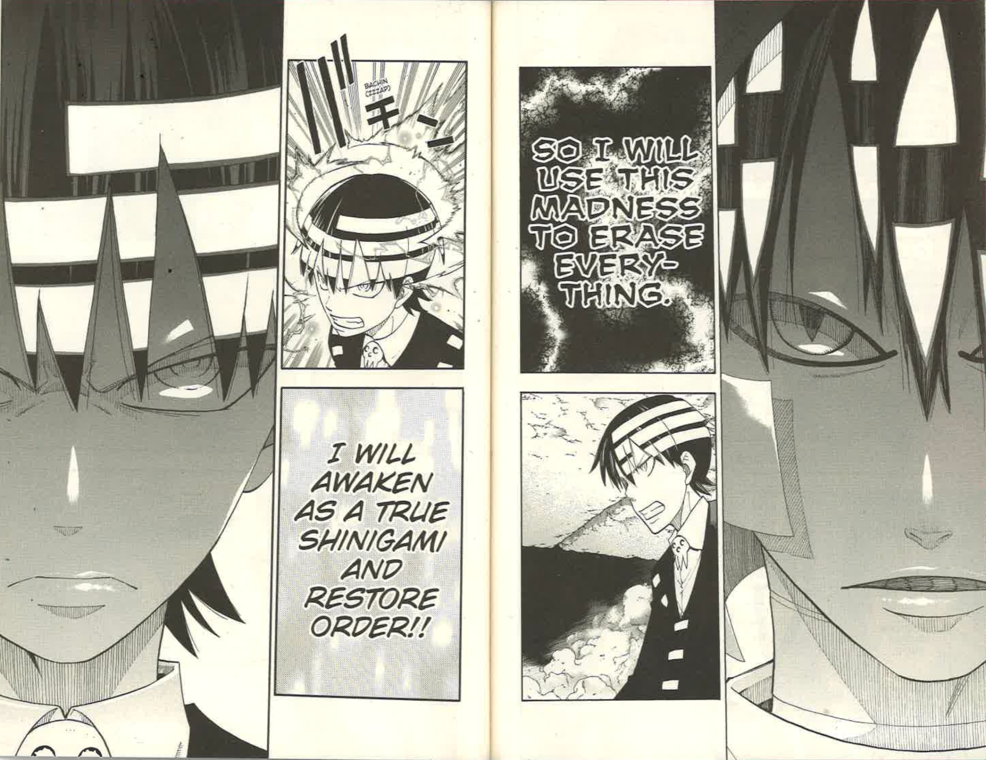
To mirror the expanded side of good in the binary, Soul Eater also depicts multiple versions of evil. The society of witches represents association with evilness through their opposing position to the heroic. Crona represents the concept of a “nurtured” evil because the root of their evil is suggested to be a result of their purposeful upbringing. The kishin Asura represents the genuine spirit or the “nature” of evil, as his sole desire is to bring pure chaos to the entire world.
The association of witches with evil offers the text’s most circumstantial version, because “the transformative souls of witches [are] the connection that [binds] human and weapon” in the first place, meaning that the 100th witch soul is the only thing that keeps the students of DWMA “incomplete” (23: 59-60). Witches directly stand in the way of the heroes achieving their ultimate goal solely by existing, which results in their vilification as “rotten bitches” (23: 103) within the society of the heroes. The witch society breeds a hatred for the heroes “deeper than the deepest pits of hell” that “might well be considered [their] fundamental drive” (23: 31). Here, Ohkubo indicates a potential risk in forcing the construction of a good versus evil binary as the heroes of have done; it creates a self-fulfilling prophecy in which the casting of an entire culture as villains leads to said culture embracing and organically flourishing in that role, alleging that this dark power of myth holds the potential to provoke cultures towards genuine atrocities. This pattern even has historical precedence as one of the many causes of World War II is widely purported to be the “designat[ion of Germany as the] scapegoat” of World War I as the consequences of the widely accepted myth of Germany as the “aggressive” sole cause of WWI gave root to “German frustrations” (Martin 94) that would ultimately contribute to the outbreak of war. In this case, the myth holds devastating ramifications that need not be detailed here, except to say that, by ingraining the source of the witches’ hatred in a cycle that reflects the heroes’ perception of them, Ohkubo rejects a long-standing fallacy of myth that defining evil as whatever happens to be the opposite of good eradicates the possibility of any wrongdoing inherent to the heroic. Therefore, Ohkubo’s narrative construction exposes the blindness the typical mythmaker has to any “evil” or inherent wrongness within the side they wish to portray as “desirable”.
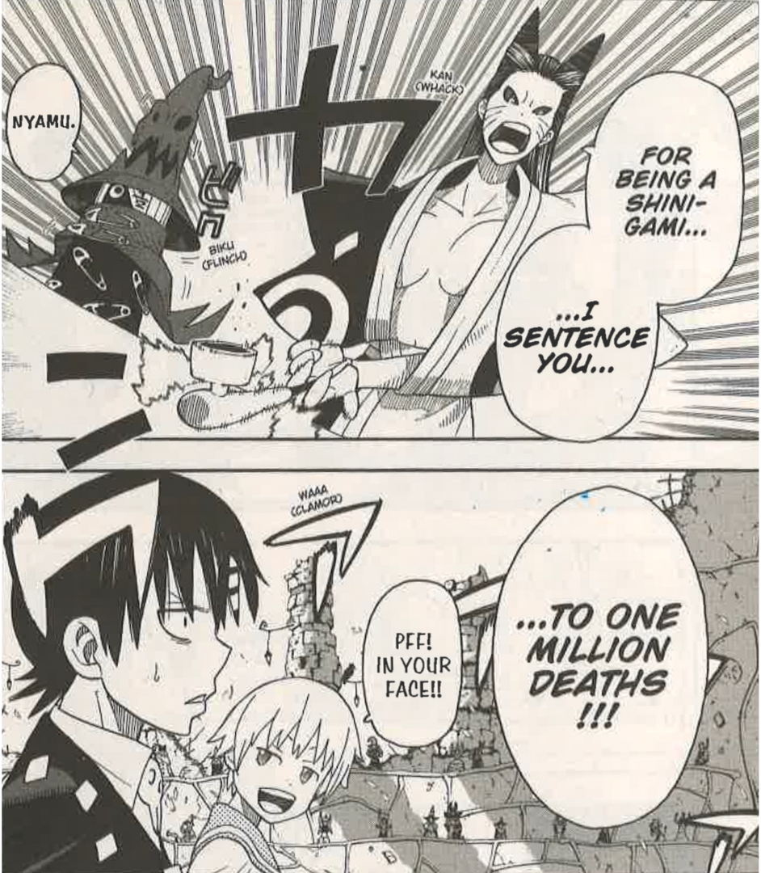
The relationship between DWMA and the witches also acts as a subversion of a tradition in myth to depict enemies as “totem, tribal, racial, and aggressively missionizing cults” (Campbell 133). This treatment of witches is reflected back to the heroes when Kid travels to the witch realm and is sentenced “to one million deaths” in witch court simply “for being a shinigami” (23: 28), a god similar to the one the heroes unquestioningly fight for. By trying Kid in this way, the witches, the “cult” persecuted by DWMA, hold Kid, a proxy for the narrative’s “good” god, accountable for the unprovoked witch hunt that is considered a heroic deed by DWMA but is a gross transgression of witch law. Kid’s shocked expression after the sentencing makes the magnitude of this revelation regarding the witches’ organized society clear (above, 23: 28). Ohkubo’s stunning reversal of roles not only renegotiates the heroes as another version of the “aggressively missionizing cult” but reveals the inherent bias of the mythmaker present in the trope of the enemy; in any context, the power to decide which side is “aggressively missionizing” lies with the mythmaker. Illustrated by these two points, the witch society’s faultless socialization as evil in the world of Soul Eater reveals the often-disguised intentionality of the mythmaker in the construction of the evil side of the binary.
Crona, however, is not designated as evil through societal perception or the potential bias of the mythmaker, but is socialized into evil through development. As a child, Crona is physically and psychologically abused (5: 157-163) for the express purpose of molding them to become a new kishin. By ingraining trauma in the creation of evil, Ohkubo creates a context for evil that complicates the notion that the opposition is a simple obstacle in the way of the hero. This history of abuse evokes sympathy from the reader, an emotion usually only reserved for heroes in myth. Due to this abuse, Crona rationalizes their “evil” goal as the only way to “get strong” enough to “deal with” the world, which, from their perspective, is “full of scary things” (5: 109). Thus, Crona’s evil acts become a defense mechanism they resort to out of desperation as opposed to unexplained evil like in the classic format of myth. The sympathy evoked by the context for Crona’s evil expands the mythic binary by intermixing the emotions usually reserved for the heroes and those that are usually reserved for the opposition.
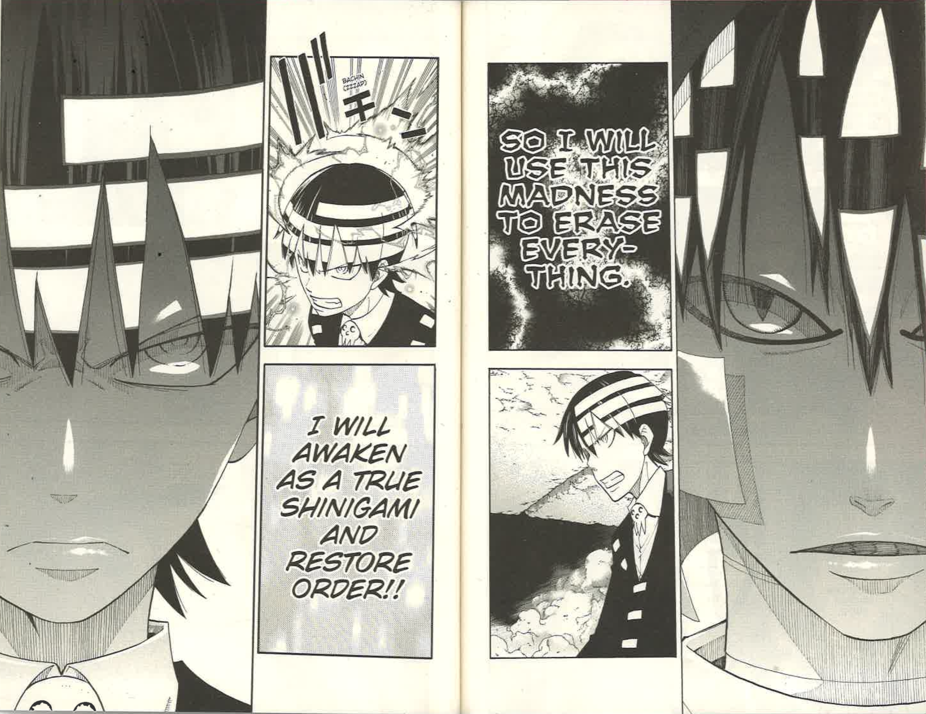
The kishin, otherwise known as Asura, serves as the recurring harbinger of “pure” evil, which the series refers to as “madness.” This role is clear when Asura confronts Kid during the final battle of the series. In this scene, Asura (right) declares that he will use “madness to erase everything” while Kid (left), to counter, declares he will “awaken as a true shinigami and restore order” (next page, 24: 162-163). Asura’s use of madness, here, does simultaneous work to link Asura with evil; it is the force within Soul Eater used by the “evil” and reminiscent of the “confusion” Frye often associates with evil. Within the text, madness manifests as a “contagious” wavelength capable of “awakening the evil inside people” (7: 21-22). Therefore, Asura directly weaponizing madness makes him a threat to the heroes’ mission to maintain order. Asura’s embrace of “madness” serves to oppose Kid’s ideal of “order,” ultimately forcing the two into collision through these antagonistic traits. In addition to their clashing traits, their missions oppose each other, which is shown through the verbs they use; Asura vows to “erase,” while Kid intends to “restore.” The use of antonyms adds to the sense of natural conflict that myth deals in. Beyond the textual elements or the mechanics of the world, Ohkubo makes use of an array of graphic elements to further develop the antonymic relationship between the two. Asura's dialogue is written in jagged text to match the madness he represents, while Kid’s dialogue is written in a neater, stricter text reminiscent of his desire for order. The text boxes themselves are shrouded in demonic black shadows and illuminated in divine light for Asura and Kid respectively. Lastly and most distinctly, the use of white in the design of both characters seem to complete the other; Kid’s three white stripes in his hair would appear to fill in the gap between Asura’s white hair if overlaid on Asura’s design, not only emphasizing the antonymic relationship, but suggesting the presence of a complementary relationship that lies within the subtext of the mythic binary. Ohkubo exposes the fact that that when each side of the binary is constructed around what the other is not, each needs the other side to define itself.
However, Ohkubo plays with the mythic structure again in origin. At one point in time, Asura was affiliated with good, but was “so terrified of death that he took the soul of a good person” thinking “if he just had power, he couldn’t lose” (3: 30). Asura was presumably so worn down by the constant struggle of questing for the greater power that comes with being a hero that he turned to evil out of desperation to carry on. He would continue to feed on the good of the world, turning fully evil. As opposed to the witches’ evil being rooted in perception and Crona’s evil being rooted in socialization, Ohkubo roots Asura’s evil in a direct affiliation with good, interrogating what happens when one fails to meet the standards set by the good side of the myth. According to Ohkubo, the pursuit of absolute goodness can sometimes hold its own darkness; though Asura’s descent into evil was allegedly born out of fear, it is spurred on by resentment through his shame, which manifests as a desire to “erase everything,” including the standards he was held to. Ohkubo’s construction implies the good side of the binary’s failure to acknowledge the often unattainable quality of its high standards.
This exploration of what causes evil to emerge across all three of the major antagonistic forces of the text rejects the tradition of there being only one singular form of evil in order to question the source of evil itself. The expansion of the binary to include more figures alludes to a more complicated definition of good and evil that the mythic binary does not account for, because multiple definitions of good and evil exist within the text.
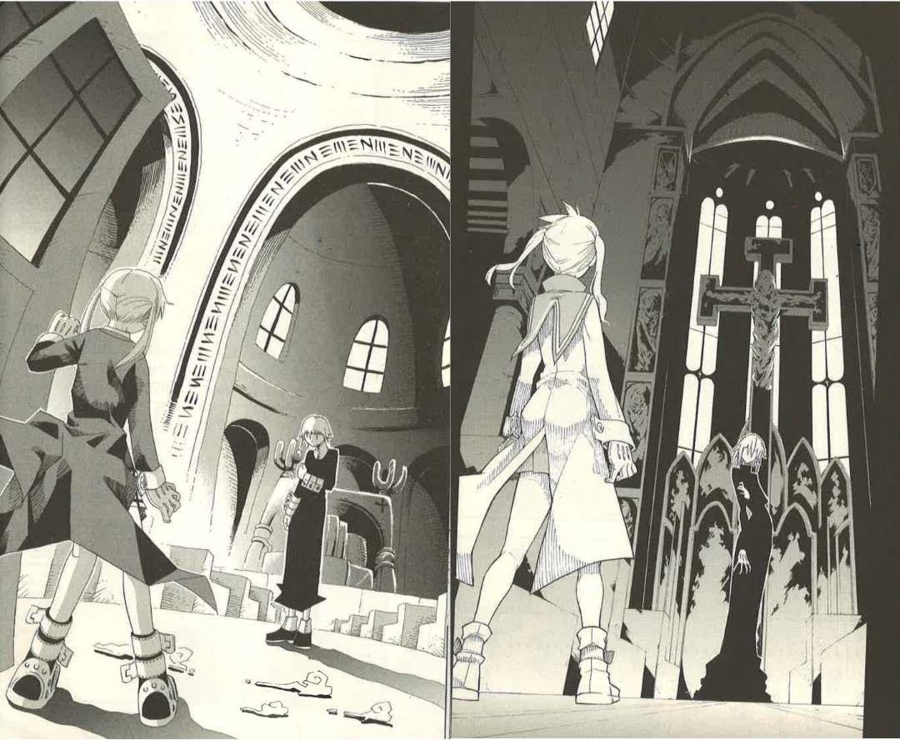
To further expand the binary, Ohkubo often makes use of Soul Eater’s medium as a manga to draw his scenes in ways that allude to which side of the binary the characters fall on or which side of the binary is dominant in the narrative at the moment; Ohkubo adds a plane on which the binary can work. The contrast between the art on page 116 in volume 2 (below, left) and that of page 98 in volume 22 (below, right) is a clear example of this tendency. On the earlier page, Maka encounters Crona for the first time inside of a basilica. At this point in the narrative, neither Maka nor Crona have reached their full potential as a hero and villain, but there are small details of the drawing that suggest which side of the binary each one of them aligns with. The foregrounding of Maka, which places her closer to the reader’s point of view, suggests Ohkubo’s intention to portray Maka as the “desirable” figure of the myth, while Crona’s head on opposition to the reader suggests they are the obstacle that must be overcome. Additionally, the elements of white in Maka’s design like her gloves and bootstraps suggest her affiliation with light or dawn and therefore good, while Crona’s mostly black attire, besides their cufflinks, suggests their affiliation with darkness and evil. However, these elements are not fully realized until volume 22. On the later page, Maka once again encounters Crona in the same basilica and fashion as before. The difference is that Maka and Crona are further aligned with their respective sides of the binary at this point. As a result, Maka is drawn even closer to the reader with one of her feet being cut off in the gutter of the book. Conversely, Crona is drawn even taller to appear as more of an obstacle than before. Moreover, Maka and Crona are fully drawn in white and black respectively to symbolize their growth into their opposing roles. Now, Maka is wearing a short white dress instead of the black one she wears in the previous scene. Meanwhile, Crona’s black dress now extends past their ankles and their collar, flowing onto the floor of the basilica and toward Crona’s head, cloaking them in the black that merely contained them before.
In addition to Ohkubo’s reflection of the binary through the design of his characters, Ohkubo also makes use of the background to indicate which side of the binary is currently more in control. Scott McCloud points out that “backgrounds can be another valuable tool for indicating invisible ideas” (132). At the time of the earlier scene, the good side has more control of the world because the kishin has not been revived yet. Consequently, the background of the basilica is illuminated with the shadow only covering the objects under the arch of the pulpit. In contrast, the later scene occurs when evil wields the most control. The background of that same basilica becomes more distorted and obscured by shadows. This lack of clarity in the background “foster[s] greater participation by the reader and a sense of involvement” (McCloud 133) that is not as necessary in the earlier scene when the world of Soul Eater is more in control of the forces of good. These visual representations create a more tangible representation of the myth binary that stretches beyond the verbal plane, expanding which mediums can be used to construct the binary.
The Arabian Nights perpetuates the classic mythic binary of the “good hero” and the “evil opposition” in order to depict Scheherazade and, by extension, the society ushered in as a result of her actions, as righteous. Meanwhile, Soul Eater experiments with this binary in order to investigate the composition of good and evil itself. The Arabian Nights is a product of the Orientalist movement, in which the “ultimate interest lies…in identifying the essential features of the Western ‘self’ which emerged as framed in opposition to that [Eastern] otherness” (Makdisi and Nussbaum 8). The resulting mythic binary within The Arabian Nights can then be interpreted as a clash of Western values against those of Eastern otherness, with Scheherazade and all the heroes in her tales representing Western ideals and Shahryar’s rage and all the other villains representing Eastern ideals, as perceived by the West. The text’s prolonged emphasis on its heroes’ adherence to piety and purity becomes an indication of an orientation in Western ideals, despite the fictional ethnicity of Scheherazade and her heroes. In turn, the Eastern-oriented enemies who either betray their piety through sinful actions or are godless from the onset, are either reformed into the Westernized pseudo-Islam or expunged altogether in death. The repetition of this pattern throughout the text serves to depict Western society as devout worshippers of God more righteous than Eastern society, which according to The Arabian Nights, is full of jinn, tricksters, and various other sinners. When compared to this heavy-handed Orientalist use of myth, Soul Eater plays the role of skeptic by interrogating what qualities define heroism and what context creates evil in the first place. Ohkubo’s division of the hero’s qualities among the three distinct co-protagonists is a manifestation of his doubts in the singular mythic hero, which ultimately suggests some inherent flaw in the universal effort of myth to construct the “divine hero.” Ohkubo’s decision to provide context for the evil in his text shows skepticism of the implicit “evil enemy” often taken for granted in the mythic binary which again exposes the power the mythmaker wields to portray an entire concept as evil. Soul Eater rejects the binary through which The Arabian Nights makes its argument and in doing so begins its revelation of the latter text’s Orientalist weaponization of myth. Both texts’ relationship to this binary is only the beginning of their own dynamic; beyond the characters of each text, both The Arabian Nights’ perpetuation of and Soul Eater’s experimentation with the monomyth continue with the ways these characters are used and moved throughout the respective narratives of each myth text.

Agon
According to the hero’s journey, before the mythmaker can begin any form of adventure, they must construct an idyllic world for the hero to reside in that, when taken away or otherwise threatened, becomes “lost happy time” the hero’s primary mission aims to return to (Frye 200). The loss of the hero’s homeworld is essential, as the hero needs to be pruned from the protective shell of society in order to begin their transformation into the hero. This is the period Frye refers to as the “innocent youth of the hero” that “is often a world of magic or desirable law [which] tends to center on a youthful hero, still overshadowed by parents, surrounded by youthful companions” (199-200). The parental figures are a signifier of the hero’s unburdened existence in this version of their world; they are still being looked after by older figures who bear the responsibilities of the world for them. The presence of the hero’s contemporaries signifies the hero’s unremarkable life pre-journey as they successfully blend in with those around them, obscured by mediocrity until the start of their journey. However, without the progression of this journey, the mythmaker has to employ another technique to orient the reader toward the hero’s conflict. This technique is to identify the hero through their “exceptional gifts,” which cause them to simultaneously be “honored by [their] society” and “frequently unrecognized or disdained” (Campbell 29). This dynamic allows the mythmaker to depict tension around the hero due to the discrepancy between the hero’s skills and the world’s consistent recognition of those skills, which must be righted by the end of the myth. Altogether, the hero’s peaceful lost world serves as an alternative with which the hero and, by extension, the consumer of the myth, can contrast the impending journey to fully realize the trauma the journey inflicts upon the hero.
Much of the innocent youth depicted in The Arabian Nights is portrayed from the point of view of King Shahryar and his brother King Shah Zaman before they discover their wives’ infidelity and extend their outrage to be focused against what they perceive as all “women’s malice and sleight” (11). The myth begins this way to emphasize the Shahryar’s naivete, making him appear that much more vulnerable to this “malice of woman” (6) so the inciting betrayal of the queen is indicated as the king’s separation from the world. The reign that follows this incident is one where “folk raised an outcry against him and cursed him, praying Allah utterly to destroy him and his rule; and women made an uproar and mothers wept and parents fled with their daughters till there remained not in the city a young person fit for carnal copulation” (13). The period before, however, is described as one where King Shahryar ruled “with justice so exemplary that he was beloved by all the peoples of his capital and of his kingdom” (1) reminiscent of the “desirable law” Frye points to as a signifier of innocent youth. The dramatic switch in public perception implies the loss of the public’s period of innocent youth while casting the blame for the kingdom’s ruin on the king’s cheating former wife. With all this kingdom-wide grief and discontent attributed to the queen’s betrayal, the betrayal becomes something with living consequences even after the queen’s execution; it is an evil reigning over the land that needs vanquishing. This attribution further removes blame from the king while emphasizing the importance of remaining pious and pure like Scheherazade.
Scheherazade herself enters the narrative once the king’s rampage through the kingdom’s women is well underway. She is either under the impression she still lives in the period of “exemplary justice” or is kept completely oblivious to the kingdom’s politics by her father; the period of Scheherazade’s innocent youth extends until the point where her father recounts everything that has occurred. During this time, her father keeps her safe from the world alongside her younger sister, who acts as Scheherazade’s youthful companion. The Wazir is unbothered by the tragic fate of the kingdom at large. Scheherazade’s family embodies hallmarks of youth, creating a bubble of innocence that allows Scheherazade to focus on developing her mind in what would otherwise be a treacherous kingdom to navigate. That mind is the quality meant to signify Scheherazade’s heroic status, which is apparent through the detailing of her incredible array of knowledge; she
had perused the books, annals and legends of preceding kings, and the stories, examples and instances of bygone men and things; indeed it was said that she had collected a thousand books of histories relating to antique races and departed rulers. she had perused the works of the poets and knew them by heart; she had studied philosophy and the sciences, arts and accomplishments; and she was pleasant and polite, wise and witty, well read and well bred. (13)
It is important to note that from “histories relating to antique races and departed rulers” to “the works of poets” to “philosophy and the sciences, arts and accomplishments,” Scheherazade’s and, therefore, the text’s definition of knowledge, is decidedly Eurocentric. The “antique races and departed rulers” are almost certainly those of the ancient Romans and Greeks, because these cultures’ writings were and, admittedly, are still highly regarded as classics in the Occidental world The emphasis on poetry, philosophy, science, and art in this passage further reflects the typical Eurocentric portrait of intelligence. However, Scheherazade’s expertise regarding the “books, annals and legends of preceding kings,” hearkens back to the divine right of kings, which continues her pious presentation, and gives root to her own regality, which is undermined by her status as the despised gender. In summary, the text explains at length that Scheherazade possesses the qualities of well-rounded intelligence that would make her valued in a particularly Western society as a great mind. Nevertheless, because of the larger context, she is despised solely because of her gender and the past transgressions of that gender. This disregard is meant to be read as the tragedy of Scheherazade’s existence that yearns to be righted by the end of the myth. As such, it is reflected back at the king throughout the work in the form of Scheherazade’s repetitive tales of other similarly gifted women stuck in roles unfit for them due to circumstances out of their control.
When Scheherazade relays the story of Morgiana, the slave woman who was able to outsmart 40 thieves by pouring hot oil into their hiding places (463), or the unrecognized princess Perizadah, who saved her two brothers by completing a dangerous quest even they could not (558-560), she alerts the king to the disparity women like her face in a kingdom where all women are punished for the actions of a few. Later, when those women are rewarded, as Morgiana is when she is freed then married to her master’s nephew (472) or as Perizadah is when she is reunited with her mother and regains her status as a princess (575), the disparity is mended that Scheherazade hopes to mend within her own life. Eventually, Scheherazade is similarly rewarded in order to “rightfully” equate her apparent skill to her position in the world, echoing the sentiment of the mythmaker that earthly rewards are in store for those who hold the Eurocentric markers of intelligence. This repeated fate of righteous women in The Arabian Nights is meant to instill in the king and, by coincidence, the reader, the principle that the “good” and righteous of the world always rise to the top of society by successfully retrieving some sense of the pastoral youth they lost.
Ohkubo, however, questions myth’s reminiscence of youth as an idyllic landscape by creating conflict in the period of the journey that should be peaceful, insisting that conflict can reveal itself during any stage of life. The two sources of this conflict stem from what should serve as hallmarks of the safety of youth: the other youthful companions and the trusted parental figure.
First, there is not only conflict but a physical altercation between Black☆Star and Kid upon Kid’s enrollment into DWMA. This incident challenges the monomyth’s implication of the automatic alliance between the hero and his youthful companions; it insinuates that while the conflict in the hero’s youth might have lower stakes, it can be just as formative for the hero because the hero might begin to display the principles that will eventually mold them into the hero during this time. In this case, Black☆Star picks this fight in order to prove that he “has risen above the gods” and he “alone stands almighty” while Kid accepts it because he feels he is the one that needs to restore order after the damage Black☆Star causes to the school in the process of challenging him (2: 68-69). Both challenge and response display each protagonist’s approach of heroism: Black☆Star’s and Kid’s respective drive—and borderline obsession—with strength and order. Therefore, in Soul Eater, the heroes are not obscured by mediocrity during this stage. Rather, each protagonist’s heroic quality reflects off of the other, shining through from the very beginning in spite of the lack of progression of the hero’s journey.

Medusa, a witch who serves as one of the major antagonists in the series, infiltrates the school by using magic to hypnotize everyone into thinking that she has been a doting school nurse for years, as seen in this image of Medusa and Maka in the school nurse’s office (next page, 2: 182). Here, Ohkubo is disturbing the trope of the protective parental figure meant to alleviate the hero’s burden during this formative stage to investigate the assumed benevolent parental figures. Once again, he is taking away the implicit of safety that comes with this stage. This danger is implied in the juxtaposition of Medusa’s affirmation to Maka of “Cheer up!! You’ll get stronger, Maka-chan!!” with the bottom panel of the page, where she shoots her a glaring look. The repeated use of double exclamation points, denoting encouragement and enthusiasm, as well as Medusa’s use of the “-chan” honorific. which implies “affection” and “familiarity” (2:192), would indicate a close bond between the two that is immediately undermined by the sentiment of hostility in the bottom panel. In the bottom panel, the design of Medusa’s eyes becomes serpentine, not only alluding to her status as a witch, the enemies of the heroes in the narrative, but also evoking imagery of her as the often-treacherous snake in literature like the Bible and Paradise Lost. Medusa even utilizes some of her magic to conjure a spectral snake slithering out of her mouth that appears poised to strike Maka’s head upon her command, connoting active hostility toward the heroes. The fact that all of this occurs while Maka is turned away from Medusa and the reader underlines the sense of blatant betrayal. By introducing this element of evil to the “innocent youth” of the hero, Ohkubo exposes another fallacy of myth, its treatment of evil as a force narratively dependent on good’s readiness to confront it, despite the fact that good is expected to be free and untied to evil during this stage. Myth’s focus entirely on the hero during this stage suggests that the hero lives in some paradise that exists before the concept of evil is born through whatever force the mythmaker introduces. Through this particular incident, Ohkubo alleges that the hero in myth doesn’t experience an innocent youth, but an ignorant youth, naive to the evil that surrounds them just as much as the good. Between conflict on a smaller scale and conflict simply unseen by the hero, Ohkubo suggests that there is no such thing as a period without conflict, resisting the monomyth’s utopic depiction of youth.
Ohkubo also experiments with the monomyth’s conflict between the hero’s skills and the world’s inconstant reception of those skills typical of this stage to reject the notion of the standout hero. The usual discrepancy between the hero’s skill set and their role during this stage is reversed as the skillset of the three heroes does not measure up to their role as elite students of DWMA. All three protagonists possess some inherent quality that orients the reader towards them as the standouts of their class: Maka is the daughter of the creator of the last death scythe, Black☆Star is the last survivor of the clan of assassins known as the Star Clan, and Kid is the son of Death himself and, as such, is heir to his father’s position as grim reaper. However, their actual ability to take on the role of heroes during this stage in the series justifiably puts them at the bottom of their class, devaluing them despite their position of prestige. The three prologue chapters showcase an example of each hero’s failure caused by one of their key flaws, which they must face over the course of the series in order to grow into their hero roles. In chapter one, Maka mistakes a cat for a witch and must restart her entire collection of souls (1: 42-44), exposing her headstrongness and the limited perspective this gives her in important situations. In chapter two, Black☆Star causes a huge scene during what is supposed to be a covert assassination (1: 50) through his arrogance and often self-sabotaging insistence on putting the spotlight on himself alone. Kid destroys an entire pyramid after going overboard in his mission to destroy an enemy (1: 130-132) due to his obsession with order to an almost-absurd degree. Each of these prologue chapters suggests that the problem the hero must face should ultimately be internal. Not only the world has to realize the rightful role of the protagonists in society, as Arabian Nights insinuates; the protagonists should mature over the course of their journey in order to fulfill those roles.
The beginning of this journey is commonly known as the “call to adventure,” which signifies that “destiny has summoned the hero and transferred [their] spiritual center of gravity from within the pale of his society to a zone unknown” (Campbell 48). In other words, this call of destiny ushers the hero to their true fate beyond the mediocrity of society. It begins the process of mending the divide between the hero’s skill and their current role in their homeworld by assigning them the new role of “hero” to fill. Within this call is the insinuation that the hero’s “spiritual center of gravity” or, perhaps, soul, is transcendent above what is seen as his familiar “society”. The call is an entrance to this “zone unknown,” the adventure that follows, which acts as a sort of limbo where the hero’s soul is molded to make them worthy of the role destiny has prescribed them. Campbell states that “one of the ways in which the adventure can begin [is] A blunder—apparently the merest chance—[that] reveals an unexpected world” (42). This “blunder” is a rift in the hero’s world that the hero’s soul slips through or, due to the power of the hero’s destiny, was always meant to slip through.
The Arabian Nights features one of these rifts. When the Wazir “relate[s] to [Scheherazade], from first to last, all that had happened between him and the King” (13), he underestimates the extent to which Scheherazade would concern herself with everyone else in the kingdom. His exclamation of “O scanty of wit, expose not thy life to such peril” (13) when Scheherazade demands that he marry her to the king confirms his assumption. Had the Wazir not told Scheherazade about the king, or had Scheherazade learned this information under more intentional circumstances, she might never answered have this call and would never have had the opportunity to quell the king’s insatiable rage. Her father’s unassuming explanation becomes the invitation to the “zone unknown,” enticing her to save the lives of the kingdom’s women. Scheherazade’s acceptance of the call is the first demonstration of the genuine nature of her heroic qualities because she is concerned with something outside herself: the wellbeing of all women in the kingdom. Because she is the Wazir’s daughter, there is little doubt that if she wished, she could be excluded from the king’s lineup of ill-fated suitresses. Instead of displaying an understandable sense of self-preservation by hiding behind her father for protection, Scheherazade shows a remarkable empathy for all the women in the kingdom, regardless of their rank. This display of empathy and the courage to accept this task, which nobody asked her to take on, becomes the myth’s proof that Scheherazade’s soul truly is transcendent of its society; it urges to leave the placidity of the homeworld the moment the opportunity to aid society appears. This acceptance of the call serves the continuation of Scheherazade as a worthy hero of the kingdom through her reflection of the qualities of the typical myth hero.
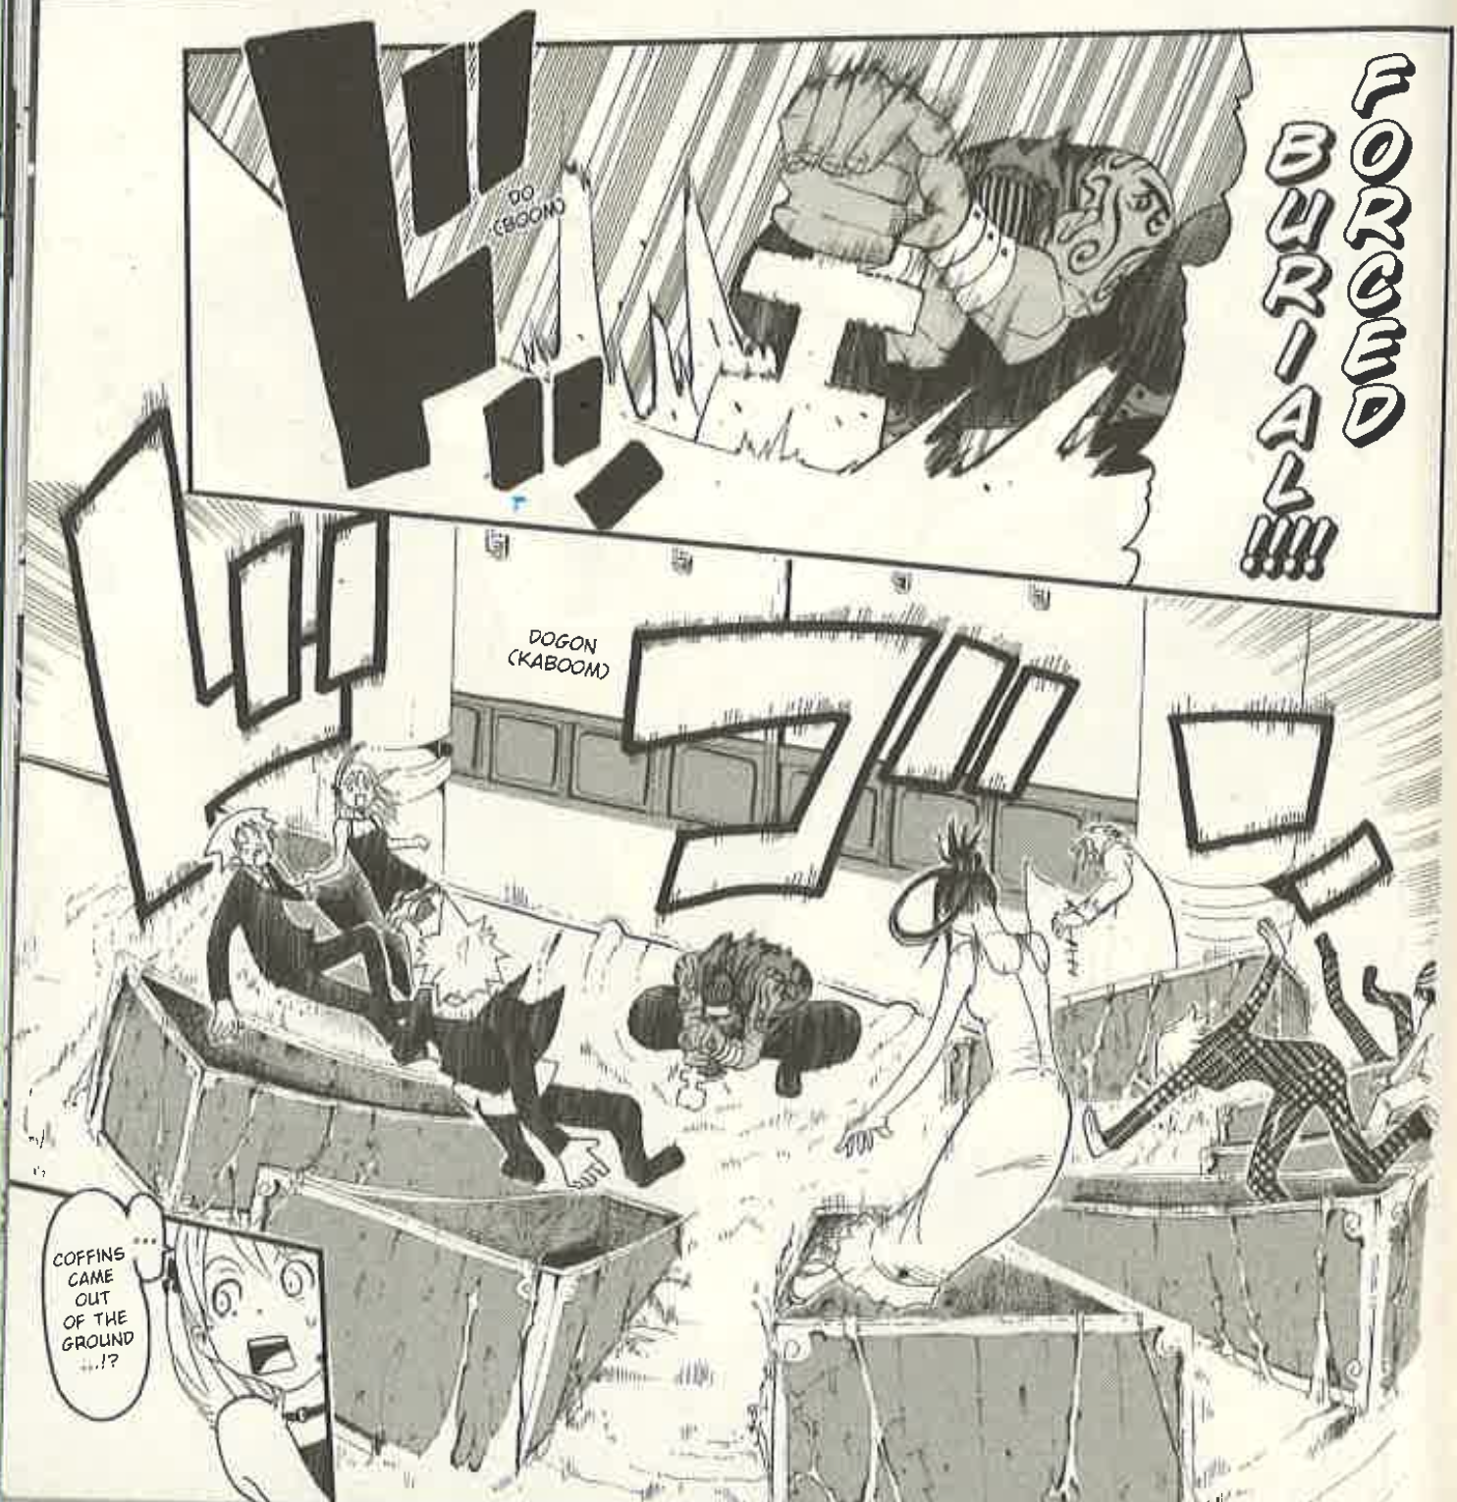
The way Soul Eater portrays the “rift” follows the same principles of transferring the hero’s soul from normal society to the “zone unknown” but differs in both its literal iteration of this trope, which exposes its true function as a transportment of the hero’s soul, and by its skepticism of the accuracy of the destiny behind the call to adventure. Soul Eater’s call arrives during a formal dance when one of the protagonists’ teachers Sid collapses. When the three heroes go to check on him, he executes a spell called “Forced Burial” (left, 5: 35), which consists of coffins that come up from the ground and swallow the heroes. This spell transports the heroes from the dance to the basement of the school, which is off limits to students, where their true adventure begins and they are given the initial mission to prevent the kishin from resurrecting (5: 28-35). The heroes are called to adventure in the midst of a social function where they are expected to dress up to conform to the norms of society when their bodies are “forcibly buried” or “transferred” by coffin into a place they have not been before, the zone unknown. This grafting of the intention of this trope onto the content of the series reveals the symbolic nature of the call to adventure as “a form of self-annihilation” by “passage of the threshold” (Campbell 77) which the hero cannot return from until the completion of the adventure. When the kids are swallowed by coffins to begin their adventure, the simulated death, which, within this trope, is normally subtextual, is not just brought to the textual plane by Sid’s “Forced Burial” incantation but is brought to the visual plane by the medium of the manga. By erasing the subtlety in this trope, Ohkubo removes a boundary between mythmaker and reader, fostering a more direct conversation between the two. Though destiny supposedly gives the kids the role of stopping the kishin from resurrecting because Sid just so happened to cast his spell on them in that moment, they proceed to fail at this task, and their failure makes the situation much worse, which calls the infallibility of destiny into question. When Black☆Star attempts to cut the needle that would reawaken the kishin, he mistakenly destroys the “goshintai” or shrine that is part of the seal that keeps the kishin contained (6: 125-126). This both assists the enemy in succeeding with their goal and prevents future containment of the kishin using this same method. The heroes’ drastic failure of the task destiny supposedly summoned them to accomplish devalues destiny’s power by challenging the assumption that destiny’s call equates to the unbridled success of the hero. In this undoing, Ohkubo removes another layer that comes with the monomyth structure.
Therein lies the difference between each text’s portrayal of agon. The Arabian Nights seeks to uphold the eventuality of a successful journey implied with this stage to portray Scheherazade as exactly the hero destiny has sent for, while Soul Eater challenges it in order to interrogate the entire notion of the “destined hero.” Scheherazade’s fixture in The Arabian Nights as the Westernized righteous hero of the Westernized Arabic people requires the blessing of destiny to portray her as righteous and the infallibility of destiny myth establishes to suggest that a prosperous society cannot exist without the values Scheherazade possesses. These elements of destiny confirm Scheherazade and, by extension, her stories of kingdoms centered around the success of equally righteous and devout people, as not just one answer to the king’s tyranny, but the only answer to it. On the other hand, Ohkubo’s constant undermining of the implicit success of the heroes disrupts the concept of destiny entirely, creating more ambiguity regarding what is necessary to combat evil. This ambiguity allows the reader to negotiate their own definition of heroism through Soul Eater’s willingness to interrogate what it means to be a hero internally. This question becomes essential for the heroes of Soul Eater during pathos, where the heroes are forced to confront their own insufficiencies to their destinies, turning the death struggle just as much inward as outward. In pathos, both texts continue their conversation with each other through their opposing interpretations of what necessitates a successful heroic journey.

Pathos
In pathos, the hero must first undertake the “road of trials” before their final confrontation with the enemy. Campbell says that this stage of the journey is “the process of dissolving, transcending or transmuting the infantile images of our personal past” through which there is a “purification of the self when the senses are cleansed and humbled” (84). The function of the road of trials is a scrutinization and cutting away of the hero’s former identity through a “succession of trials” (81) in which the hero must maintain “the integrity of the innocent world against the assault of experience” (Frye 201). When the hero endures this “assault of experience” with the “integrity” of their own values intact, those values are reinforced as righteous by the survival and absorption of that which is their antithesis. As a result, the hero and, by extension, those values, gain the strength and status they require to finally confront the primary opposition that initially separated them from their innocent homeworld. The survival of the protagonist’s core values serves as the monomyth’s method of validating those values as those of the heroic. With the protagonist’s values unchanged by the conflict between them and their antithesis, the collective effect of this “assault of experience” becomes the erosion of the protagonist’s younger, weaker identity, exhibited in agon, which is known as the “ego” keeping the protagonist individualized from the universal identification of hero. Because of this process, they can substitute in the new identity of the hero, completing the transformation. The “road of trials” is a vital stage of the journey; to take on the selfless mantle of “hero,” the hero must “put aside [their] pride, [their] virtue, beauty, and life” that is their ego to “find that [they] and [their] opposite are not of differing species, but one flesh” and reckon with the evil that shared flesh is capable of by internalizing it—in Campbell’s words, “swallowing it or [if the evil is too great,] being swallowed” (89).
Throughout The Arabian Nights, Scheherazade replicates this process through her role as orator, since by putting her life on the line with each story she tells, she takes responsibility for or “swallows” the text’s moral binary of mankind’s actions represented in the tales. Each of Scheherazade’s fantastical tales are meant to be one part of her entire plan for “deliverance [for the women of the kingdom]…which shall turn the King from his blood-thirsty custom” (21), Thus, each of them shares an equal weight in this deliverance. By representing the righteousness of humanity through figures like Prince Khudadad, who saves his kingdom from a foreign attack despite his survival of an assassination attempt by his own brothers (292-316), and the irredeemable aspects of humanity through ifrits and jinn throughout her tales, Scheherazade reintroduces the king to both potentials of morality through her “gamble” exhibiting her “belief in her tales” (Naithani 276) and her belief in humanity. By telling these tales, unabashed of their depiction of mankind’s morals or “moral force” (Makdisi and Nussbaum 18), Scheherazade ceases to be solely the Wazir’s daughter or just another wife for the king to have executed by sunrise. She comes to represent a renewed belief in the potential of mankind for the king to embrace through his eventual marriage to Scheherazade. Even beyond the tales, by burdening herself with the fate of the kingdom at the risk of suffering the same end as the king’s preceding wives, Scheherazade casts aside her own emotions, potential ambitions, and sense of self-preservation, that, when combined, effectively represent her ego. All of this is done for the greater sake of taking the evil responsible for the ruin of her kingdom head on. She is determined to either “swallow” it by reforming the king or let it “swallow her” through her own death. Therefore, each of the 1001 nights is a reaffirmation of her ego-death, as she must continuously suppress her own ego in order to continue her mission as not only the king’s wife, which is daunting enough, but as his redeemer. Scheherazade’s nightly storytelling puts her through a prolonged ego-death; when she internalizes the moral binary between that of the characters in the tales and between that of the king’s action and her, she eliminates her own personal sense of morality. Instead, she molds herself into a queen not defined by one selfish action and one who will come to represent the universality of human morality by the end of the myth. The use of ego-death that occurs in the narrative perpetuates the tradition of myth and depicts Scheherazade as the righteous myth hero, because it serves as her selfless molting before her transformation into something greater than herself.
In contrast, Ohkubo’s Soul Eater plays with this formula by once again literalizing a trope of the narrative ego-death behind this stage of the journey. During the road of trials, the hero encounters “crooked lanes of his own spiritual labyrinth...[finding] himself in a landscape of symbolical figures” (Campbell 84). These “symbolical figures” are often represented as beasts or monsters for the hero to face, such as the Minotaur in the legend of Hercules. In Scheherazade’s stories, this role is often filled by jinn and various other creatures the hero must confront and defeat. However, in Soul Eater, some of these figures manifest as altered versions of the heroes themselves that they must master to continue their adventure.
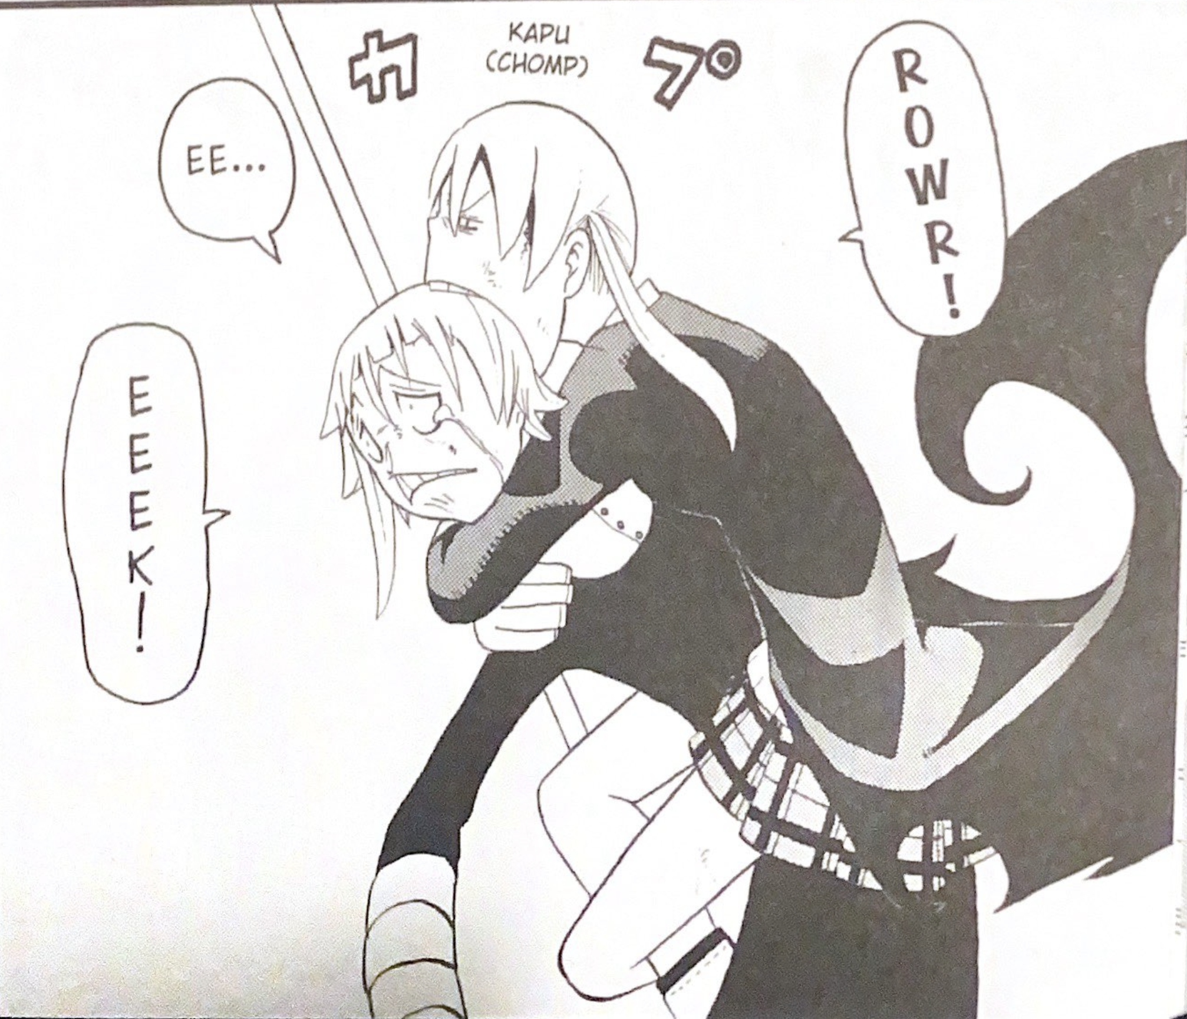
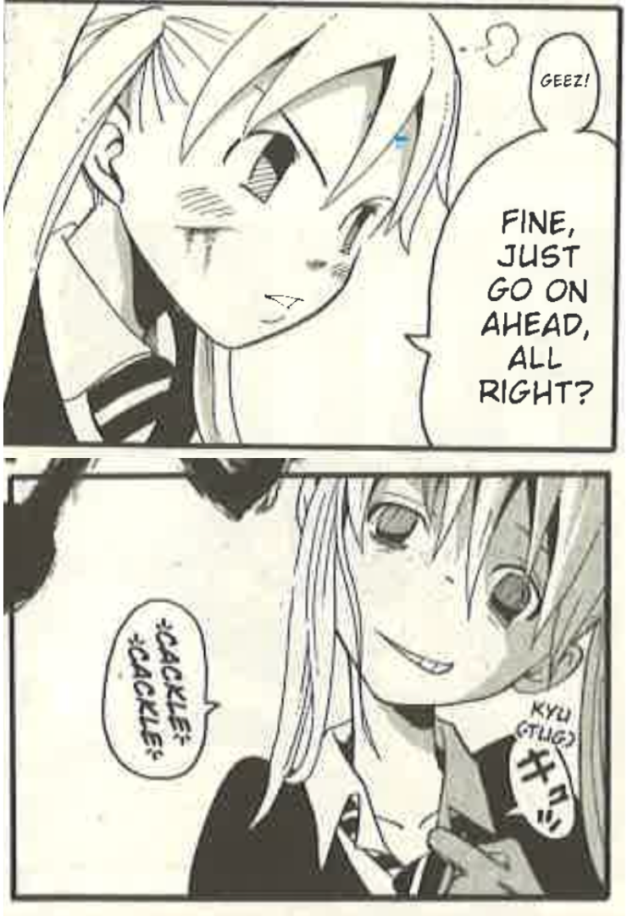
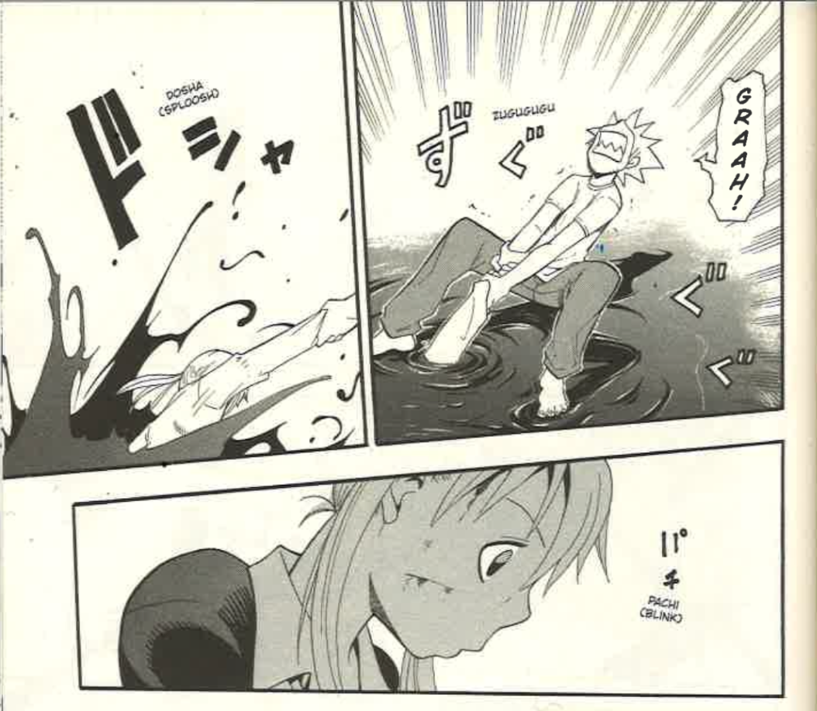
Maka experiences this during another fight against Crona as she embraces “the same madness as Crona” in order to “feel Crona’s soul wavelength” (5: 171). While doing so causes her to lose her sense of fear, it takes her to the limit of her sanity, causing her to become a manic version of herself uncharacteristic of her usual straightforwardness and composed manner. For example, she dares her adversary to “[pull] out an eyeball or [her] tongue or something” and even bites their head (next page, top, 6: 16), displaying a disturbing lack of her typical tact. This modified state of Maka is further distinguished from her normal one by Ohkubo’s change in the design of her pupils. In contrast to their usual narrow design (middle, top, 5: 95), the pupils of her insane version are drawn wider and shadier (middle, bottom, 5:180). Once Maka accomplishes what she has to in this form, she returns to sanity by having her weapon partner resynchronize souls with her. Visually, he pulls her out of a fully black body of water (bottom, 6: 41). While this design move further distinguishes the two forms from one another, it also implies that becoming this newfound version of herself threatens to drown the “real,” heroic version of Maka within the abyss of evil. This element simulates the consumption of the ego visually; Maka appears to be submerged in an inky lake. Had Maka embraced the altered version, it would imply a sort of drowning in a metaphorical lake of madness.
Black☆Star’s confrontation with his altered state occurs in volume ten of the series. After having his confidence shaken by a string of losses to the enemy, Black☆Star attempts to come to terms with his own mortality by challenging Kid just as he did on Kid’s first day of school, jealous that he possesses “the body of a god” (10: 121). During this fight, Black☆Star shows signs that, in his pursuit of more power, he may be retreading the path of his father, which resulted in the rest of his clan being “slaughtered by DWMA” (3: 58) due to their evil acts. One of his teachers identifies the appearance of a new form manifested by his identity crisis and asks him, “You gonna follow your father’s path, boy? That’s the path of a kishin” (10: 156), indicating concern over an evil beginning to show within Black☆Star that was not apparent until this moment. The new form is more vulgar and aggressive, as exhibited by Black☆Star’s almost incoherent rant in response to his teacher’s concern over his behavior:
‘Cos why? ‘Cos it leads to the ‘next thing’? What a load of shit. You could be the biggest pussy and drag ass your whole way through life, and as long as you're still alive, there's gonna be somethin’ comin’ up the road that's no big insight. Whaddaya think this is moron? Playing ball without a ball? (10:155)
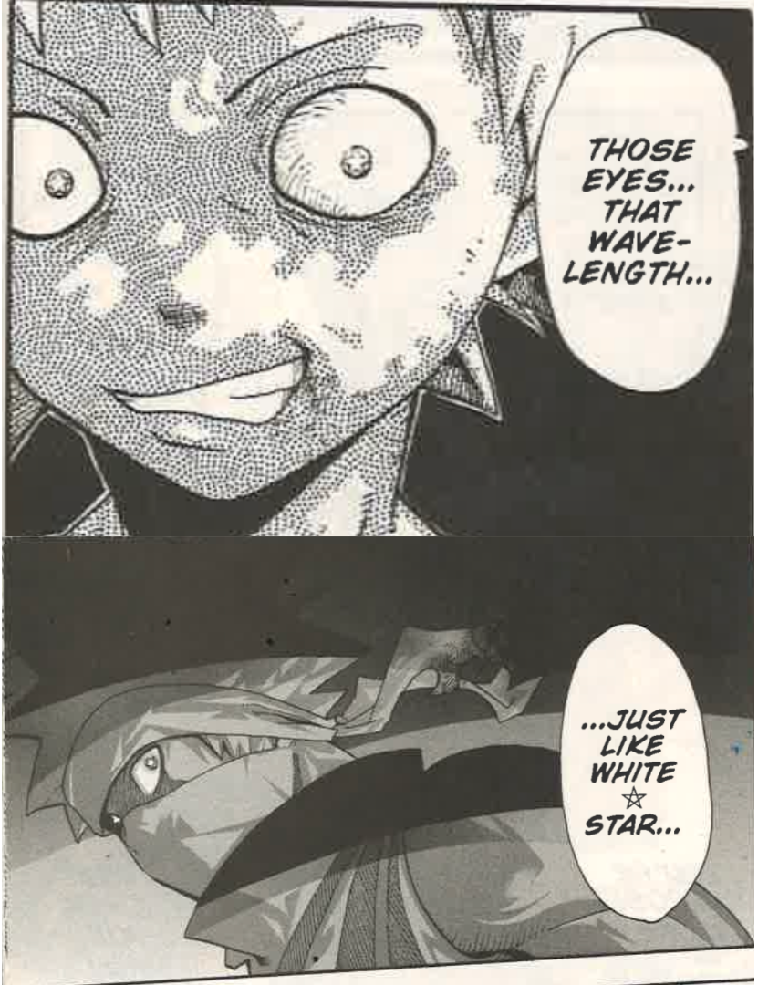
As with Maka’s altered form, this form is reflected through the what McCloud called the “iconic” plane as stars appear in Black☆Star’s eyes that were not there before (left, top, 10: 155) and a panel indicates that his father, White☆Star, had the same eyes (left, bottom, 10: 156). These images suggest that Black☆Star is in danger of being “swallowed” by a desire for power similar to the desire that consumed his father. Also, both panels have a black background, implying the evil nature of the form Black☆Star and his father share. As Maka does, Black☆Star must “kill” the version of himself. Black☆Star acknowledges the evil of this form by offering himself as both one of the 99 evil souls for Kid to slay to make his death weapon and an evil soul Kid must rid the world of as per his duty as eventual grim reaper. He taunts Kid, “Then kill me!! You’re supposed to be a god of death, right!!?” (10: 157). Kid responds by eventually knocking Black☆Star out during this fight. By simulating the addition of his own name to Death’s list of evil souls and the subsequent capturing of that soul, Black☆Star allows this version of himself to be “swallowed” in some way by another hero for him to move forward with his own journey.
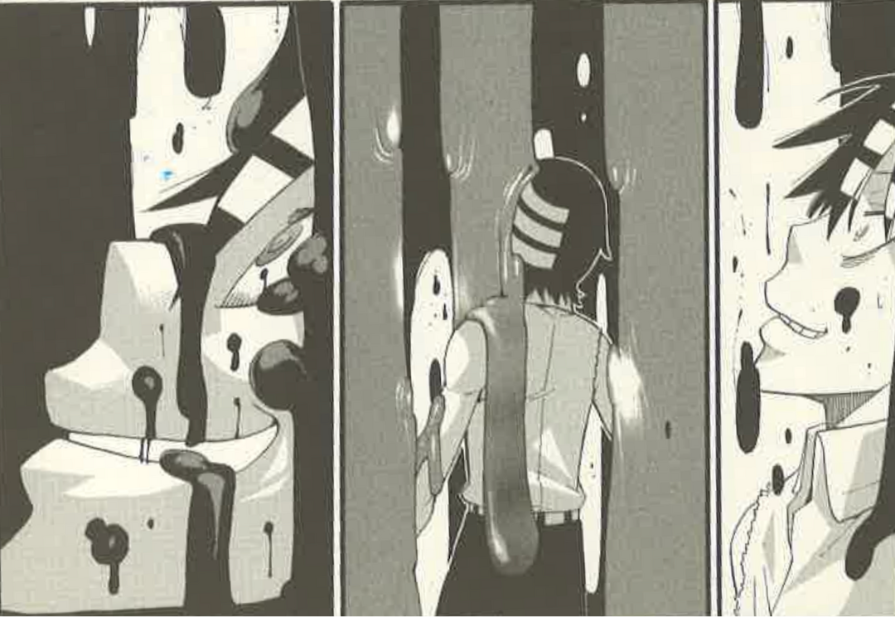
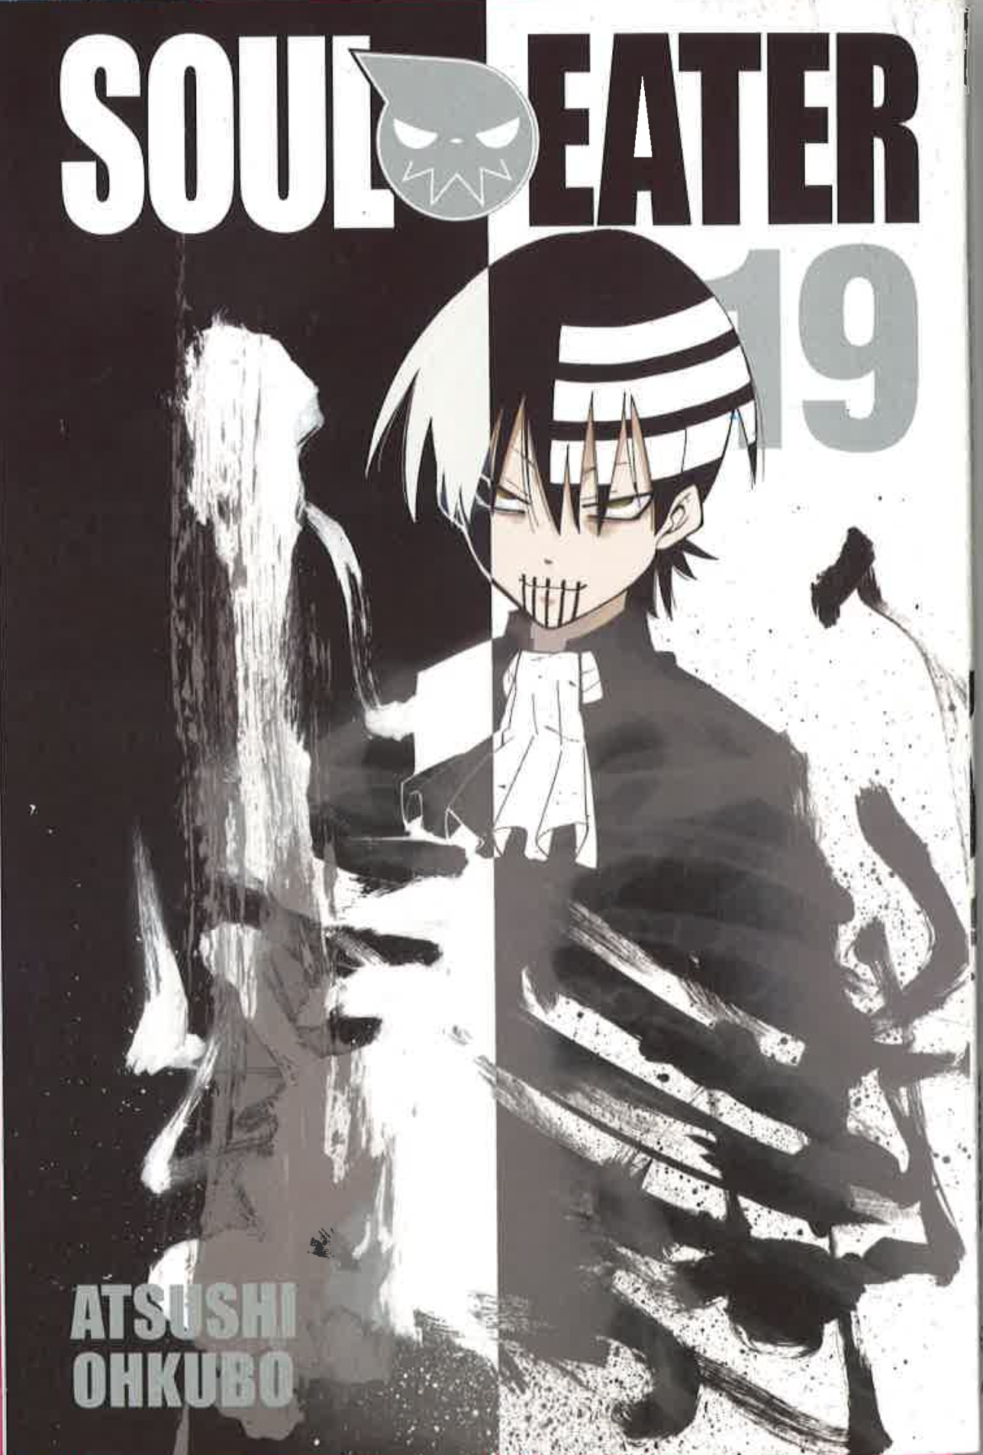
Kid confronts his altered self at the end of volume 17 of the series when he is consumed by the madness that is inside of the book of Eibon. As the malevolent power “swallows” him, he exhibits an uncharacteristic, crazed smile that is a symptom of the corrupted psyche that manifests Kid’s altered self (left, 17: 175). Once again, the act of ego-death is literalized by visualization. When Kid is covered by the madness that manifests as ooze inside the book of Eibon, he loses control of himself and his ego. Like with Maka’s and Black☆Star’s, Kid’s altered form features visual differences as well as moral ones. Ohkubo again alters the design in the eyes of his protagonist to show this shift; he changes them to a menacing sharper design. Beyond the eyes, he adds five disconcerting black stripes over the mouth (right, 19: Cover). These visual elements differentiate a new form while alarming the reader to a present new evil through this more threatening design for Kid. As for the morals of this new version, among the first words this new version of Kid utters is a declaration of a new goal to “kill, expel all that exists from the world” (18: 10). Taken to the extreme, this paradoxical “[evil or] madness of order” inspires this new form of Kid to bring about “nothingness[,]” for within nothingness, “there’s no left…no right…just a transsymmetrical unity that surpasses all symmetry” (18: 8). Nothingness is an utter void where order appears perfect because there is nothing that can be out of place. Therefore, this new goal does not originate from a diversion from his original goal, but rather an exaggerated, twisted interpretation of the same principle. By grounding this altered version of Kid in the heroic Kid’s goal, Ohkubo calls back to his construction of evil in the case of Asura by revisiting the concept of a danger in the pursuit of absolute good. Like the other two, Kid does away with this version of himself. Black☆Star, returning Kid’s aid in his own ego-death, helps Kid to “swallow” this version of himself by awakening him to the conclusion that simply wiping out everything “ain’t ‘ultimate’ anything, bro. That ain’t nothing at all” (19: 63). Black☆Star reestablishes Kid’s belief in “ultimate order” as “[his] answer to the question of ‘power’” (19: 85), which shows that his principles have survived the ordeal and made it out stronger from the assault of this experience with madness.
As Campbell says, this stage is a continuous posing of the question: “Can the ego put itself to death?” (89) In both myth texts, the answer is yes. However, while the process of the annihilation of the ego is externalized in The Arabian Nights through the defeat of villains who attempt to thwart the hero in the encapsulated tales and through the tales themselves in the frame narrative, it becomes an internal struggle with the hero’s “ego” in Soul Eater.
Scheherazade is unable to access her own or the king’s ego directly at the risk of compromising her determination or being so direct that Shahryar wisens up to her plan. To destroy her own improper ego and the king’s diseased ego, she must externalize them both through outrageous stories that slyly hold both of their morals in the balance of human morality. Scheherazade’s achievement of her destiny through indirect mythic commentary is a cunning yet heroic use of the resources available to reverse the fate of her declining kingdom. Her extensive objectification of morality repeatedly romanticizes external conflict as a way of evolving oneself, hearkening back to the idea that The Arabian Nights provides “ways to justify [European] conquests and rule over other peoples” (Makdisi and Nussbaum 4).
Soul Eater rejects this notion by turning the process of evolution inward. All these rejections of the heroes’ altered versions follows the same concept of the eroding of the “ego” that the road of trials is meant to portray. It does so in such a literal fashion that it peels away another barrier of subtext that usually exists between reader and mythmaker, exposing the raw essence of the monomyth as a depiction of internal evolution. By allowing access to a direct exploration of each hero’s ego, Ohkubo neutralizes the need for the externalization of inner conflict, eliminating another fallacy in myth, having to place opposing viewpoints in juxtaposition in order to establish a sense of moral superiority. Through a repeated internalization of these evils, Ohkubo suggests that both potentials can be true. This move towards duality is summarized when Black☆Star says:
Maybe I’m usin’ the power of madness to become the strongest warrior there is but that doesn’t mean I’m losin’ myself in it, if you know what I mean. Becomin’ the strongest by lettin’ yourself fall deeper into madness with each step only makes you a joke. (19: 78)
Here, Black☆Star does more than simply “swallow” evil and discard it. He argues that while he actively accesses the same power of madness the kishin weaponizes against the heroes, which is a stand-in for the concept of evil as a whole, evil does not become the full measure of his morality. Rather, the absorption and reinterpretation of this power makes him a better and more capable hero. Furthermore, Black☆Star calls the notion that one automatically “fall[s] deeper into madness” or, in myth terms, evil, by having an imperfect side or “usin’ the power of madness” “a joke.” Ohkubo throws Black☆Star’s ingrained accusation toward the entire binary structure, suggesting that the concept that one could accomplish transformation into a perfect hero solely by championing only one interpretation aspect of the moral spectrum is an oversimplification that does not do justice to the complexity of morality. By expanding the moral binary to a spectrum, Ohkubo allows for a more nuanced exploration of the heroic “ego” that offers a more realistic portrayal of morality than is often found in myth. Both The Arabian Nights’ adherence to the objectification of its heroes and villains using the monomyth and Soul Eater’s refusal to abide by a singular truth through its rejection of the monomyth continue at the apex of this road of trials: the apotheosis.
Apotheosis, or the deification of the hero, is the climax of the hero’s journey. Campbell states that it is the moment in which the hero “shattered for himself the bounds of the last threshold [of his old self and humanity as a whole.]” He continues that “this godlike being is a pattern of the divine state to which the human hero attains who has gone beyond the last terrors of ignorance” (127). It is here where the hero’s values, strengthened through the assault of experience and the repeated “swallowing” of its antitheses, are married to ultimate power in the form of a final “annihilation” of the “envelopment of consciousness” (Campbell 127) that is humanity. Because the ego is typically externalized in the narrative, this usually manifests as a final showdown between the hero and a villain that represents evil on the same scale as the godlike power the hero seeks. When the hero defeats this “final boss,” they become a limitless being “more than man” (Campbell 133) “free of all fear, beyond the reach of change[.]” Campbell continues that myth purports this final form of the hero as “the release potential within us all, and which anyone can attain—through herohood” (127).
The Arabian Nights borrows the monomyth’s concept of this universal release potential to portray Scheherazade’s values and, by extension, western ideals as the sole path of herohood. Scheherazade’s opposition is the fury of King Shahryar, so her apotheosis naturally manifests when she ultimately cures his rage. Her request for pardon is granted, bringing an end to the era of genocide that gripped the kingdom for three years. The three tenets of apotheosis—a completed ego-death, the consumption of an equal evil, and ascendance to godlike status—can all be found in this moment.
Firstly, the completion of ego-death can be seen in the manner in which Scheherazade requests her pardon. Still under the impression, even after 1001 nights, that Shahryar intends to execute her the next morning, she asks for him to spare her life not out of fear for herself but “as a dole to these infants” she bore with the king, because “for, an thou kill [her], they will become motherless and will find none among women to rear them as they should be reared” (733). The fact that she even endured bearing children with Shahryar, a man responsible for over the deaths of over 1000 women just like her, is already a significant act of selflessness; it represents the casting away of pride and sense of self-preservation for a greater purpose. However, when Scheherazade asks for the king to spare her life for the sake of her children, she demonstrates the completion of her own ego-death. She implies a readiness to die if her personal mission failed, but recognizes that her life is worth being spared so that her children can be raised by not just their mother, but a woman worthy enough to stave off the king’s rage as long as she has, to “rear them as they should be reared”. On a cultural scale, Scheherazade’s desire to live for this express purpose reflects an emphasis on the “responsibility” women have not just to birth children, but to properly raise them that is prevalent in European societal values.
As for the consumption of an equal evil, through the 1001 nights of storytelling, Shahryar's three years of oppressive rule are numerically counterbalanced, fostering a sense of gradual reconciliation with the forces of good. Though the king’s genocide technically lasts 94 days longer than Scheherazade’s time spent regaling the king, it is still implied through the similar duration that one night of storytelling reflects one former wife of the king murdered. Hence, each night Scheherazade spends with the king is a moral cleansing or “swallowing” of that murder. She is a force of piousness and loyalty equal in weight to the evil Shahryar commits for three years prior. Ultimately, Scheherazade’s curing of the king serves as a complete undoing of the past. Shahryar admits that “Since there befel the Kings of the Chosroes more than that which hath befallen me, never whilst I live, shall I cease to blame myself for the past” (734). He acknowledges, even upon the divine kings of the past, that what transpired in the kingdom was unquestionably his own fault and not the fault of the entirety of the female gender. This serves as Shahryar’s atonement and realignment with good, which is proof of Scheherazade’s absorption of his evil through her storytelling.
Lastly, Shahryar’s pardon of Scheherazade serves as her transcendence into a role approaching divinity. As he pardons her, he explains that his reason for doing so is that he found her “chaste, pure, ingenuous and pious[,]” a sentiment he would repeat upon his decision to marry her and make her queen, calling her “pure and pious, chaste and ingenuous” (734). Primarily, the elevation of Scheherazade specifically to queen of the kingdom represents the divine implications of her ascendancy. Once again, the historical context of the belief in the “divinity of kings” that was prevalent during the time of The Arabian Nights’ composition is necessary in order to understand that the king deeming her worthy for him to marry is the closest a mortal woman can get to achieving divinity. Scheherazade ceremonially becomes one with the king, who represents the word of God—or Allah, in this case. However, this divine regality applies to Scheherazade, because by becoming a royal herself, she is cast in a similar—though slightly less valued—role to King Shahryar. Additionally, Shahryar’s repeated application of these adjectives to Scheherazade christens her as the divine redeemer of her gender through these traits. Her chasteness contrasts the original betrayal of the unloyal former queen. Her purity echoes the same sentiments of chasteness while alleging her as unsullied by any force of evil, once again defining good through its opposite. Her attribution of “ingenuous” continues these sentiments but adds a sense of inability to even perform evil by implying a complete innocence to the forces of evil. Finally, her piousness directly links her to the divine as not only a loyal believer, but as one who is almost saintly contextualized by her role as the king’s redeemer.
However, each element of apotheosis also perpetuates the use of myth to reflect Western ideals, culminating in a deification of the ideals of Western society through the deification of Scheherazade. Scheherazade’s use of the family structure to attempt to avert the king’s wrath reflects the traditional role of women in Western society as the dutiful mothers of the household. Scheherazade’s apotheosis being achieved through the restoration of and recognition by the king regurgitates and reaffirms belief in the “divine right of kings.” Shahryar’s recognition of Scheherazade as “chaste, pure, ingenuous and pious” elucidates her exemplification of the ideals that are expected of those in society during the The Arabian Nights’ time of composition. When Scheherazade is crowned queen, she becomes a symbol of righteous yet attainable glory for readers to live up to, which can only be achieved by embracing the ideals of Western society.
In Soul Eater, Ohkubo uses three separate moments of apotheosis to not only reject the idea of a singular route to herohood, but to explore the implications of apotheosis and the methods used to attain it in multiple ways. Narratively, each hero’s apotheosis involves the defeat of a major antagonist. However, in each defeat, one of the three tenets of apotheosis are complicated by some element in the narrative, as if to suggest that there lies something beyond the apotheosis which the monomyth depicts as the ultimate end.
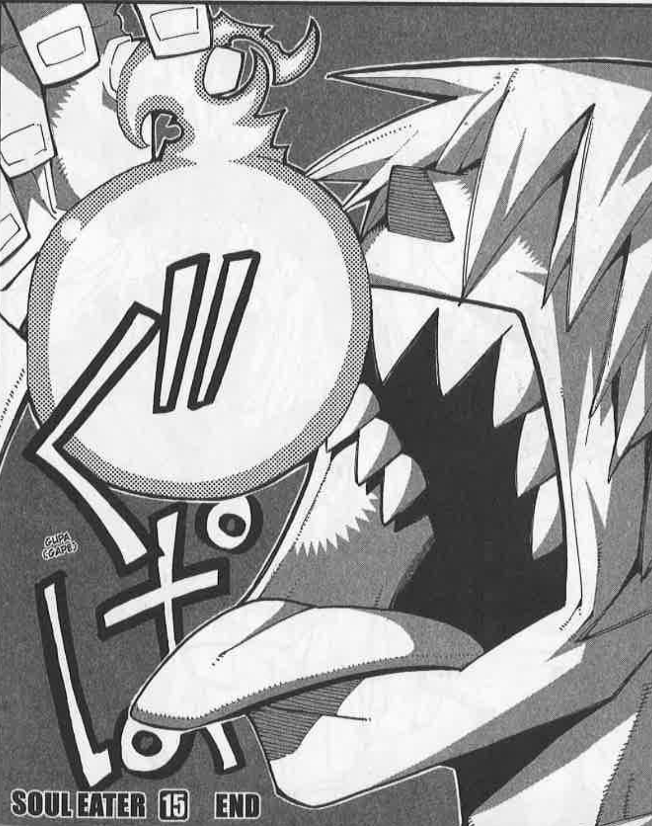
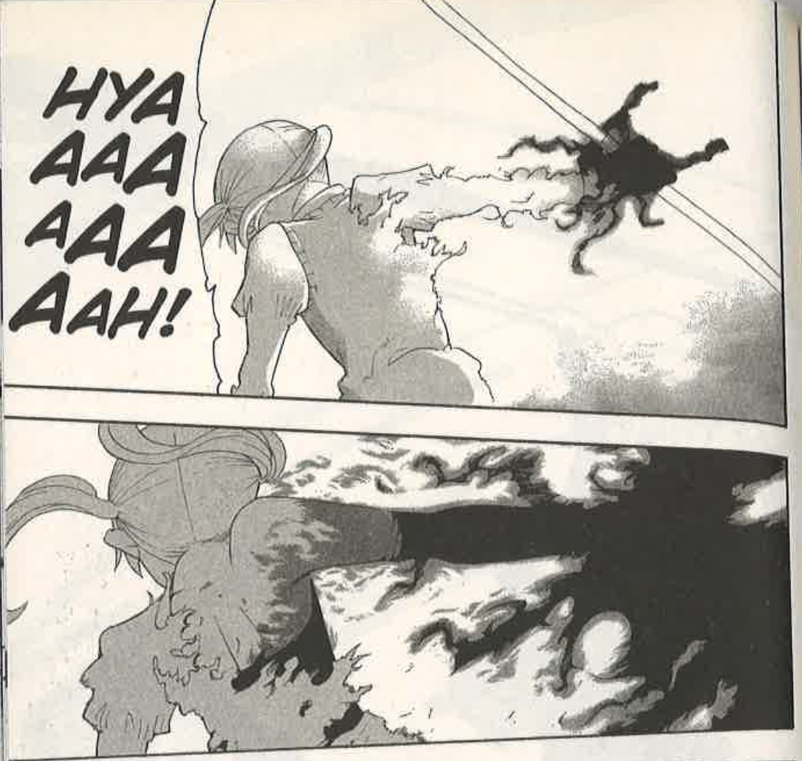
Maka’s apotheosis revolves around the accomplishment of the explicit goal of all students at DWMA: the creation of a death weapon. Through her victory over the witch Arachne, Maka gains possession of Arachne's soul, the last soul needed to turn her partner, Soul Evans, into a death weapon. This accomplishment, while it has been Maka’s goal since she wished to follow in the footsteps of her mother, who created a death scythe, situates her among a small, elite group of alumni of the school, who have completed DWMA’s ultimate task for its students; she becomes one of the DWMA’s greatest successes. While the rarity of this achievement represents Maka’s ascendancy to godlike status, the apotheotic nature of this moment is also particularly marked by what Maka says as she slays Arachne: “Face it–I’m stronger than you. And it serves you right” (15: 83). In this moment of victory, Maka holds Arachne accountable for the evil acts she has committed by saying her execution of the witch “serves [her] right[,]” embodying the side of good and doing away with her own “ego” for the sake of the world’s safety. This act serves as the ego-death the apotheotic moment calls for. The one-liner also indicates the equality of the evil Arachne represents and to the good Maka represents. When Maka says, “I’m stronger than you[,]” she brings finality to the encounter but also reaffirms the fact to herself after a hard-fought battle against a formidable opponent who matches her in power. In the chapter preceding this one, Maka has to rely on the power of madness-inducing black blood in order to defeat Arachne, the same power that once brought her to the brink of her sanity. This is visualized by a black surge of energy emanating from her weapon (above, 15: 71). Maka’s use of this last resort to defeat Arachne stands as testament to the witch’s daunting strength. This equal evil is literally swallowed when Soul devours Arachne’s soul at the end of the volume (previous page, right, 15: 182), once again literalizing an element of the hero’s journey to erase a layer of subtext between reader and mythmaker.
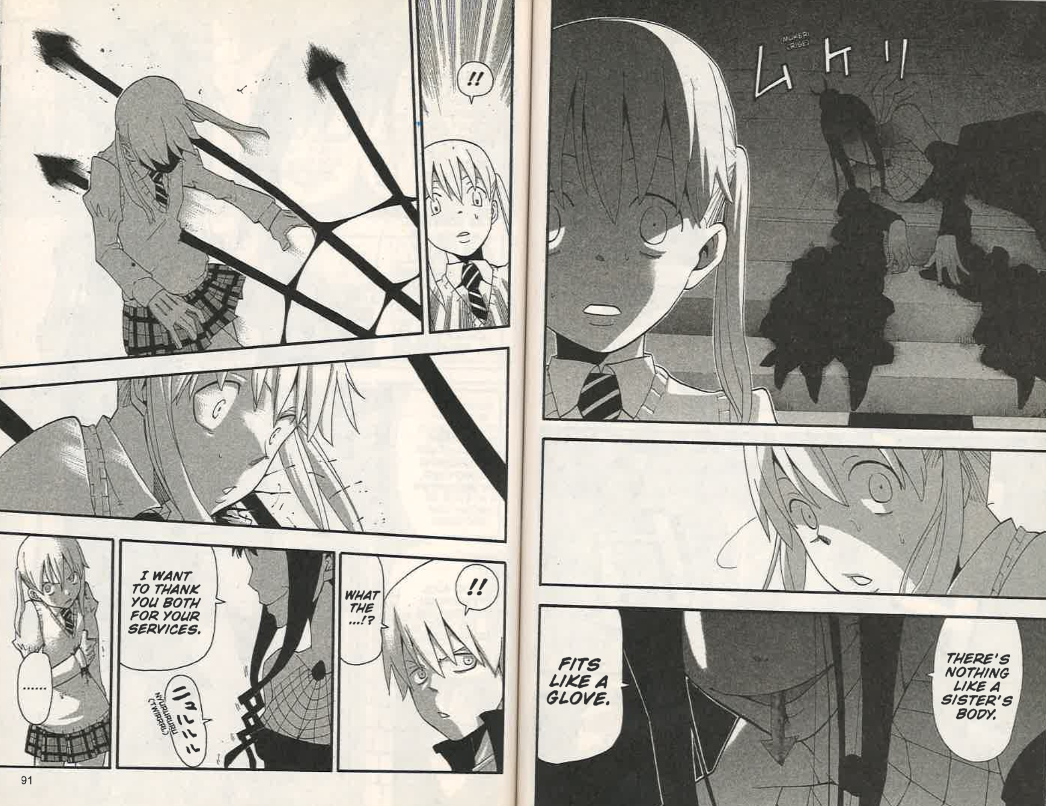
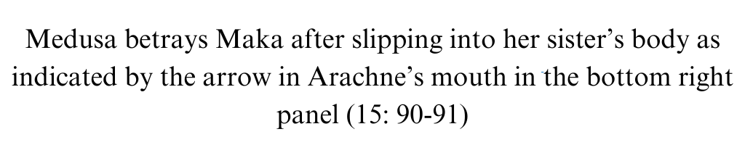
However, this aspect is also the tenet of apotheosis Ohkubo toys with. The moment the hero achieves the ultimate goal of apotheosis is usually celebrated by a “boon bestowed on [them]...scaled to [their] stature and to the nature of [their] dominant desire” (Campbell 163). This is seen in The Arabian Nights when Scheherazade and her sister are made queens of kingdoms by Shahryar and Shah Zaman and, therefore, earn royal divinity as a reward for ending the king’s prolonged rampage. Yet, despite the incredulity of Maka’s victory, it goes uncelebrated because she is immediately betrayed by the witch Medusa, who she was working with for the purpose of taking down her sister (left). This denial of the boon in favor of the appearance of a new enemy interrogates the apotheotic element of equal evil consumption by elucidating that while apotheosis may be achieved by the consumption of an equal evil, it does not eliminate the potentiality of secondary, if not greater evil that it still falls on the hero to resolve.
The apotheosis of Black☆Star is achieved through the slaying of his rival throughout the series, the infamous swordsman Mifune, during their third encounter. Until this point, the two traded victories in combat, with Black☆Star winning the first fight and Mifune winning the second. As a result, the third clash serves as the final encounter that decides not only which of them is the better warrior, but which of their value sets will survive and surpass the other in strength. The apotheotic nature of this final showdown is first indicated by Black☆Star’s proclamation of ego-death as he says to his rival that “walking the path of the warrior means he’s ready to die if it comes to it” (14: 157). This outright acceptance of death is an indication the growth into the heroic persona Black☆Star has gone through and an indication of his doing away with much of the arrogance he had in the beginning of the series. The young, ignorant version of Black☆Star in the innocent youth stage does not have the capacity to reckon with dying “if it comes to it[,]” as he once flippantly declared he “surpassed the gods” after Kid essentially beat himself by fainting in a fight against Black☆Star (2: 93), too preoccupied with prowess in combat to see the broader implications of the hero role. His declaration that he is “walking the path of the warrior” also serves in contrast to his teacher’s earlier concerns that he is walking the “path of a kishin,” showing that he has also done away with the part of himself that was in danger of self-vilification. Furthermore, the equation of strength between Black☆Star and Mifune is indicated by Black☆Star’s request to his weapon, Tsubaki, to have the same “weight of a normal katana” so he can “fight Mifune on equal terms” (14: 183). While still displaying Black☆Star’s ego-death as he shows respect for a fellow warrior by meeting Mifune on his level so that their fight is a true measure of who is the greater warrior, this request is also an indication that Mifune is on equal terms with an unpowered Black☆Star and, therefore, aligns with the apotheotic pattern of consumption of an equal evil upon his eventual defeat by the hero.
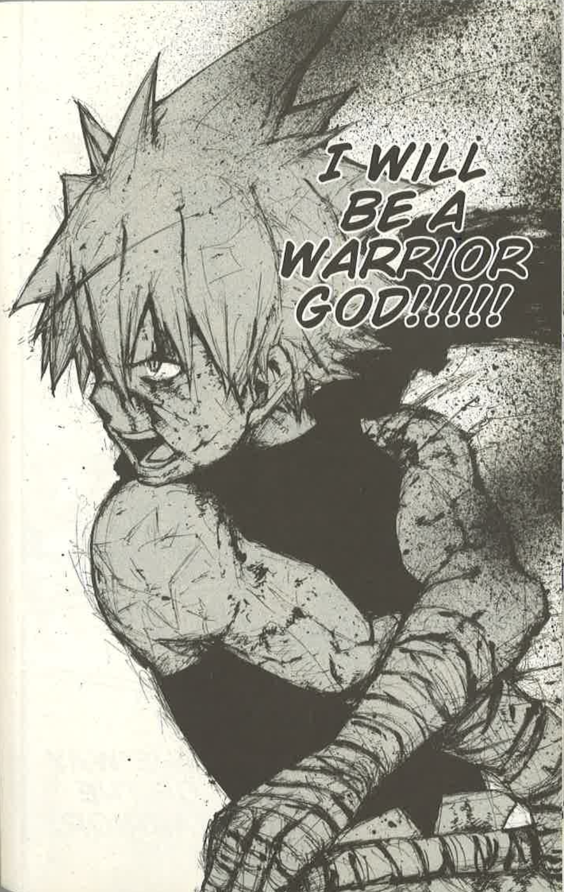
So then, the apotheotic pattern that is experimented with in Black☆Star’s case is the process of ascendance to godlike status; Black☆Star is the only one of the three protagonists who is not formally recognized by an ingrained system of accomplishment in the world of the narrative. While Maka accomplishes the legendary goal everyone at the academy strives for and Kid becomes the world’s next god, Black☆Star ascribes himself the title of “Warrior God” (left, 14: 188) upon his triumph over Mifune. Bypassing the legitimacy of this ascendancy through an ingrained system within the narrative, the legitimacy of Black☆Star’s proclamation of himself as “Warrior God” is instead pictorially and thematically represented. In this image, Black☆Star emerges from a black haze created by his own blood and the blood of his rival and into the light, moving toward his target with sword in hand out of frame, which represents his ascendance to self-ascribed divinity. This moment is simultaneously symbolic of his rise away from the “path of the kishin” represented by the haze, the color of which is typically associated with evil, and toward the ideals he adapts in his rivalry with Mifune, who represents the “path of the warrior” in the light indicative of divinity. Thematically, the self-ascription of divinity ultimately questions what power gets to proclaim who is divine and who is not, making the metatextual argument that there is always a certain definition of divinity the mythmaker brings to the myth. This sentiment is later echoed as Black☆Star asks, “Who the hell decided that human beings are weaker than Gods!!?” (25: 23) during the final battle with the kishin, further questioning the necessity of alignment with the divine as a necessary step on the path to herohood.
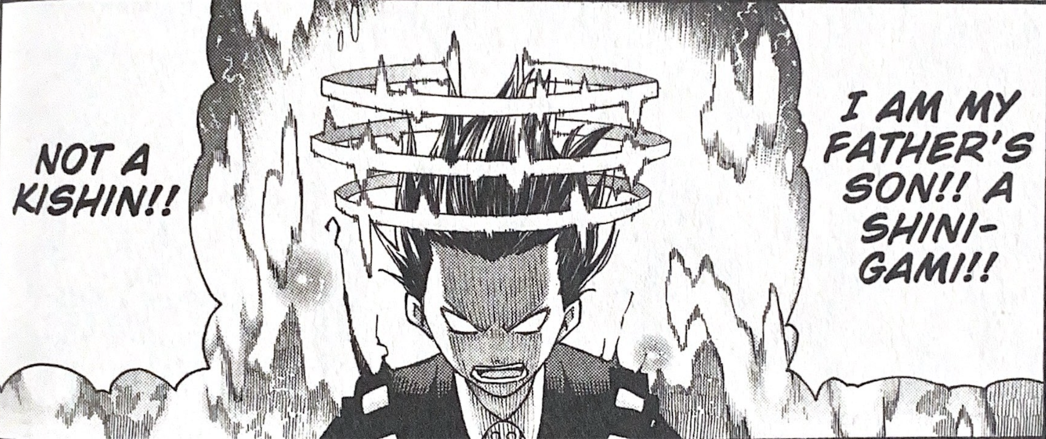
For Kid, apotheosis is bittersweet; the process of his apotheosis—narratively and visually represented in the text by the third sanzu line in his hair connecting (below, 25: 78)—indicates his growth into a true shinigami. He inherits the power of, and therefore technically kills, his own father when he takes over grim reaper. The equal evil Kid consumes in his route to apotheosis is the ultimate evil depicted in the text, the kishin, as he is the reason Kid awakens as a true shinigami. This equality is represented by their similarities. In addition to the similarities in design described in section two, Kid and Asura are both fragments of the current grim reaper; they are technically brothers and equally rightful heirs to their father’s position as, essentially, the god of this world. Therefore, the clash between them deciding the fate of the narrative world and which of their values will become stronger as a result of the consumption of the other’s, also decides which of them will usurp their father as the world’s next god. This shared ambition, while narratively evoking the feeling of epic and powerful conflict by simultaneously linking the two forces and putting them at odds as the monomyth does, creates a relationship between them that is equality in power and potential. Kid’s subsequent consumption of Asura’s evil through victory allows his ascendancy to the divine position of the world’s new shinigami. Kid becomes the new grim reaper, who is usually associated with death and darkness—and evil in myth. However, in this world, the shinigami’s association with divinity and goodness is clear. All DWMA students have the explicit mission to create a death weapon the shinigami can use, which keeps the world safe through its contribution to the consumption of evil souls. Additionally, it was the grim reaper himself who was able to seal Asura away in the first place, “swallowing” his evil the first time.
The apotheotic ingredient Kid interrogates through his process is, then, that of the completion of ego-death. Once he gets back from his battle, he suddenly must reckon with the truth that he has killed his own father. As Kid ascends to divinity, he declares, “I will become a shinigami just like the father I believed in” (25: 68). Kid states his ego-death as he verbally sacrifices any other potential he may have in order to take on the hero role destined for him from birth for the good of the world. This element is complicated is in its complete dependence on the death of Kid’s own father, a sacrifice he obviously struggles with as he grieves, saying, “So I became a shinigami to kill my father?” (25: 209) Since Kid’s ego-death is tied to such direct negative consequences, it challenges the inherent universal benevolence of the tradition of ego-death. The ego-death, as a killing of one’s former form, presents implicit growing pains for Kid, which exposes a certain unseen bitterness in this tradition; it represents not temporary loss as the hero once thought, but the permanent loss of the world of innocence the hero and reader once associated with safety and youth.
Through these challenges to the tenets of apotheosis, Ohkubo is exposing and rejecting a supposed finality in apotheosis, while The Arabian Nights abides by this finality in order to cement Scheherazade as a standard to live up to. Typically, in the monomyth, the hero, having completed apotheosis, enters a “world very similar to that of [the hero’s youth] except that the mood is a contemplative withdrawal from or sequel to action” (Frye 202) or essentially, a stage where they exit the narrative limelight of the hero’s journey and retreat to the safety of the familiar world with the knowledge and honors they have gained from the journey.
The Arabian Nights achieves this effect of finality through a broadening of the scale of the narrative after Scheherazade marries the king:
In due time King Shahryar summoned chroniclers and copyists and bade them write all that had betided him with his wife, first and last; so they wrote this and named it The Arabian Nights and A Night. The book came to thirty volumes and these the King laid up in his treasury. And the two brothers abode with their wives in all pleasure and solace of life and its delights, for that indeed Allah the Most High had changed their annoy into joy; and on this wise they till there took them the Destroyer of delights and the Severer of societies, the Desolator of dwelling-places and Garnerer of grave-yards, and they were translated to the ruth of Almighty Allah; their houses fell waste and their palaces lay in ruins and the Kings inherited their riches. (740)
Here, The Arabian Nights takes on a metanarrative approach as it supposes that the text the reader is consuming is the very same that King Shahryar has copied down in order to document the ordeal. Primarily, this unloads the weight of narration from Scheherazade to these “chroniclers and copyists,” signifying that the world of “annoy”—in which the kingdom needed Scheherazade to be the storyteller for the sake of all their lives—has been successfully transformed into a world of “joy” thanks to Westernized Allah’s chosen hero. She can now rest in “pleasure and solace.” This marks the definitive end of Scheherazade’s journey. She withdraws from and offloads the duty of narration, which has served as her continuous expression of heroism throughout the text, and she returns to a world much like the one preceding the ramifications of the original betrayal of Shahryar, before eventually, like many of her own regurgitated heroes, being rent asunder by the “Destroyer of delights and Severer of societies.” This move toward the meta also sets the text in the reality of the reader in order to make the “pleasure and solace of life and its delights,” as experienced by the kings and their wives, attainable as long as readers abide by the text’s standards. In this sense, the text shows its true Western roots by treating the post-apotheosis society similarly to how Europeans often romanticize Ancient Rome, as a time of “pleasure and solace” “fell waste” to some “Destroyer of delights and Severer of societies.” The sense of finality achieved through this move toward meta-narrative makes the age of peace and the method in bringing it about something for the reader not only to learn from but to aim to return to, in spite of its ultimate unattainability.

In Ohkubo’s three-pronged rejection of this finality, he rejects the mythic cementing of the hero that The Arabian Nights uses in its construction of Scheherazade and the other heroes in the tales. Instead, he reaffirms the respective value sets of his protagonists, making Soul Eater’s narrative more concerned with the process of establishing a set of principles that can make a hero than with crafting a specific hero who holds a certain set of principles for the reader to accept as the sole truth of heroism. This centering of the values of the hero rather the hero itself makes for a myth text that does not purport a certain value set as the one and only path to heroism. Rather, the myth text alleges that each of its protagonists have their own unique path to heroism that is equally as legitimate as the others and is one they must continuously walk to maintain their heroism. Maka may have been ambushed by the unexpected appearance of a secondary evil after her apotheosis, but her reaction to that evil remains the same as her reaction to the evil previously defeated: an unflinching determination to stand against it, demonstrated by her expression and stance in the bottom left panel during her betrayal (below). In this image, the expression on Maka’s face, while connoting understandable confusion, also connotes an air of hostility against her reintroduced enemy, signaling a willingness to fight even on the unequal terms brought on by the element of surprise. Black☆Star’s appraisal of himself as a “Warrior God,” while through the name itself implying that he will always have a connection to fighting, gives root to a constant need to prove himself worthy of divinity in lieu of any formal recognition. Finally, Kid’s bittersweet acceptance of his father’s death and his new role makes clear that the heroic ego-death requires an emotional toll each time it is performed in the hero’s post-apotheosis role, emphasizing the paradoxically cruel fact that the innocent, inculpable world that the hero knew in their ignorant youth is permanently lost, not solely through the villainy enacted upon them but also by the hero’s own growth. In each of these cases, Ohkubo suggests that the work of the heroic should not and does not end with apotheosis, but merely begins with it.
Upon receiving this great burst of potential and status, the hero still must fend off evil that springs up, no matter the might or circumstance. The hero still must continually live up to the name they have carved out for themselves. The hero still must outgrow themself time and time again in the pursuit of a world without conflict. By resisting the finality of apotheosis, Soul Eater exposes one last fallacy ingrained in the monomyth structure. In the real world, there is no power or designation a person can obtain once that will indisputably immortalize them as a hero, because the duty of maintaining that heroism must involve a continual abidance by the principles that made them a hero in the first place once gaining said power. To borrow the mantra of another hero, “With great power comes great responsibility.”

Conclusion
If “the happy ending of the—myth—is to be read…as a transcendence of the universal tragedy of man” (Campbell 21) and, therefore, an immortalization of the hero, the monomyth encapsulates not optimism that man holds the potential to become a hero—as many believe—but rather pessimism that man cannot achieve that potential without abandoning his humanity. Therefore, the monomyth becomes a structure that does not simply construct heroes out of the hopeful man, one that does so at the cost of erasing the humanity and individuality that distinguishes man enough to create these stories in the first place. The Arabian Nights’ continual reinforcement of the specific ideals Scheherazade emphasizes during the king’s “transformation” perpetuates this tradition, while it is rebuked by the totality of Soul Eater’s deconstruction of the monomyth. This creates a revelatory relationship between each of their narratives that exposes the propagandized version of myth in The Arabian Nights and the genre-rebellion of Soul Eater.
The format of The Arabian Nights as a frame tale extends and scales the monomyth structure across both the tales told by Scheherazade and the parent frame of Scheherazade’s tale to make the Western ideals discussed throughout this paper heroic. These repeating, compounding monomyths are meant as “narratives that subtly counter [the King’s] world view and pose an alternative to despotism” (Makdisi and Nussbaum 19), but serve as an enchanting “counter-hypnosis to the one afflicting Shahryar” (Naithani 279) and an indoctrination of the reader into the text’s own version of heroism. The evidence is in the false binary between despotism and the specific brand of heroism sported in Scheherazade’s narratives, which is instilled in the text from the beginning. By setting these repetitive narratives in direct opposition to despotism, which everyone during the time The Arabian Nights was composed and sold was familiar with and concerned over, the text continuously alleges that the only way to combat despotism is to abide by the text’s definition of heroism, and that which is in opposition to the definition stands in the way of chaste and righteous heroes like Scheherazade, Perizadah and Morgiana. Thus, the text forces the reader to make an uninformed and unfair choice between adapting the text’s biased ideals and a universally unwanted extreme. By repeatedly centering the chaste, devout, righteous and typical mythic hero, the text adapts the classic definition of heroism, which excludes any human flaws or characteristics, to exclude Enlightenment values of religious skepticism and sexual “impurity” as perceived by Christianity as flaws of man that must be shed in order to not just combat despotism, but “transcend the tragedy of man” entirely. Furthermore, the role of myth in this text as “counter-hypnosis” to Shahryar’s madness reflects the text’s intended effect on the reader, who at the time of composition was surrounded by texts emphasizing Enlightenment ideals over the magic and fantasy depicted in this text. According to The Arabian Nights, the reader’s and “Shahryar’s mind is afflicted with experience, and [Scheherazade] takes [both] on unbelievable journeys, creating magical scenarios with such a craft that he can believe in these shimmering illusions” (Naithani 279). The Arabian Nights uses the “unbelievable, magical shimmer” of Scheherazade’s tales to attempt to cure the reader of their “affliction of experience,” surmising that a mindset only able to draw conclusions based on that which has already happened—the perpetuation of logic and reason largely popularized during the Enlightenment period—is a poisoned one that needs to be mended through the magic of myth. In this sense, while The Arabian Nights uses myth to rebel against the Enlightenment ideals of reason and realism, it does so by using myth as a disguise for its own agenda of ascending the exclusively Westernized ideals of society and character found in Scheherazade and her heroes.
Conversely, Soul Eater’s continuous deconstruction of the monomyth tradition wholly criticizes monomyth’s goal to have the centered hero and their principles ascend past the so-called “tragedy of man.” In a highly condensed summary, Ohkubo gets this ultimate skepticism across through the prolonged rejection of the inherent interference of the divine in the hero’s journey. First, Ohkubo disrupts the one-to-one translation of good and evil onto the myth’s hero and enemy that the mythic binary operates on by centering multiple protagonists and antagonists of differing values, disturbing the explicit definition of good and divinity myth texts require to allow for transcension. Next, Ohkubo erases the implicitness of destiny established in agon to create distortion in the relationship between the centered hero and the higher power behind the hero’s destiny, rejecting the supposed inherent nature of the relationship between the hero and the divine. Finally, through the rejection of both the externalization of evil in the road of trials and finality to the hero’s journey in apotheosis, Ohkubo denies the central allegation of myth that evil can be overcome eternally within a singular act, ultimately foregoing the culmination of the monomyth that is ascension to the realm of the divine. Through this thorough denouncement of the mythic mission to transcend man, Ohkubo simultaneously exposes and severs the deep-rooted ties between the hero and the divine, creating a myth text that is more unapologetically human and, therefore, more accessible than the myth has ever been.
The effect achieved when reading these two texts in conjunction is similar to the effect achieved by the infliction of the mythic binary; the stark contrast of the opposing natures of the narratives is further accentuated through the differences between them. When compared to the multiplicity of heroism in Soul Eater, the singularity of Scheherazade as the sole hero of the parent tale, as well as sole heroic archetype that all of the heroes throughout the tales are based on, reveals a focused effort on the part of the mythmaker to portray Scheherazade’s Westernized values as the sole righteous path. Consequently, the multiplicity of Maka, Black☆Star, and Kid contrasts with The Arabian Nights not just in the literal number of heroic figures featured in each myth text, but in Soul Eater’s assertion that there is an equalized spectrum of methods to achieve heroism. Turning attention to the other side of the mythic binary, Soul Eater’s multifaceted exploration of the various roots of evil reveals The Arabian Nights’ definition of evil as that which is in opposition to the text’s Christianized pseudo-Islam as a gross bastardization of the concept of evil used solely deter Enlightenment thinking. Meanwhile, The Arabian Nights’ habit of identifying a target as evil and attempting to narratively eliminate it emphasizes the multifaceted nature of evil depicted in Soul Eater as a subversion of tradition that opts to instead confront the definition of evil and explore it. During agon, Soul Eater’s erasure of the assumption of destiny leaves out of this once divinely ordained role of hero, while The Arabian Nights has a stubborn sense of entitlement that Scheherazade’s value set is the sole righteous one. By exposing this entitlement, Soul Eater combats the notions of predestination within the monomyth that The Arabian Nights thrives on. Finally, Soul Eater’s rejection of concrete achievement as the end of the monomyth, the collective effect of pathos, exposes a rather antiquated imperialistic tendency of The Arabian Nights to suggest attainability of herohood through the elimination or absorption of opposition. Reflexively, Soul Eater’s revelation of this tendency to conquer in The Arabian Nights resists that tendency in the monomyth itself by calling attention to it and denying it. touting internal betterment as the path to heroism rather than searching for external validation.
Through the relationship constructed here, The Arabian Nights, which is seen as a quintessential counter-cultural text of the Enlightenment era, is made aggressive propagator of Western values masquerading as Eastern mythology, self-righteous purveyor of its own loosely founded ideals, and colonizer of the East’s mythology for its own benefit. Soul Eater, then, as a result of this relationship, emerges as a new counter-cultural text to myth itself by broadening the mythic binary, abolishing the role of the divine in man’s journey to heroism, and renewing emphasis on and appreciation for the internal struggle of man. In the end, both texts accomplish their rebellion against a prevalent mode of thought that threatens to dominate the culture of storytelling in which they are situated. However, where The Arabian Nights does so by ushering in a new regime of oppressive thought, Soul Eater rebels by wholly embracing the romanticization of the success of man, unabashedly breaking open that “secret opening through which the inexhaustible energies of the cosmos pour into the human cultural manifestation” (Campbell 1) that myth is for all to see.

Works Cited
Campbell, Joseph. The Hero with a Thousand Faces. 3rd ed., New World Library, 2008.
Cohen, P. S. (1969). “Theories of Myth.” Man, 4(3), 337–353. https://www.jstor.org/stable/2798111
Comstock, Nancy W. “Mythology.” Salem Press Encyclopedia, 2023. EBSCOhost, search.ebscohost.com/login.aspx?direct=true&db=ers&AN=98402147&site=eds-live.
Frye, Northrop. “THIRD ESSAY. Archetypal Criticism: Theory of Myths.” Anatomy of Criticism, Princeton University Press, Princeton, NJ, 1957, pp. 131–239.
Makdisi, Saree, and Felicity Nussbaum. “Introduction.” The Arabian Nights in Historical Context: Between East and West, 1st ed., Oxford University Press, Oxford, UK, 2009, pp. 1–23.
Martin, Tracey. “Propaganda: How Germany Convinced the Masses .” History in the Making, vol. 13, Jan. 2020, pp. 91–112. History at CSUSB ScholarWorks, https://scholarworks.lib.csusb.edu/cgi/viewcontent.cgi?article=1138&context=history-in-the-making.
McCloud, Scott. Understanding Comics. HarperCollins Publishers, Inc., 1994.
Naithani, S. (2004). “The Teacher and the Taught: Structures and Meaning in the Arabian Nights and the Panchatantra.” Marvels & Tales: Journal of Fairy-Tale Studies, 18 (2), 272–285.
Ohkubo, Atsushi. Soul Eater. Translated by Amy Forsyth, Yen Press, 2009-2015. 25 vols.
The Arabian Nights. Translated by Sir Richard F. Burton, Sterling Publishing Co., Inc., 2016.

Makdisi, Saree, and Felicity Nussbaum. “Introduction.” The Arabian Nights in Historical Context: Between East and West, 1st ed., Oxford University Press, Oxford, UK, 2009, 1.
Makdisi, Saree, and Felicity Nussbaum, “Introduction,” 11.
Makdisi, Saree, and Felicity Nussbaum, “Introduction,” 14.
Makdisi, Saree, and Felicity Nussbaum, “Introduction,” 18.
Makdisi, Saree, and Felicity Nussbaum, “Introduction,” 16.
Makdisi, Saree, and Felicity Nussbaum, “Introduction,” 21.

